​ OWASP Juice Shop Penetration Testing
​Introduction:
​This report documents a comprehensive penetration testing exercise conducted on the OWASP Juice Shop web application. OWASP Juice Shop is an intentionally insecure web application designed for security training. The primary objective of this assessment is to identify and exploit critical vulnerabilities using industry-standard tools such as Burp Suite. By providing a detailed proof of concept (PoC) for each attack, we demonstrate the potential impact of these flaws and provide a foundation for implementing robust security measures.
Scope of Assessment:
​The project covers several vulnerability classes from the OWASP Top 10, including:
​Injection (SQL Injection)
​Broken Access Control (CSRF)
​Cross-Site Scripting (XSS)
​Security Misconfiguration (Error Handling)
​
1. SQL Injection (SQLi):
​1.1. Vulnerability Location:
​The vulnerability was identified in the Login Page within the Email input field, and also in the Product Search bar.
​1.2. Discovery Phase:
​To identify potential SQL Injection, I performed manual testing by injecting a single quote (') into the input fields to observe how the application handles database syntax errors.
​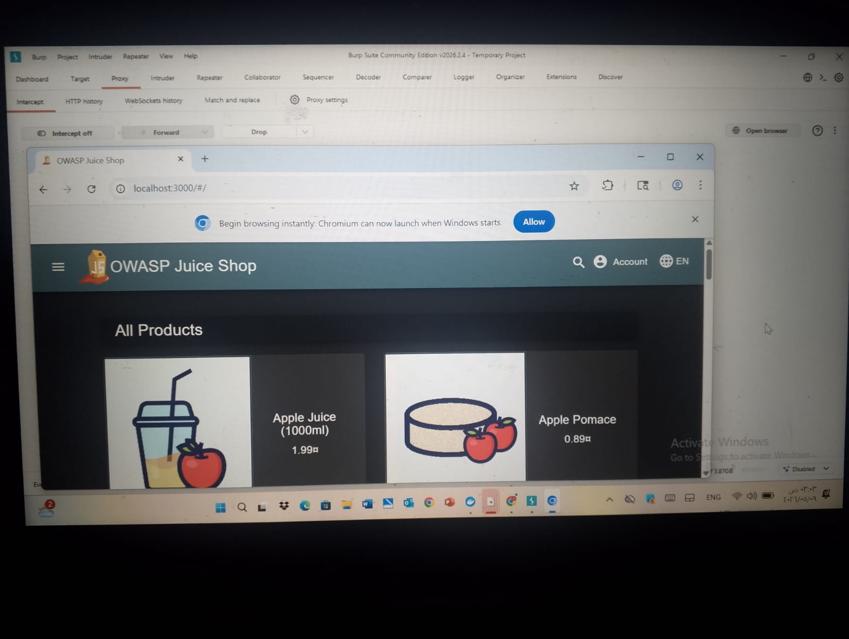
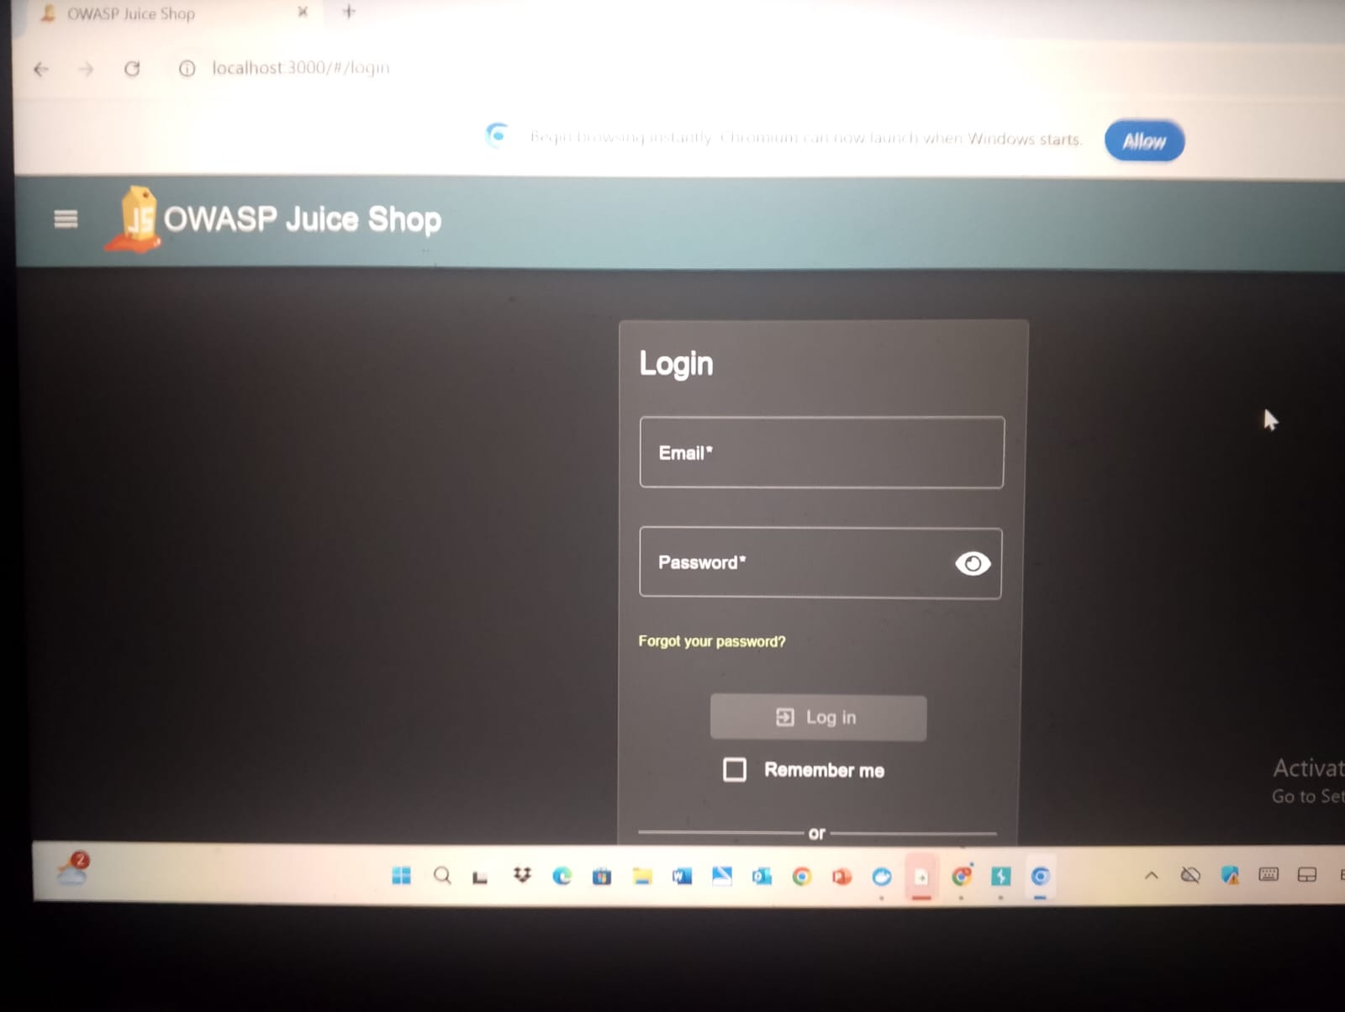

​

Observation: Entering a single quote in the email field triggered an internal error: [object Object]. This confirmed that the application does not properly sanitize user input before passing it to the backend SQL query.
​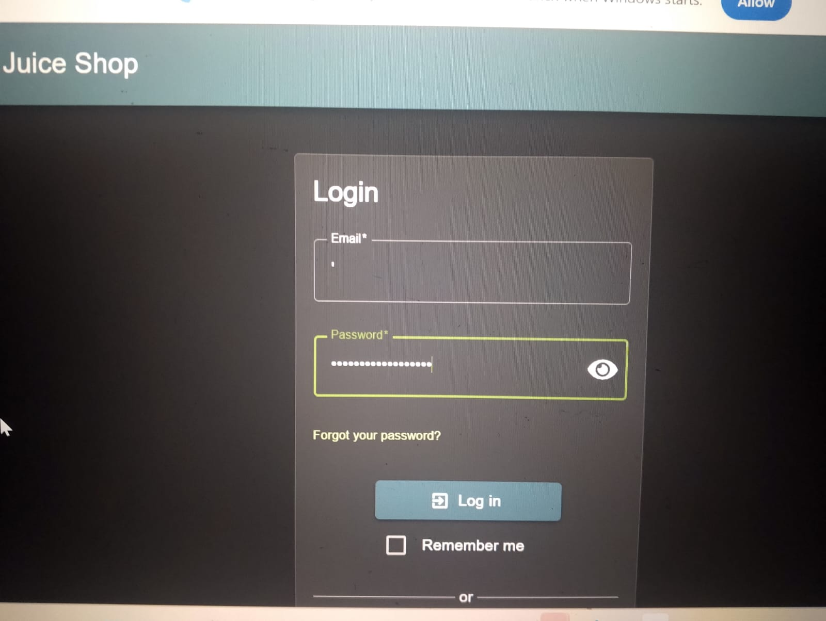
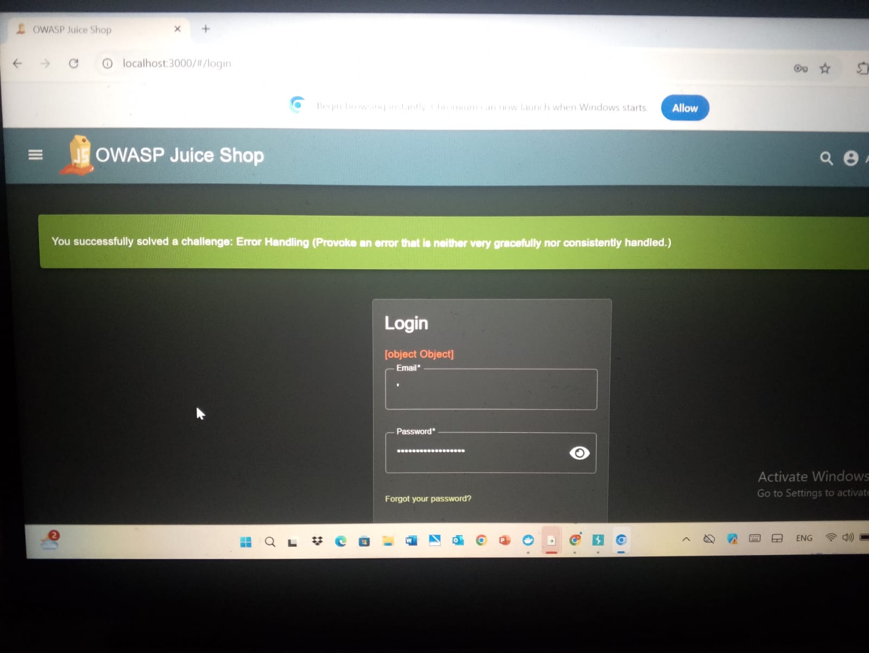
​
1.3. Exploitation: Authentication Bypass:
​Payload: ' OR 1=1 --
Step 1: I entered the payload in the email field with a random password. The logic ' OR 1=1 makes the SQL statement always true, and -- comments out the rest of the query. Step 2: The server authenticated me as the first user in the database, which is the Admin.
​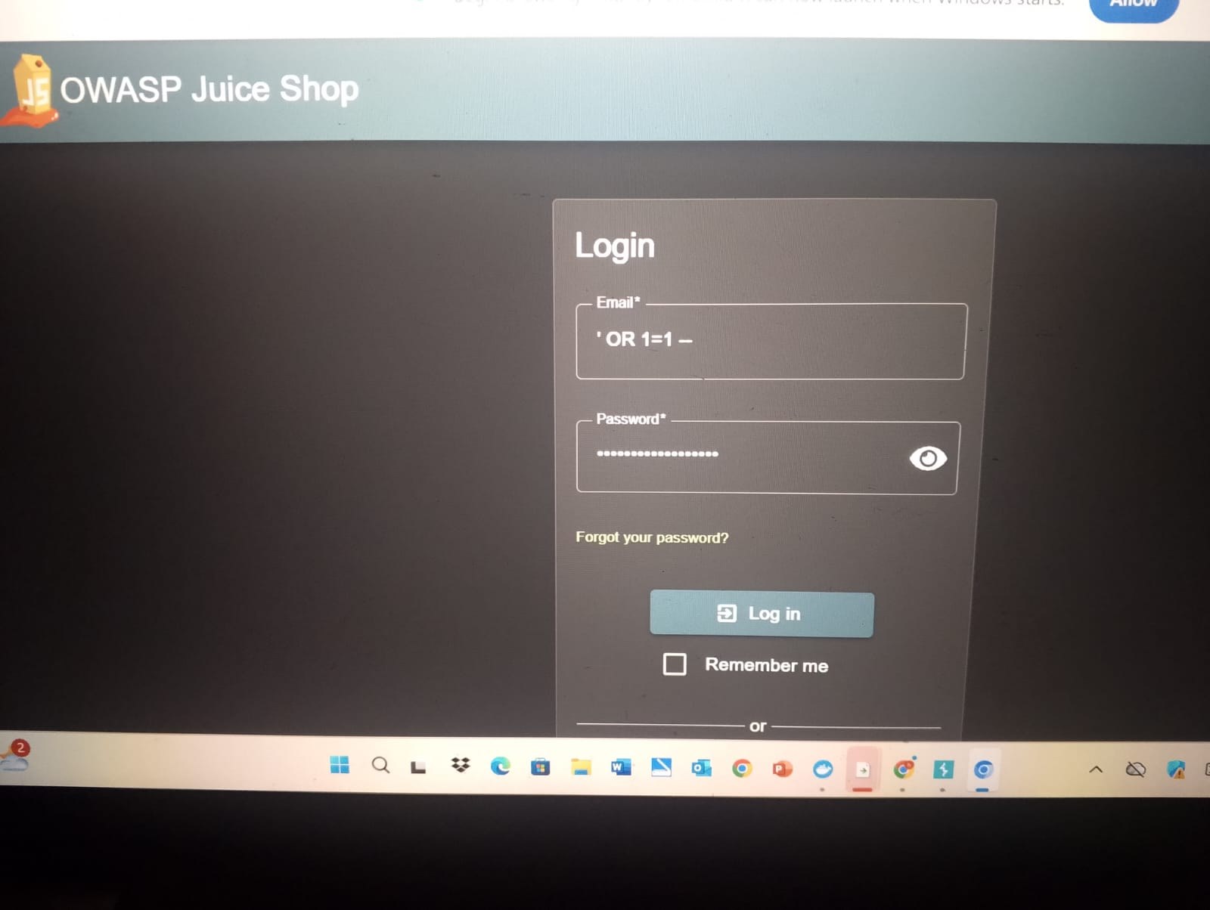
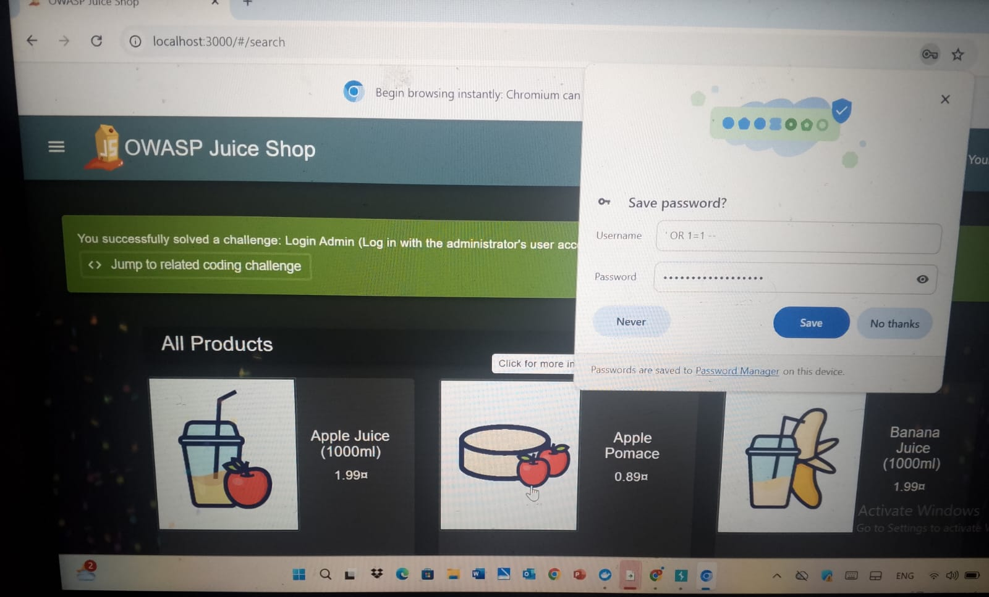
1.4 SQL Injection (Search Field):
​To verify if the search functionality was vulnerable to injection, I used a specific payload to break the SQL query logic and manipulate the results returned by the application.
​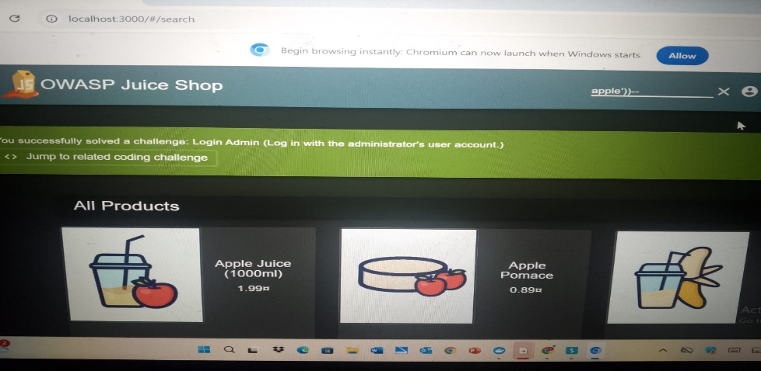
(Confirming SQL Injection in the search bar using the payload apple'))-- to bypass standard filtering)
​1.5 (Traffic Analysis via WebSockets):
​During the exploitation phase, it was essential to monitor how data is transmitted between the client and the server. I used Burp Suite to capture and inspect the WebSocket traffic.
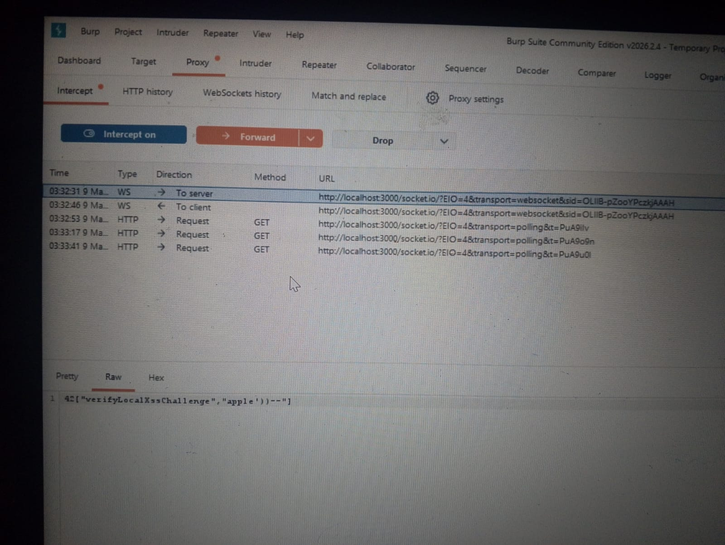
(Using Burp Suite Proxy to monitor real-time WebSocket messages and verify the delivery of the injected payloads)
1.6 (HTTP History Analysis):By reviewing the history of HTTP requests and responses, I was able to analyze the server's behavior and confirm that the SQL queries were being executed as intended by the attacker.
​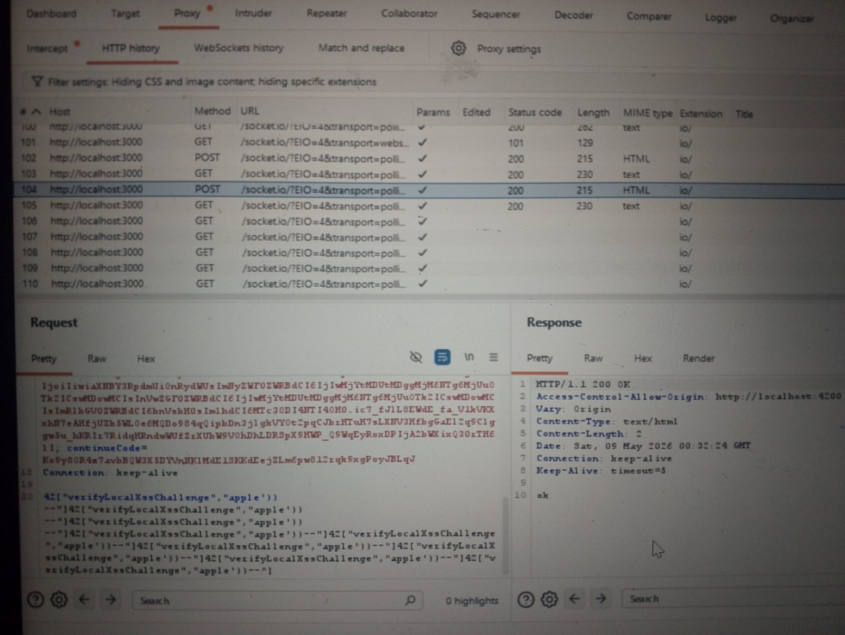
(Reviewing the HTTP History in Burp Suite to analyze the server's responses and confirm the successful exploitation)
​
1.7 (Challenge Completion):
​After successfully exploiting the SQL Injection vulnerabilities in both the Login and Search features, I verified the progress on the application's internal tracking system.
​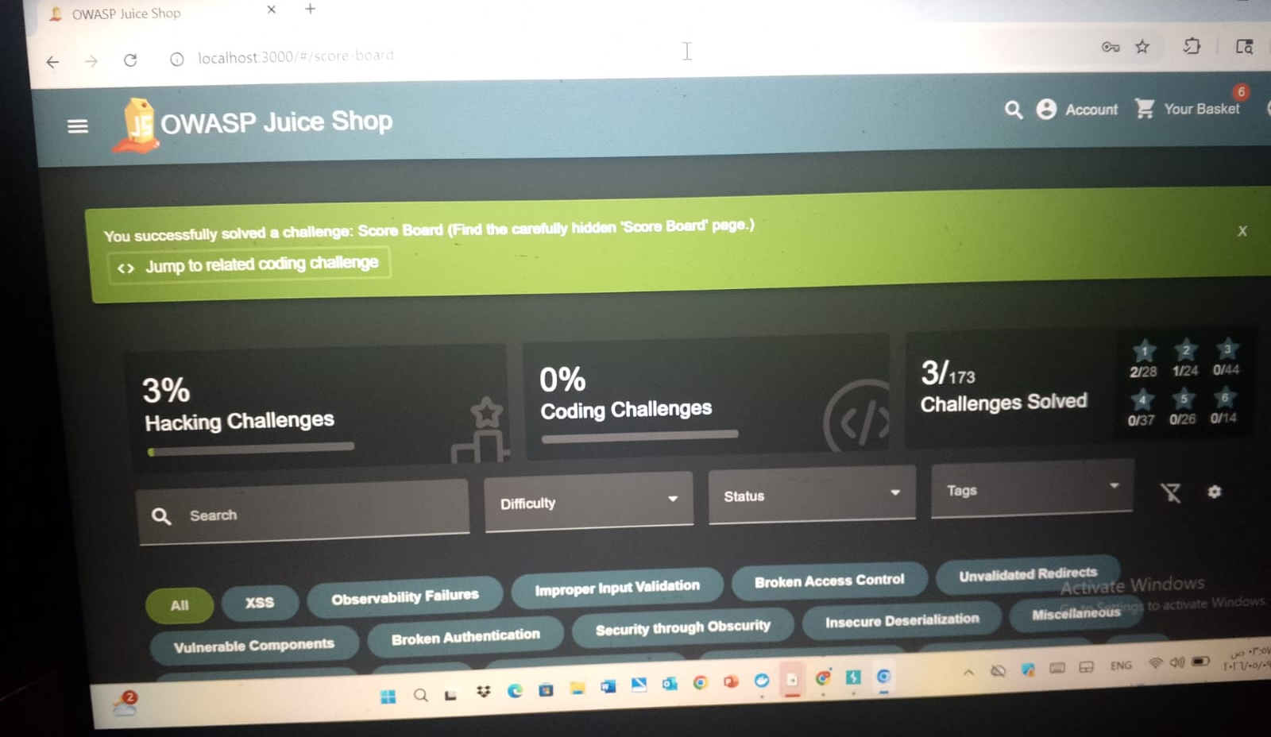
(The Score Board displaying the successful completion of SQL Injection challenges and overall project progress)
1.8 Advanced SQL Injection: Accessing Administrative Data:
​Discovery & Targeted Injection
​To test the boundaries of the database's security, I targeted the administrative interface. The objective was to determine if the search fields could be manipulated to reveal hidden administrative endpoints or sensitive user data that is not typically exposed to standard users.
​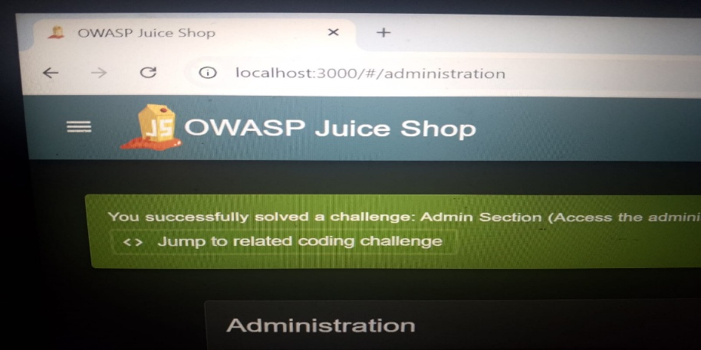
(Executing a targeted SQL Injection payload in the search field to uncover hidden administrative paths.)
​1.9Exploitation & Privilege Escalation:
​The application successfully processed the malicious query, allowing me to bypass standard authorization checks. By manipulating the backend SQL logic, I gained unauthorized access to the administrative dashboard, confirming a severe "Broken Access Control" flaw driven by SQL Injection.
​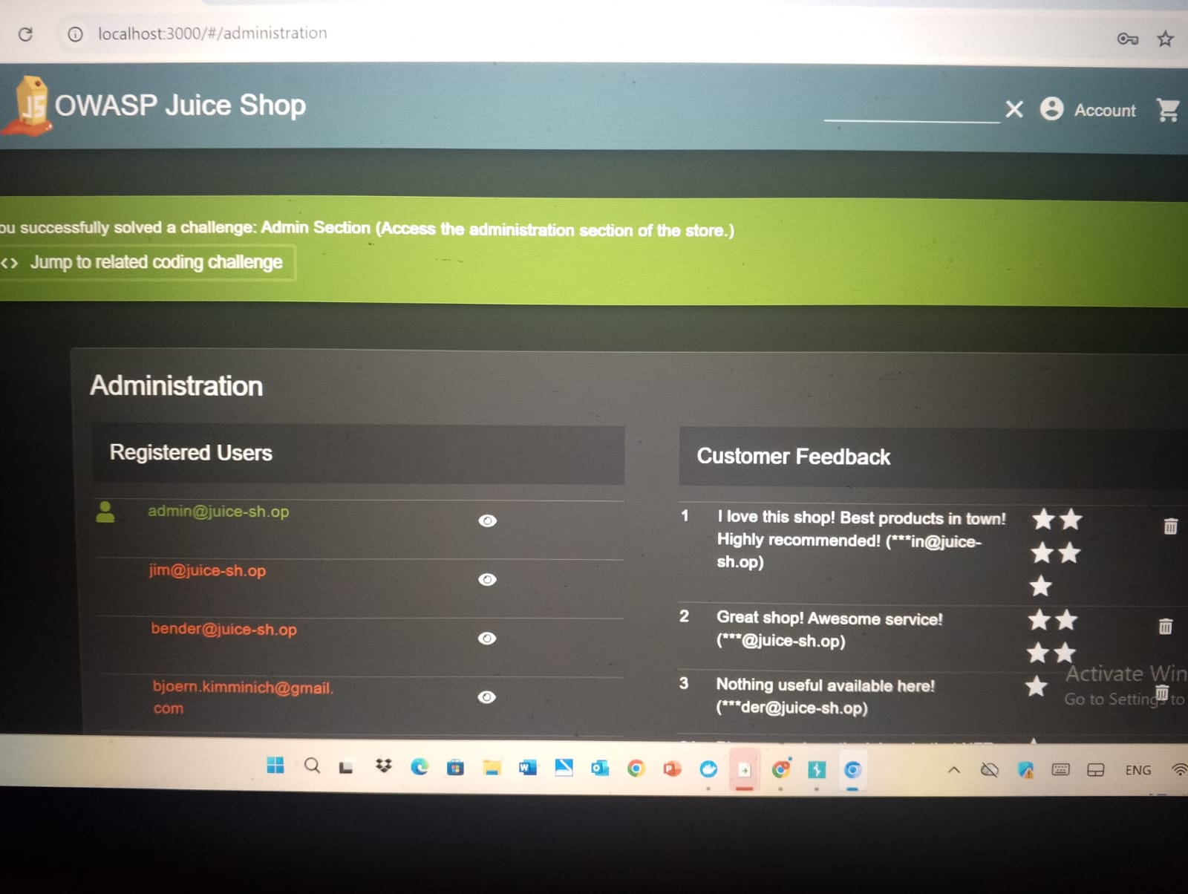
(Successful exploitation showing the application's response to the manipulated administrative query.)
​

1.10 Technical Verification via Burp Suite:
I used Burp Suite to monitor the interaction between the client and the server. Analyzing the HTTP History and WebSockets allowed me to see the raw data exchange and confirm that the server was executing the injected commands as part of its internal database operations.
​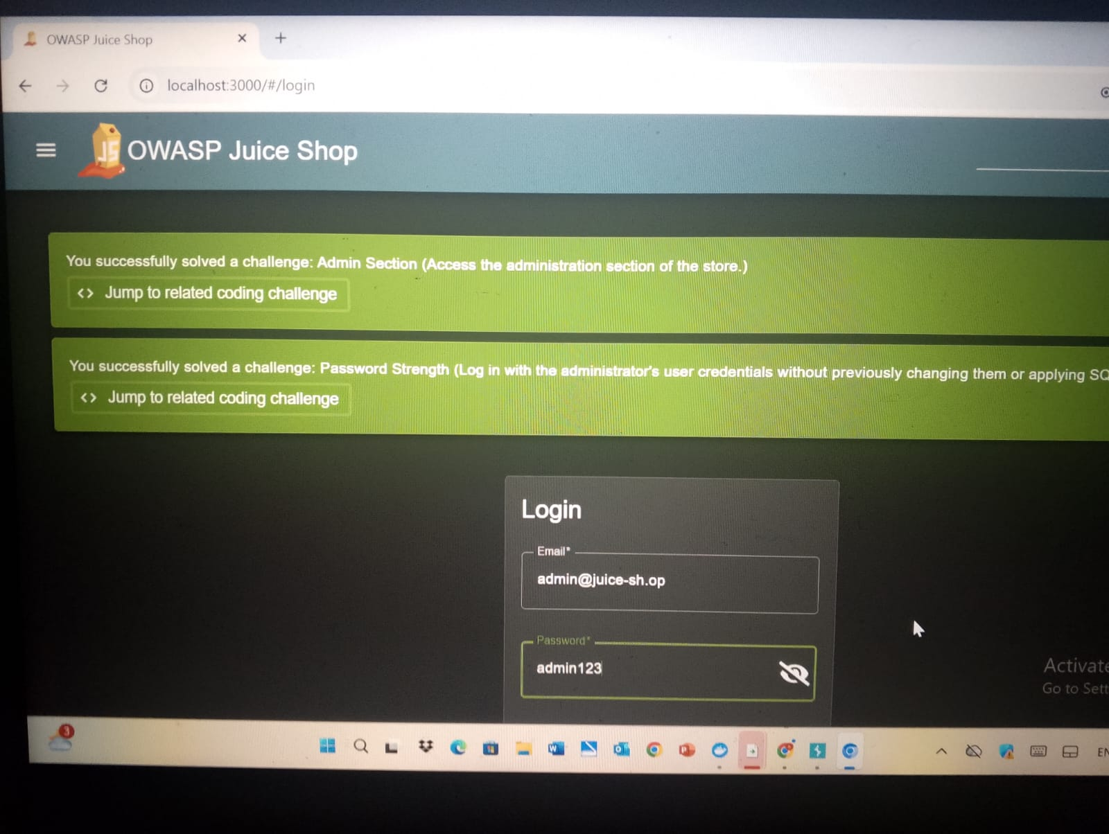
(Analyzing the intercepted request in Burp Suite to verify the data leakage and query execution.)
​1.11Final Proof & Challenge Completion:
​The exploitation was finalized by confirming the results on the Score Board. This demonstrates that the SQL Injection vulnerability provides a direct path to total system compromise by allowing an attacker to take over administrative functions.
​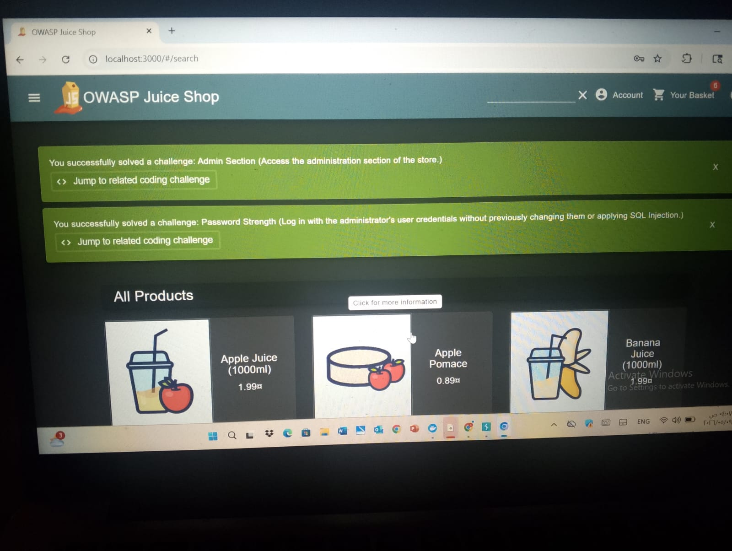
(Final confirmation of the 'Administration' challenge completion and verification of the attack's success.)

1.12 Union-Based SQL Injection:
​Step 1: Identifying the Vulnerability (Entry Point)
​The first step was to test the search parameter for SQL injection vulnerabilities. By injecting a single quote followed by a closing parenthesis '), the application returned a verbose SQLite error.
​Payload: ')
​Observation: The error 500: SQLITE_ERROR confirmed that the backend uses SQLite and that the input is not properly sanitized.
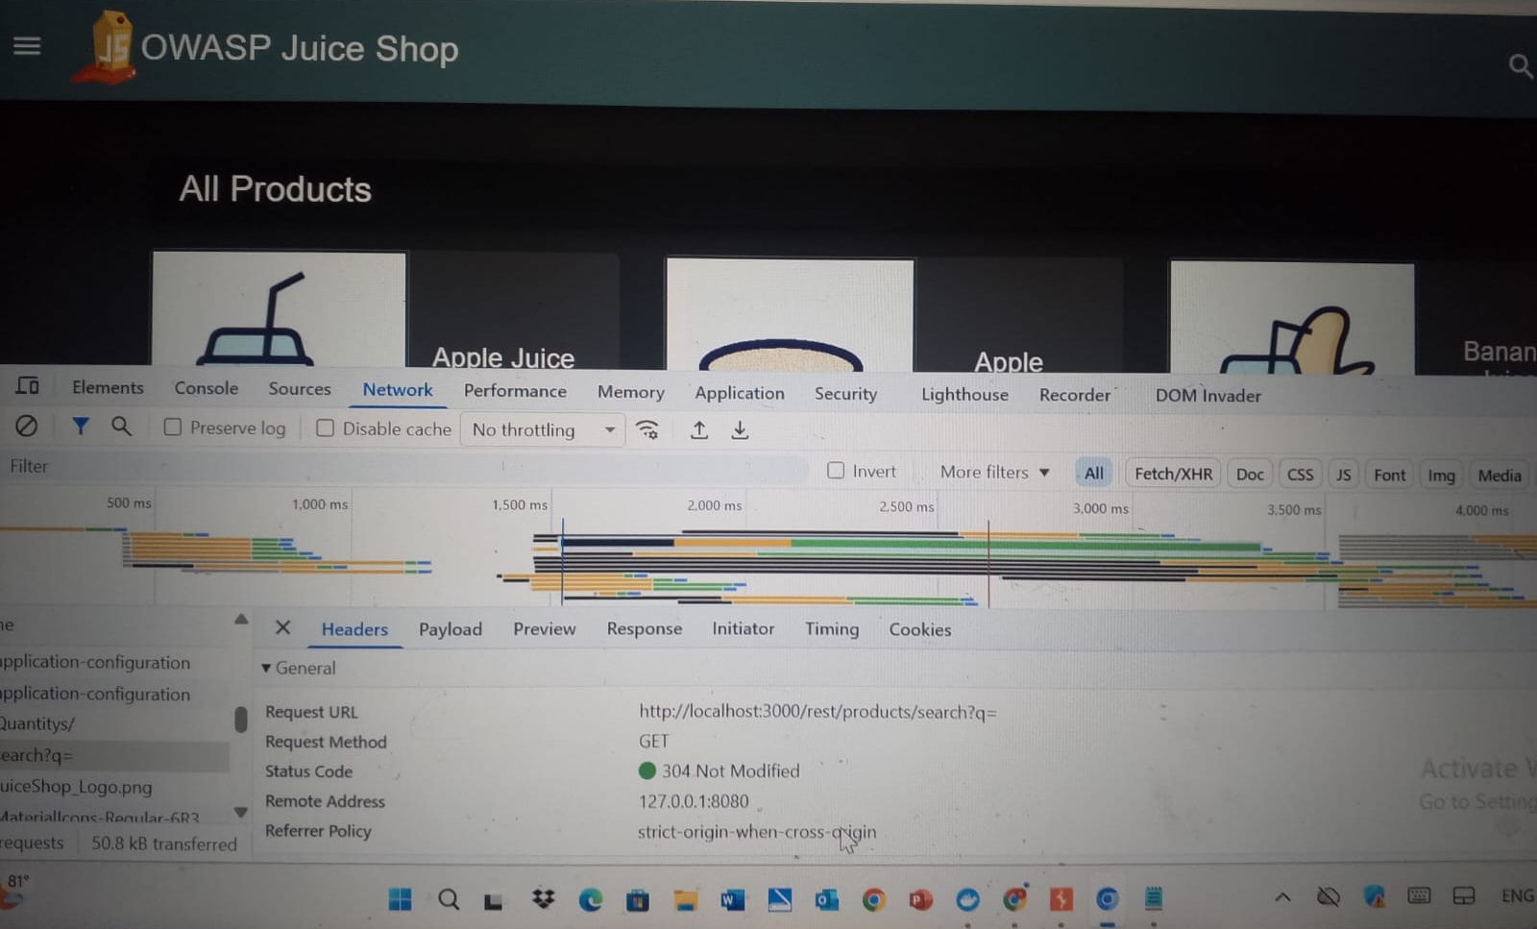
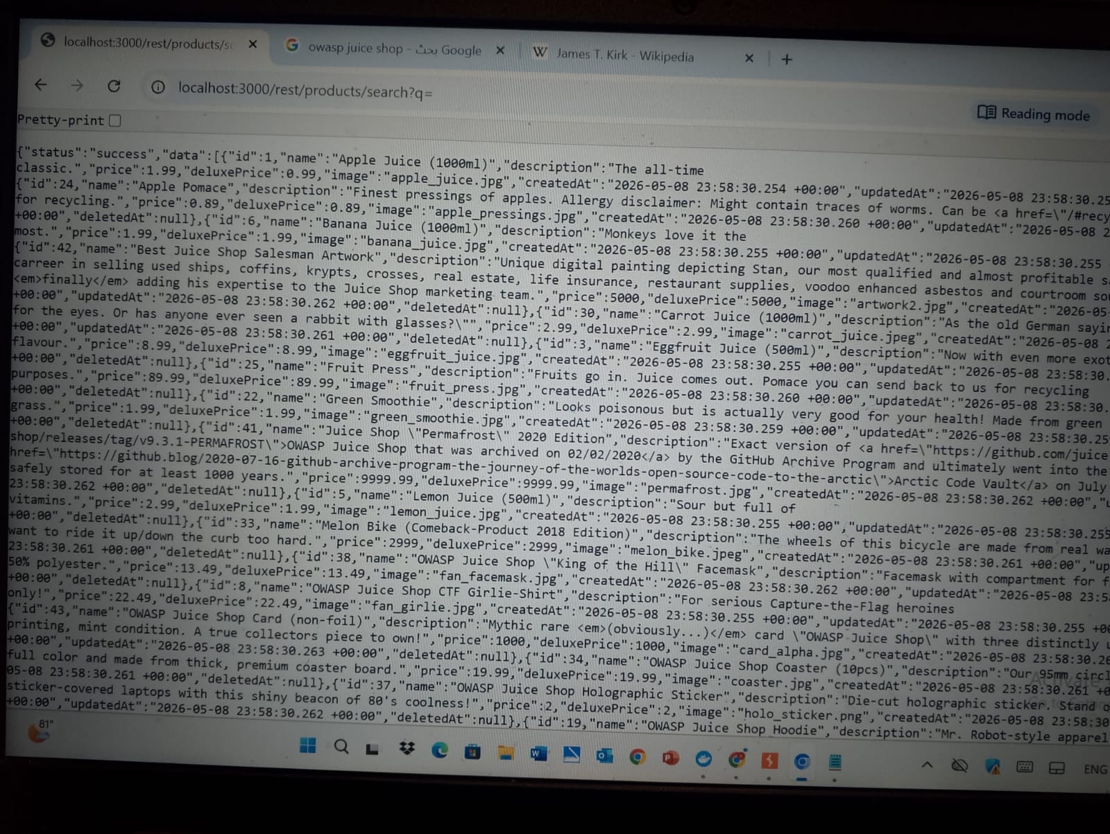
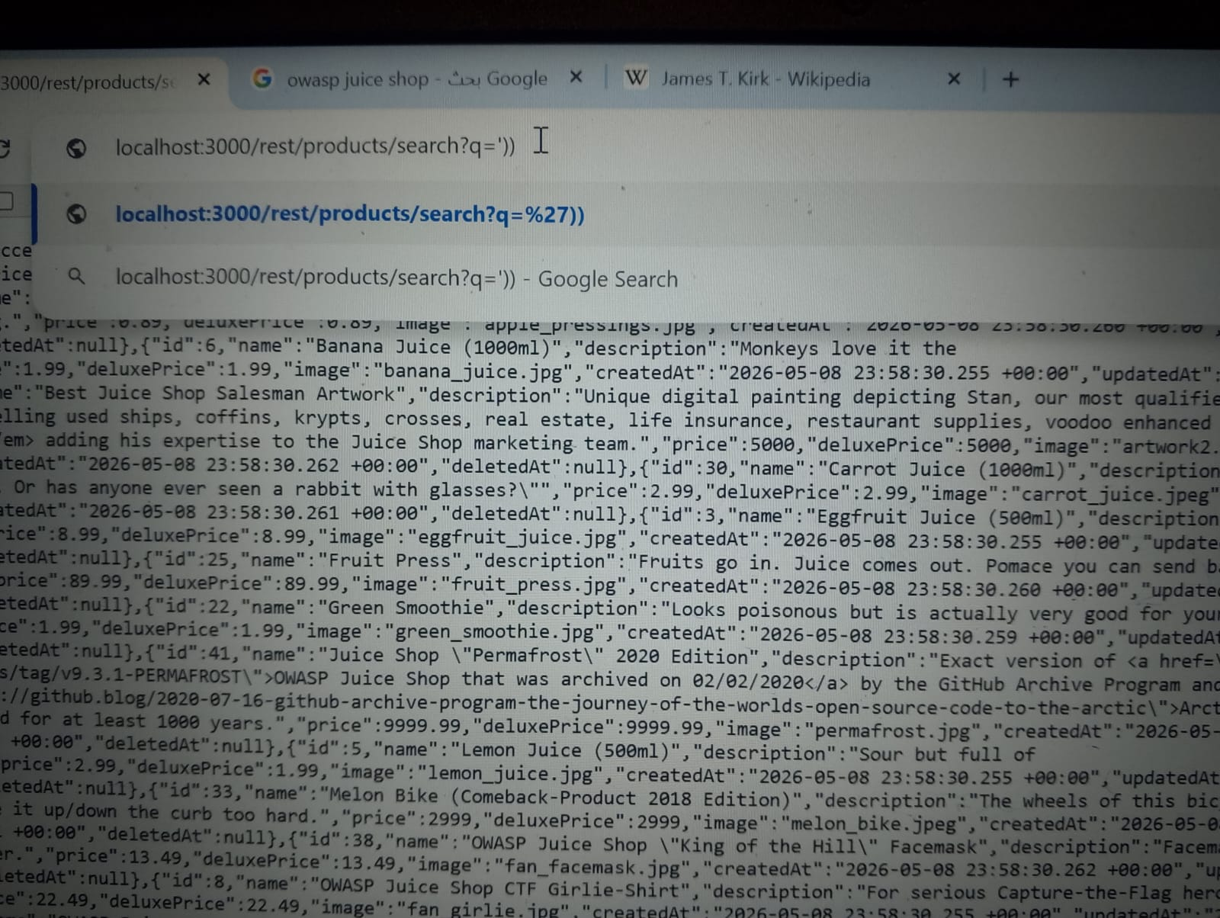
​Step 2: Determining the Number of Columns
​To perform a UNION attack, the number of columns in the injected query must match the original query. We used UNION SELECT with a series of numbers until the error disappeared.
​Payload: ')) UNION SELECT 1,2,3,4,5,6,7,8,9--
​Observation: Any number other than 9 columns triggered an error ("SELECTs to the left and right of UNION do not have the same number of result columns"). When 9 columns were used, the page loaded successfully.
​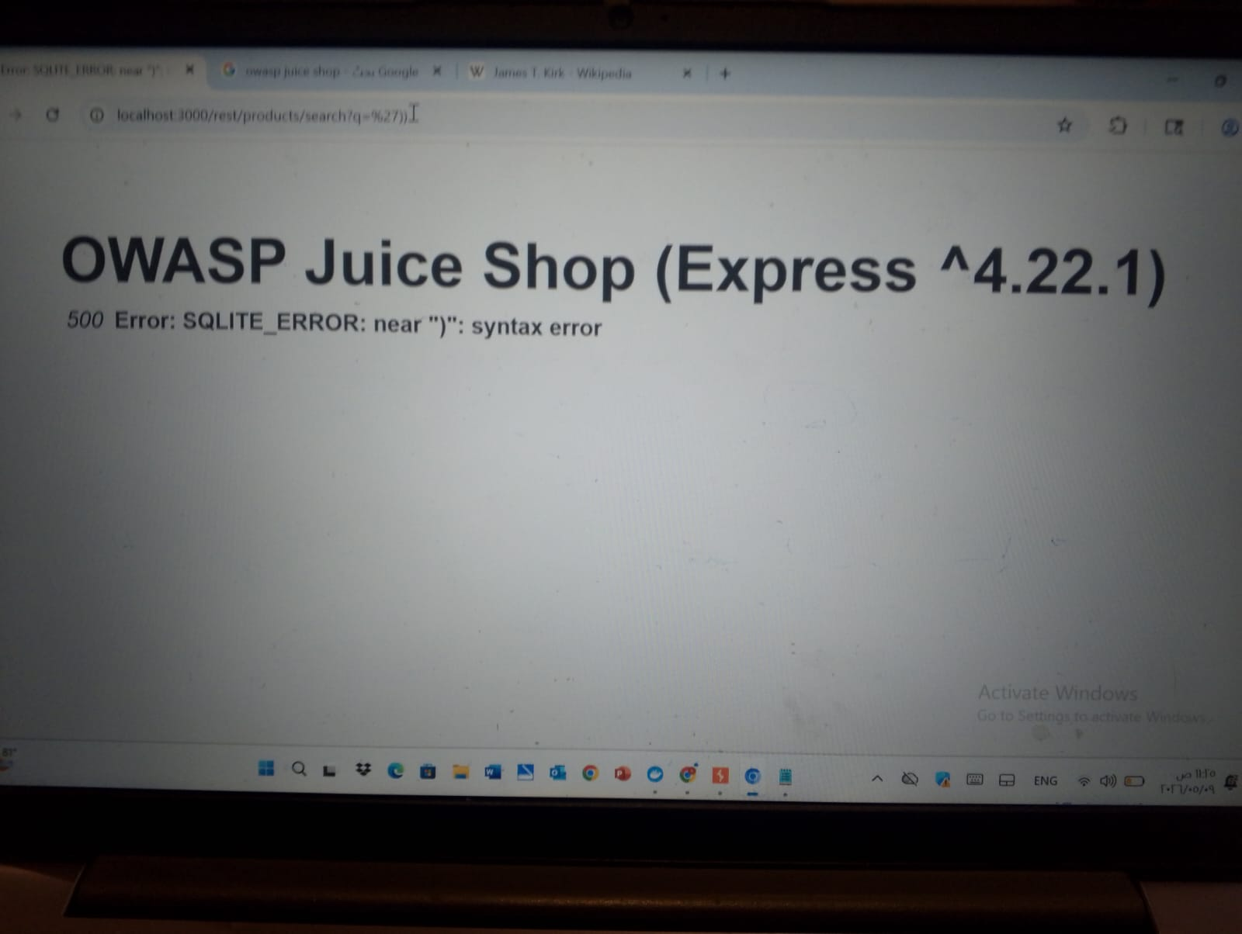
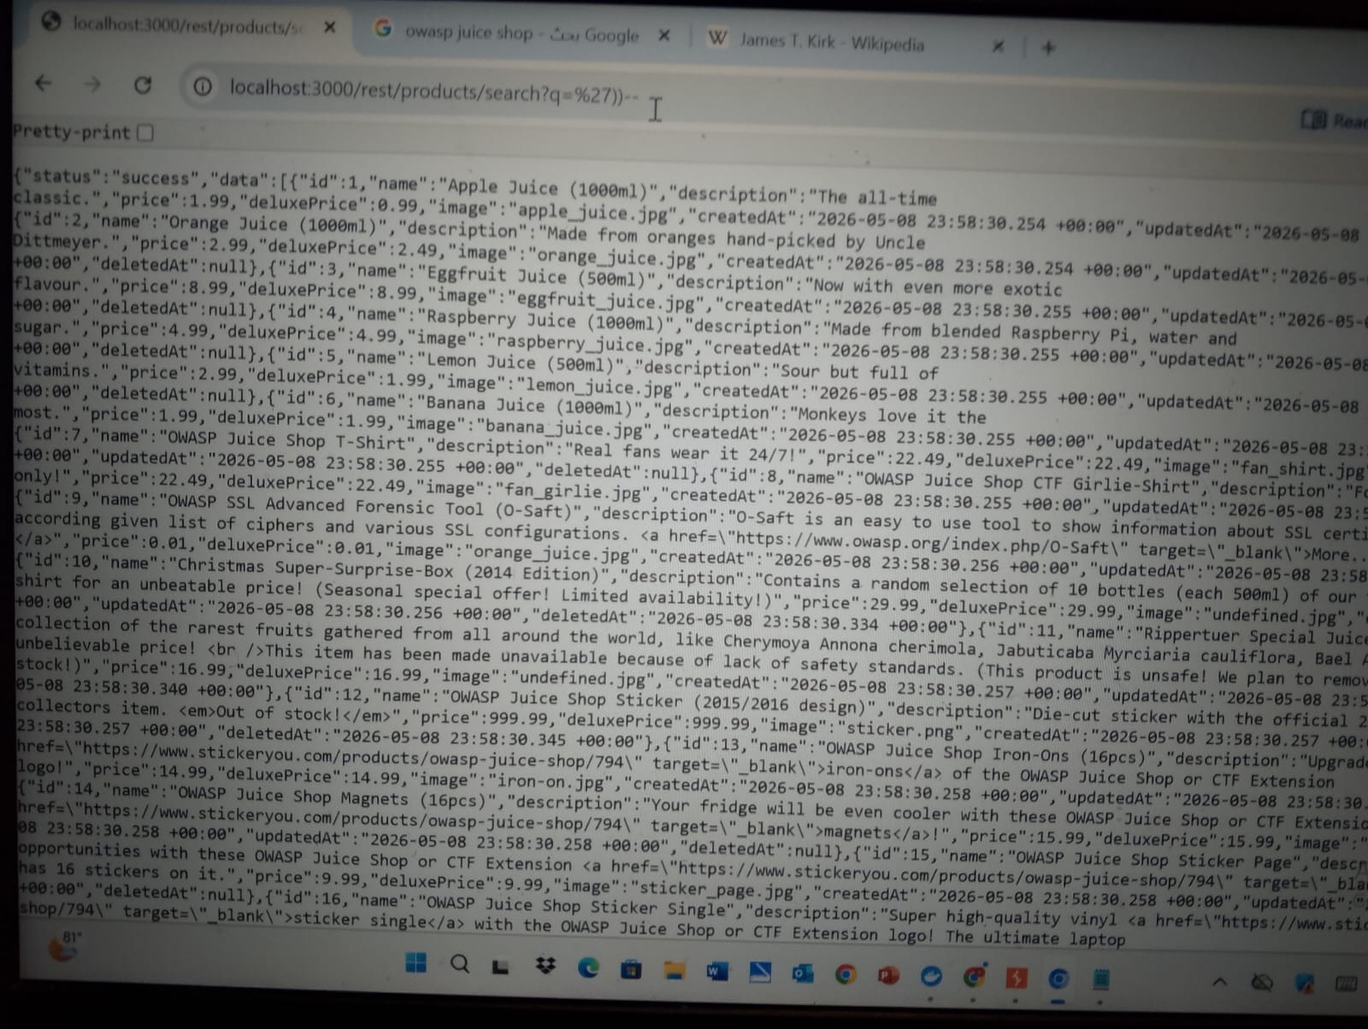
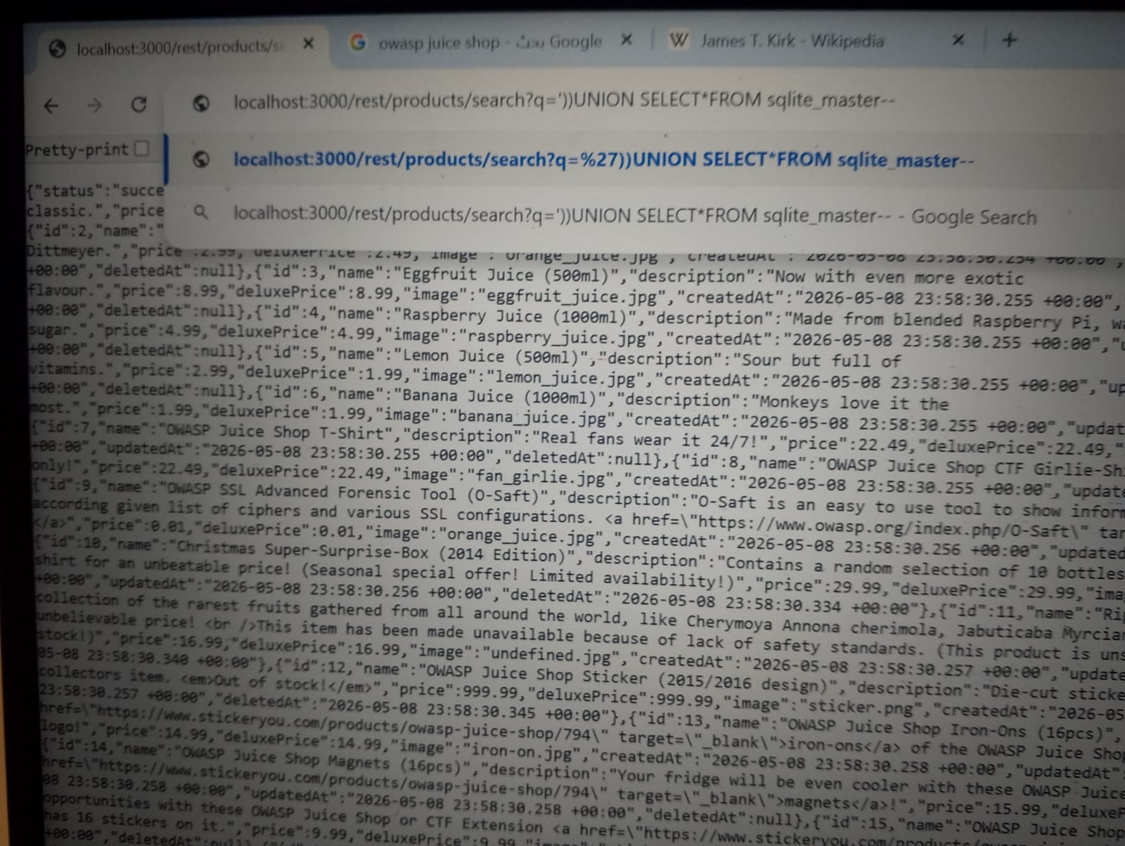
​Step 3: Locating Injected Data (Mapping)
​After finding the correct number of columns, we needed to see which columns were reflected on the page (the JSON response).
​Payload: ')) UNION SELECT '1','2','3','4','5','6','7','8','9'--
Observation: The numbers appeared in the JSON fields (e.g., "id": "1", "name": "2", etc.). This confirms that we can use these positions to extract real data.
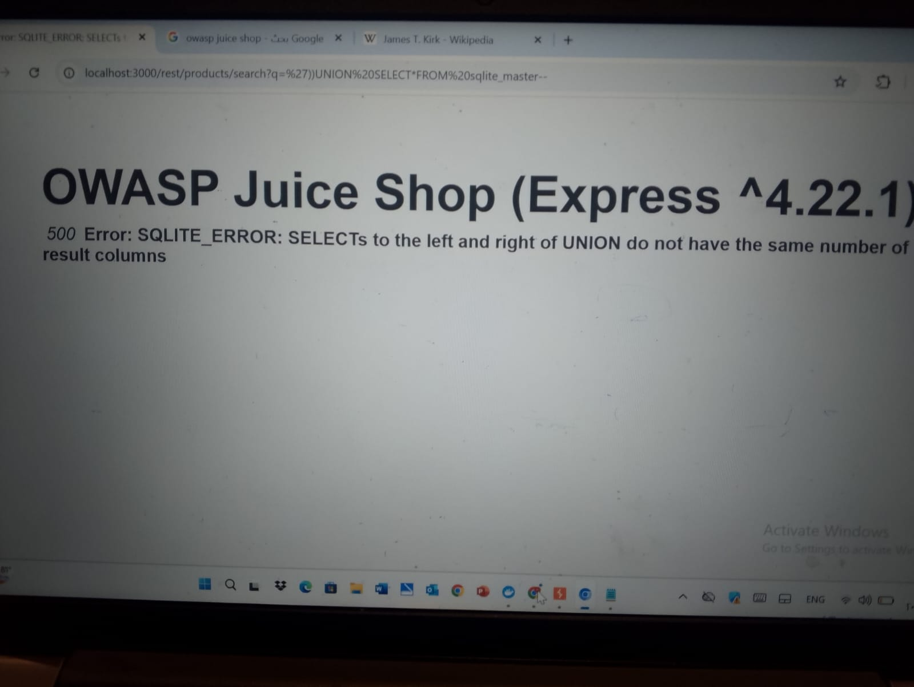
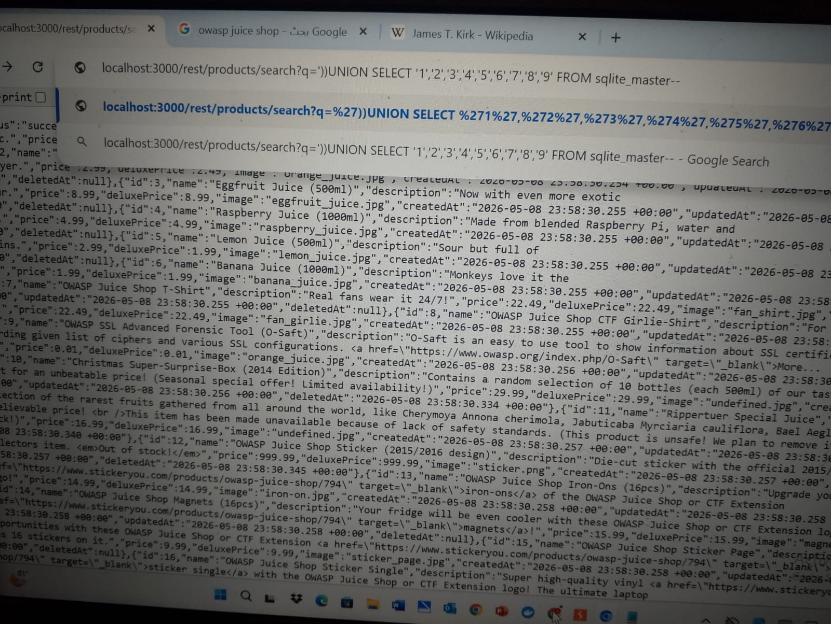
​Step 4: Enumerating Database Schema (Tables)
​Now that we have a "map," we query the sqlite_master table to find all table names in the database.
​Payload: ')) UNION SELECT '1',group_concat(tbl_name),'3','4','5','6','7','8','9' FROM sqlite_master WHERE type='table'--
​Observation: The second column displayed a list of all tables (e.g., Users, Products, Cards).
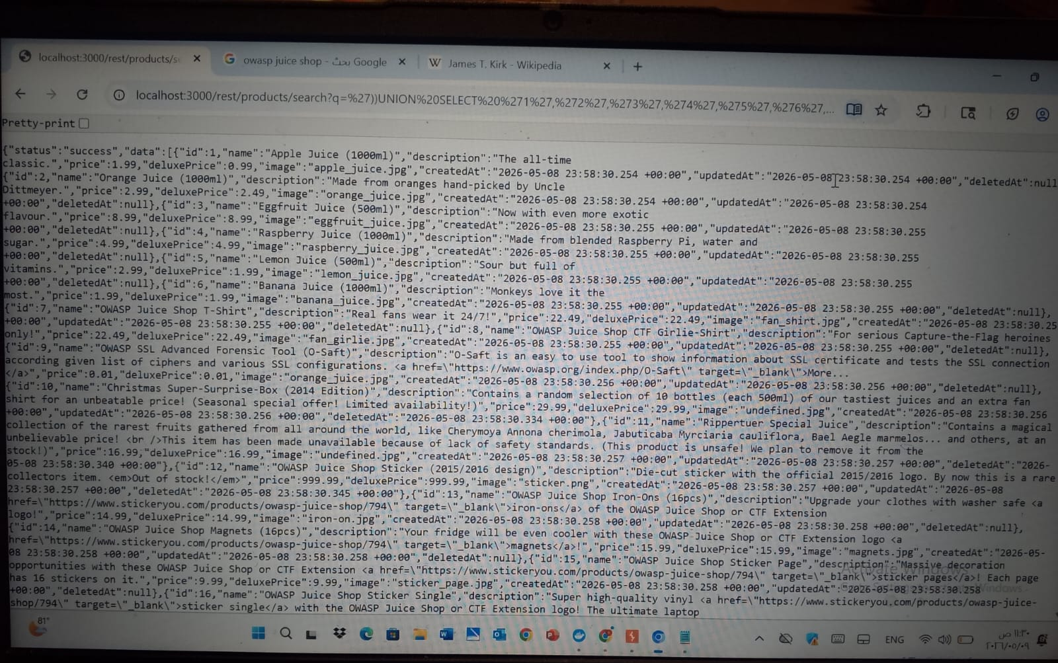
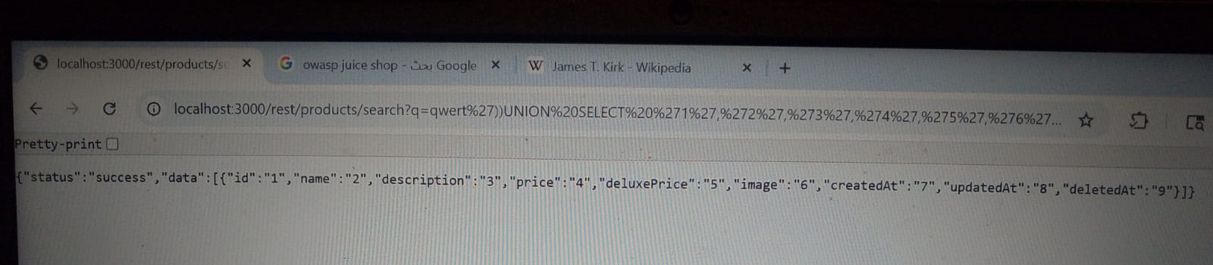
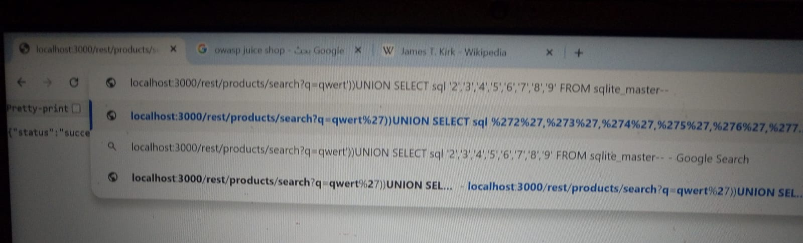
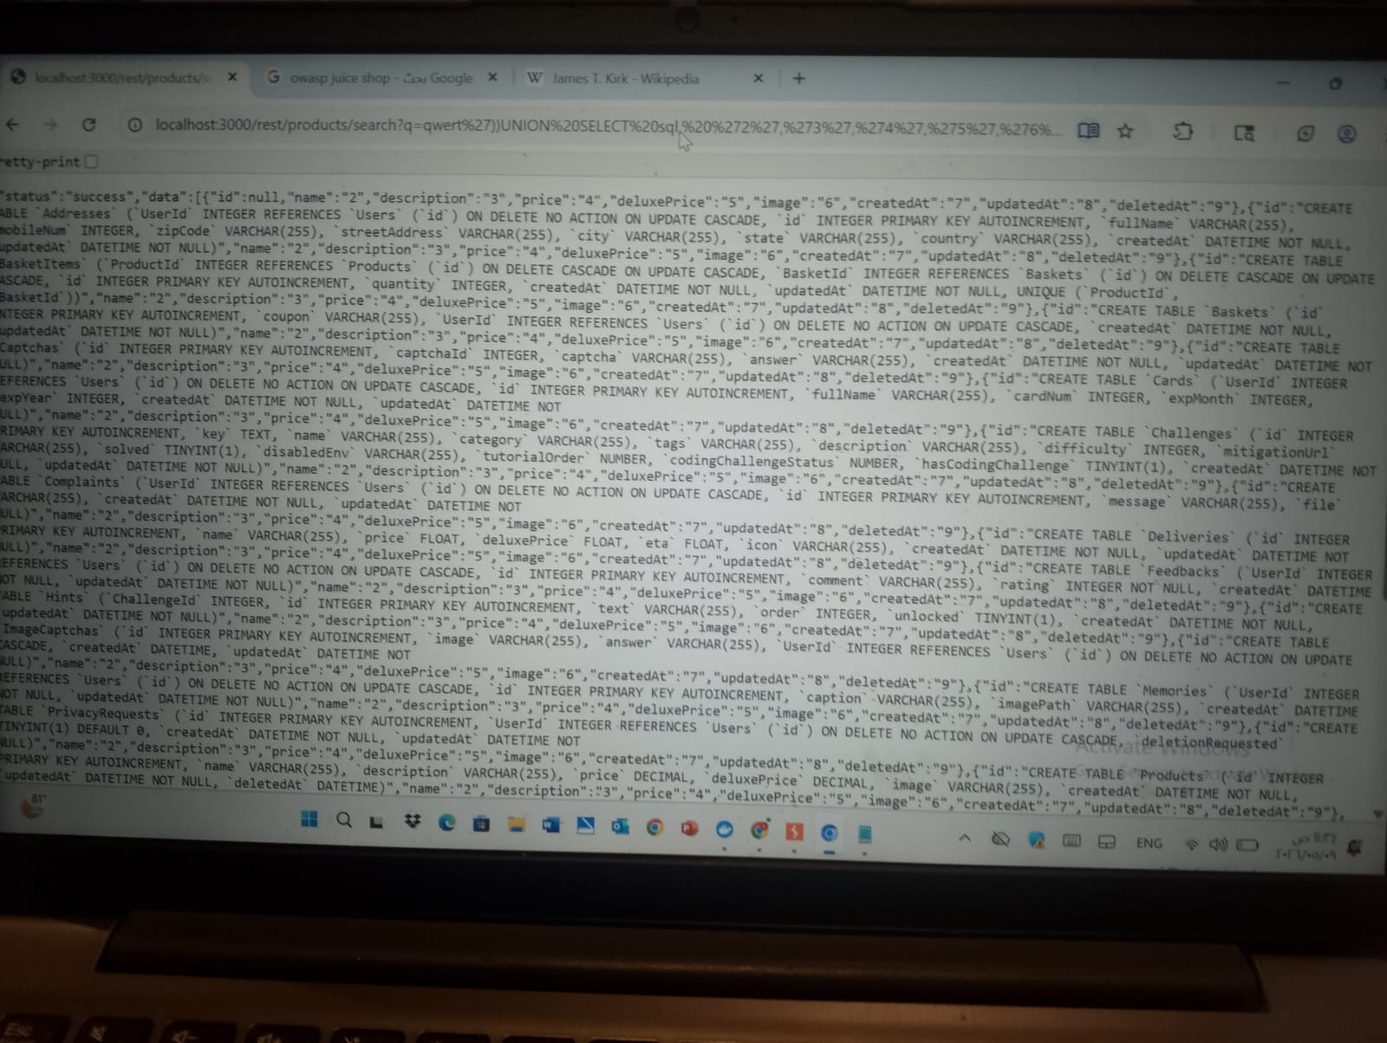
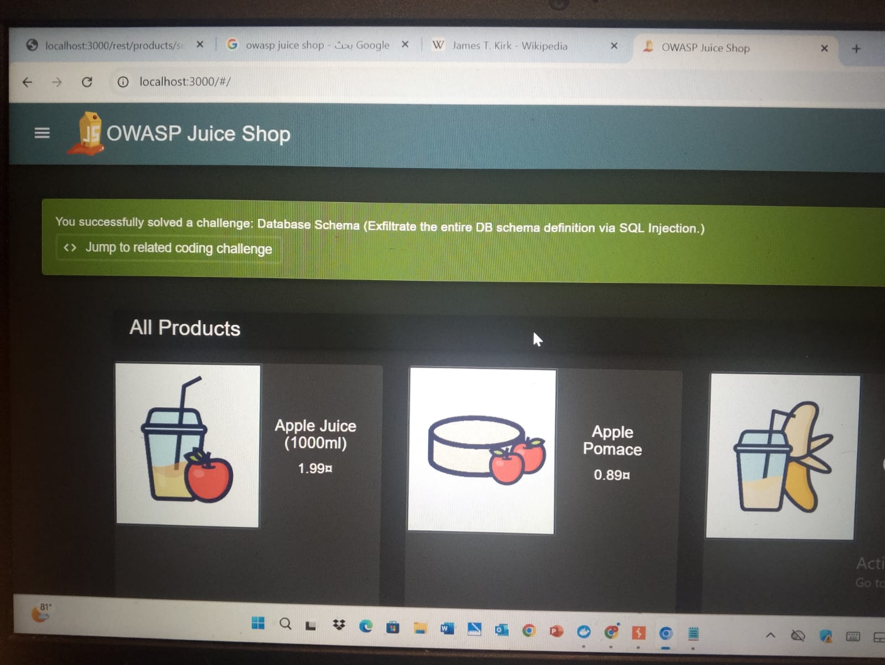
​Step 5: Data Exfiltration (Extracting Credentials)
​The final goal was to extract sensitive information from the Users table. We target the email and password columns.
​Final Strong Payload: ')) UNION SELECT id, email, password, '4', '5', '6', '7', '8', '9' FROM Users--
​Result: The application returned a full list of user emails and hashed passwords in the JSON response.
​1.13 To build a solid Defense (Mitigation) against the SQL Injection you performed, you need to implement several layers of security. In professional cybersecurity, this is called Defense in Depth.
​Here is the technical defense strategy for your report:
​SQL Injection Defense Strategy:
​1. Primary Defense: Prepared Statements (Parameterized Queries):
​This is the most effective way to prevent SQLi. Instead of building a query string with user input, you use a template. The database is told exactly what the query is first, and then the user's input is treated only as data, never as executable code.
​Vulnerable Logic: Query = "SELECT * FROM products WHERE name = '" + user_input + "'"
​Secure Logic: Query = "SELECT * FROM products WHERE name = ?" (The ? is a safe placeholder).
​2. Input Validation (Allow-listing):
​Never trust what the user types. Use a strict "Allow-list" to filter inputs.
​How it works: If a search box is meant for product names, only allow alphanumeric characters.
​Why it helps: If the user tries to enter special characters like ') or UNION, the system will reject the request immediately before it even reaches the database.
​3. Principle of Least Privilege (PoLP):
​The database user account used by the web application should have the bare minimum permissions.
​The Restriction: The application should not have permission to access the sqlite_master table or any system tables.
​The Impact: Even if an attacker finds a SQLi vulnerability, they wouldn't be able to list the tables or see the database schema because the "web_user" doesn't have the rights to see them.
​4. Disabling Verbose Error Messages:
​In your images, the error SQLITE_ERROR: near ")": syntax error gave away the database type and the query structure.
​The Fix: Configure the server to show a generic "An error occurred" message to the user.
​The Benefit: This prevents "Error-Based" attacks because the attacker is left "blind" and doesn't know why the query failed.
​5. Using Modern ORMs (Object-Relational Mappers):
​Use libraries like Sequelize, Prisma, or TypeORM. These frameworks are designed to handle database interactions securely by default.
​

2.0 Cross-Site Scripting (XSS):
​2.1 Vulnerability Type: DOM-based XSS
​In this attack, the vulnerability exists in the client-side code rather than the server-side. The application takes user input from the URL (the q parameter) and writes it directly to the page's DOM without proper sanitization, allowing for arbitrary JavaScript execution.
​

Step 1: Identifying the Attack Vector
​By browsing the Score Board, we identified the "DOM XSS" challenge. The goal was to inject a specific HTML tag that triggers a JavaScript alert.
​Target Parameter: q (Search query in the URL).
​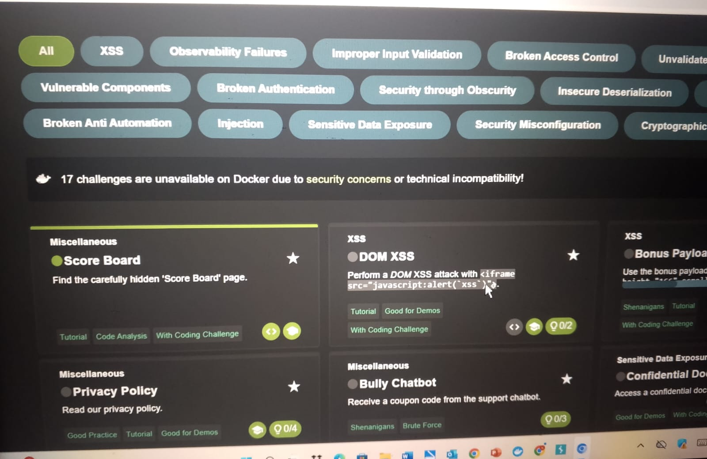
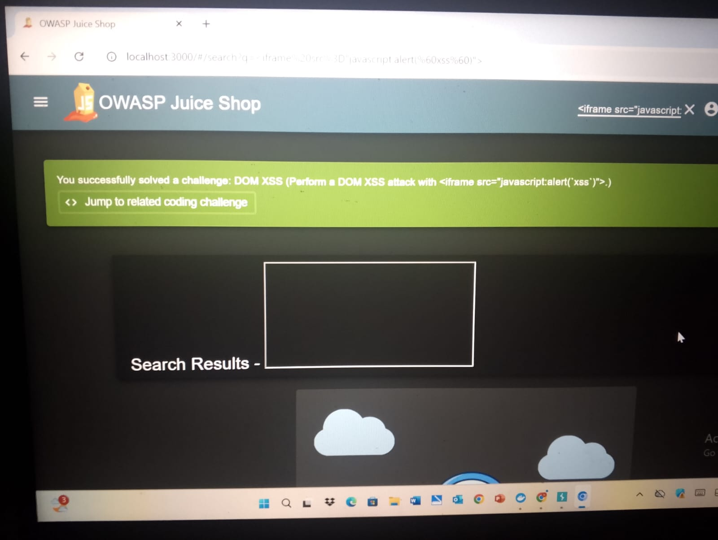

​Step 2: Executing the Basic Payload
​We injected an <iframe> tag with a javascript:alert as the source. This is a classic way to test for XSS because it bypasses simple text filters.
​Payload: <iframe src="javascript:alert('xss')">
​Observation: The browser executed the JavaScript inside the iframe, and a popup alert appeared. The "Success" notification confirmed the challenge was solved.
​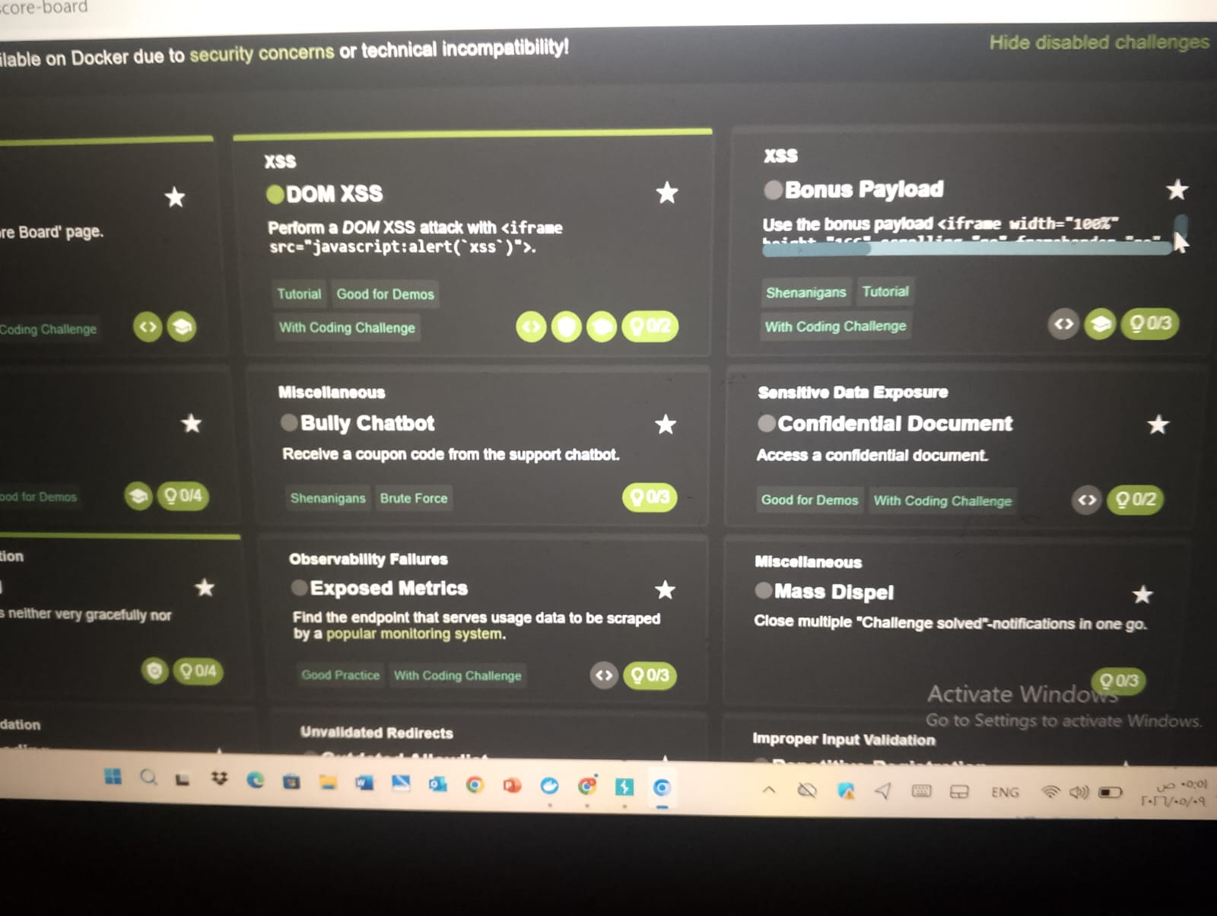
​Step 3: Advanced Exploitation (Bonus Payload)
​To further demonstrate the impact, a more complex "Bonus Payload" was used. This payload injects an iframe that loads an external resource (a SoundCloud player) directly into the search results page.
​Payload: <iframe width="100%" height="166" scrolling="no" frameborder="no" allow="autoplay" src="https://w.soundcloud.com/player/?url=..."></iframe>
​Observation: The search results page was successfully defaced, and a functional music player was embedded, proving that an attacker can control the UI and load malicious external content.
​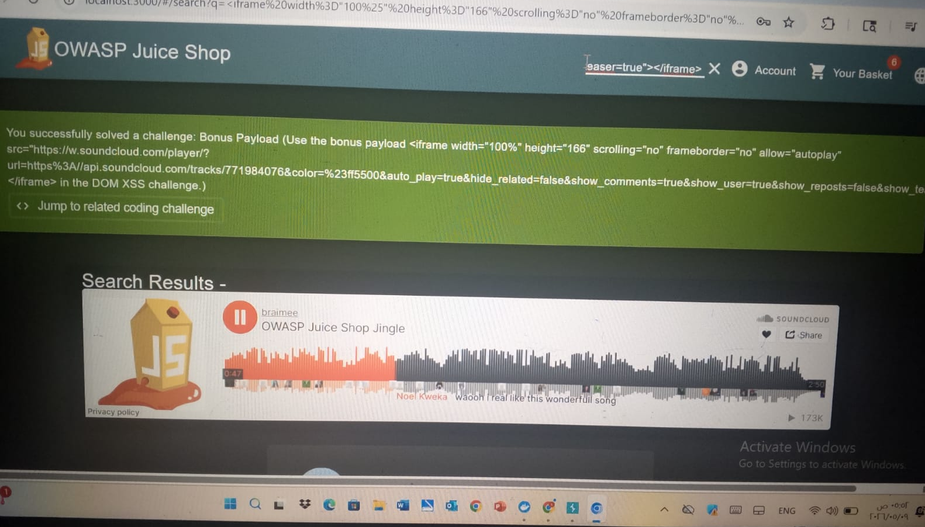
2.2 Exploiting Reflected XSS:
​1. Challenge Objectives & Scope:
​The goal was to perform a reflected XSS attack on a legacy page within the application. The challenge specifically required using an <iframe> tag to trigger a JavaScript alert.
​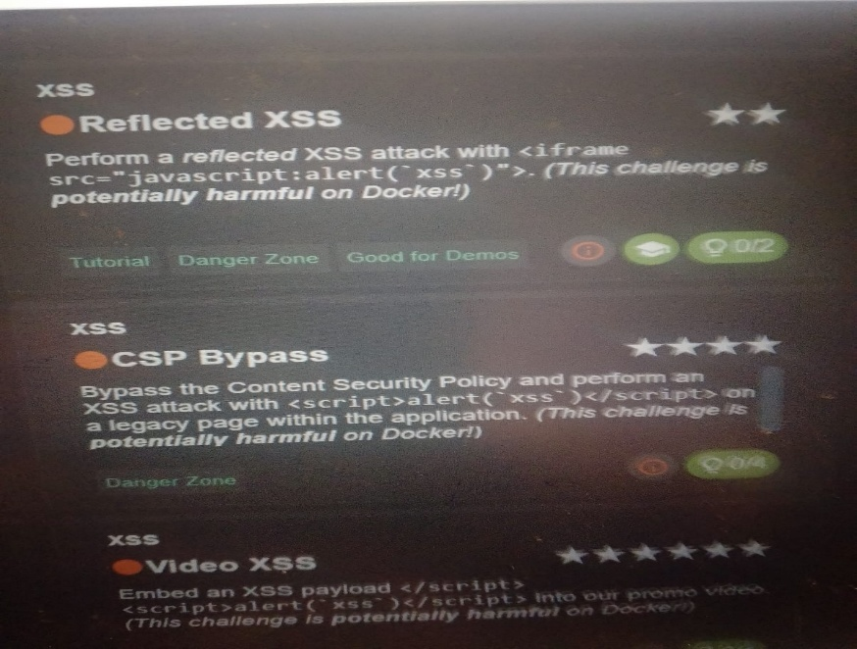
​2. Information Gathering & Navigation:
​To find a suitable injection point, I navigated through the application's checkout and tracking flow. This allowed me to identify how the application handles order IDs and tracking parameters.
​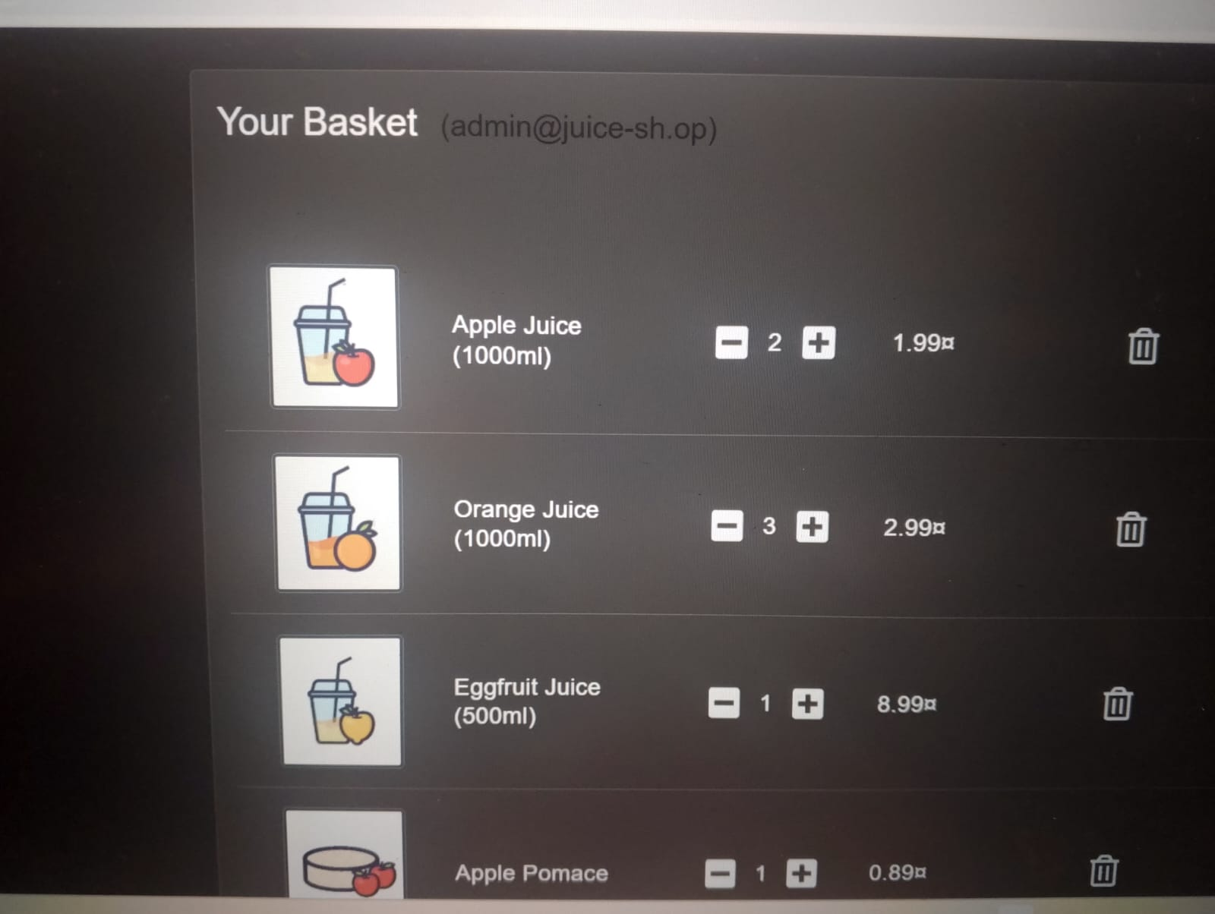
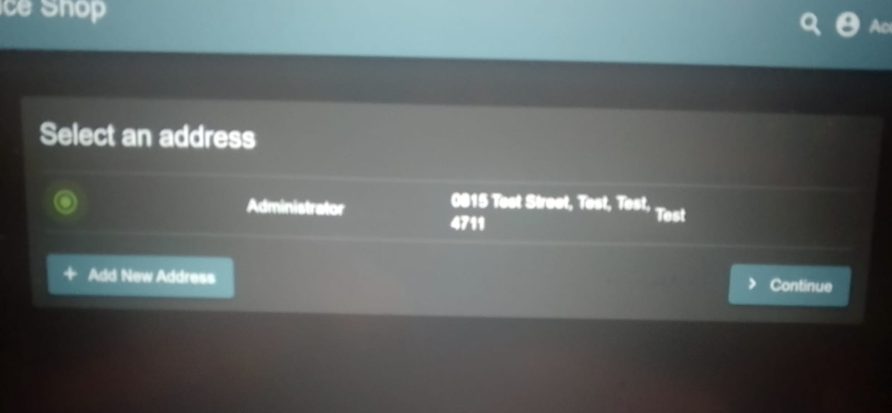
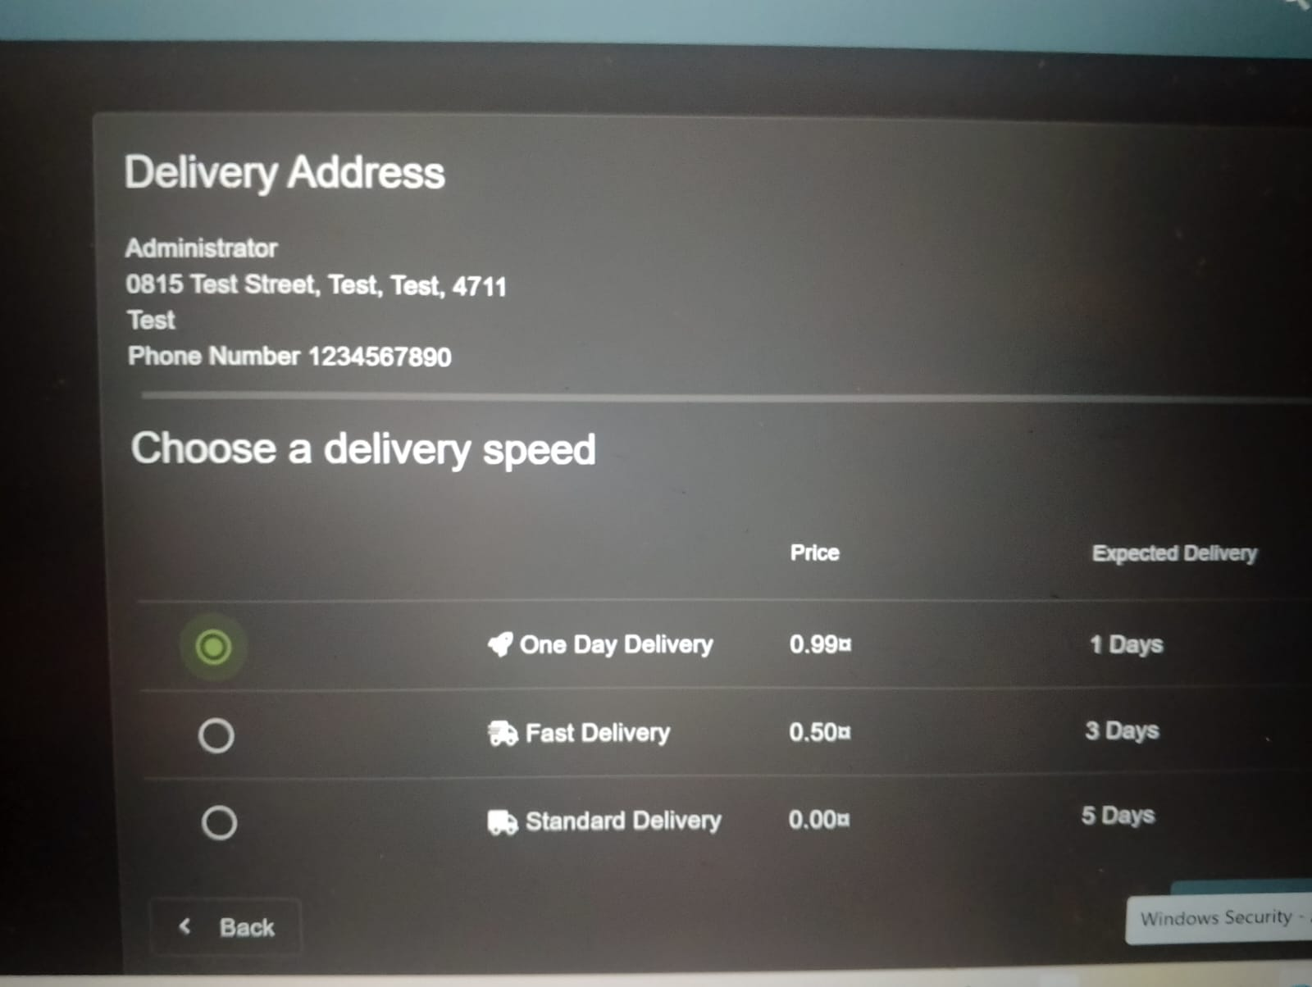
​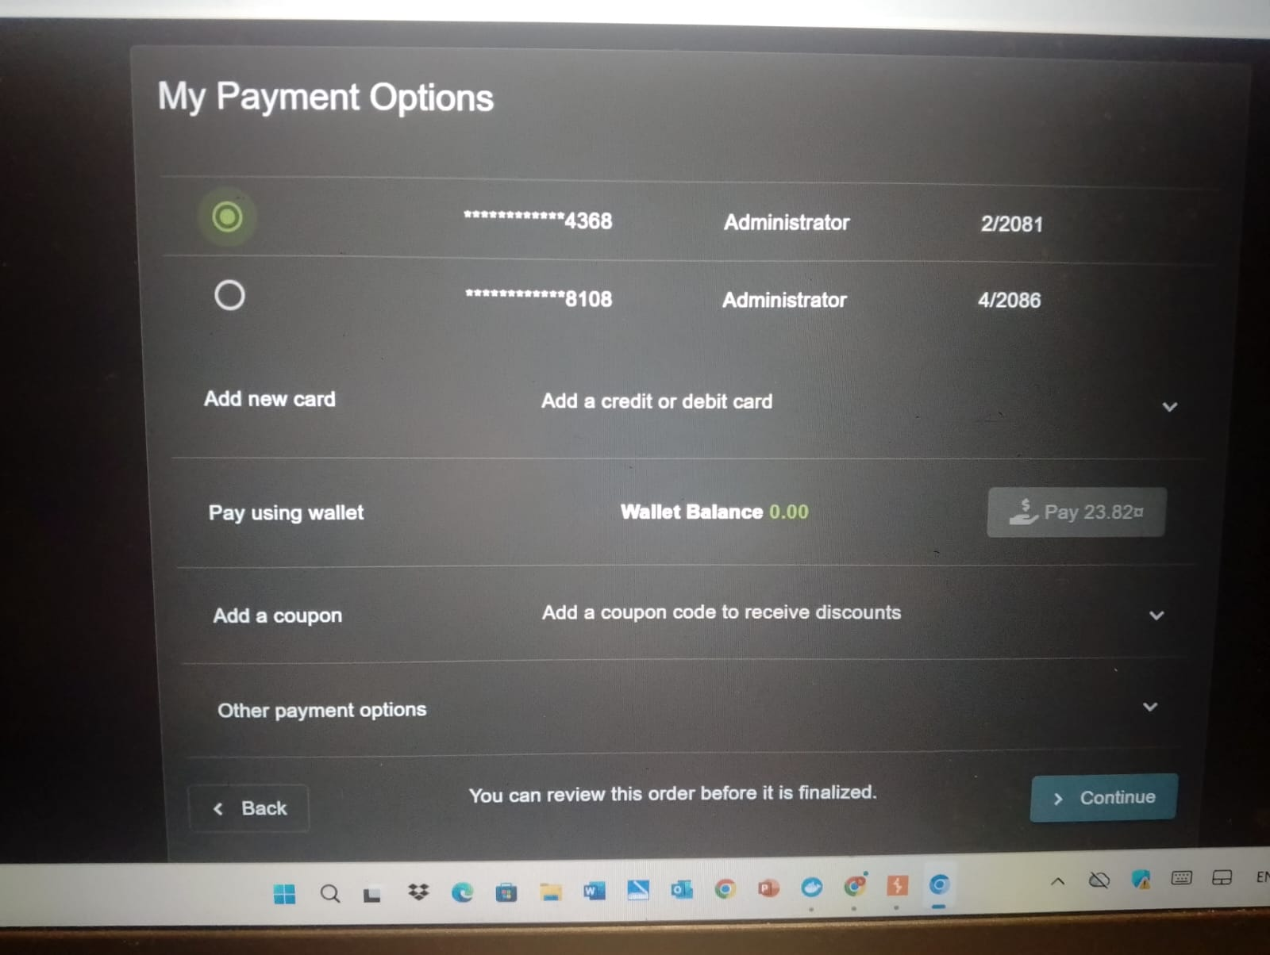
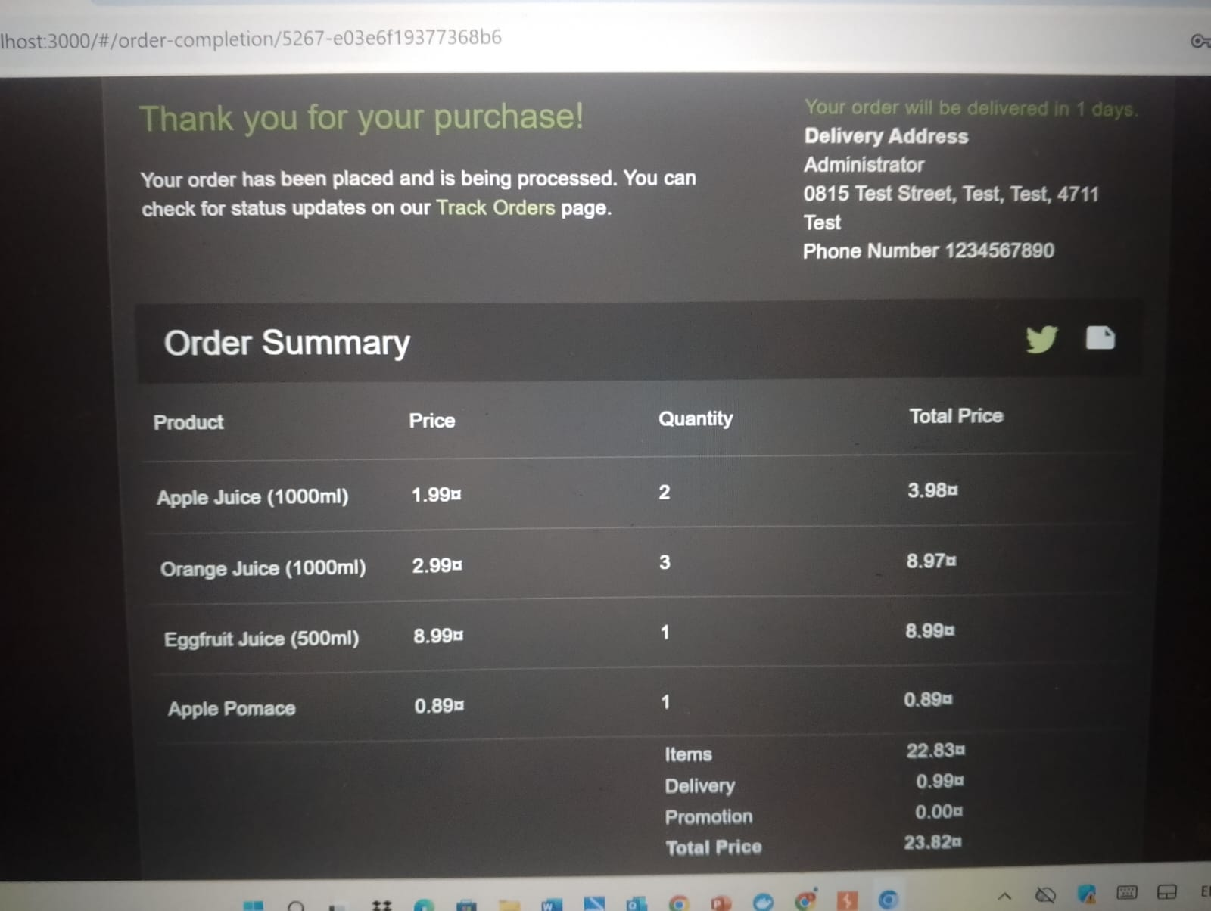

3. Vulnerability Identification (Order Tracking)
​After placing an order, the application provides a "Track Order" feature. I noticed that the id parameter in the URL of the tracking page was reflected directly onto the page's UI.
​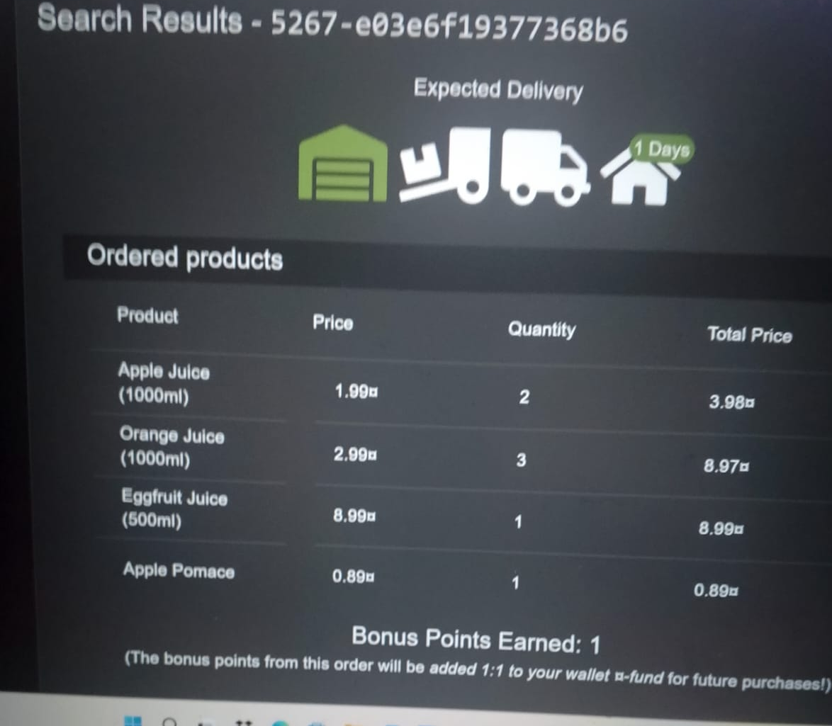
​4. Initial Injection Attempt
​I first attempted to inject the payload into the id parameter of the tracking URL. While the text was reflected in the "Search Results" header, the browser did not execute the code immediately due to how the application rendered the string.
​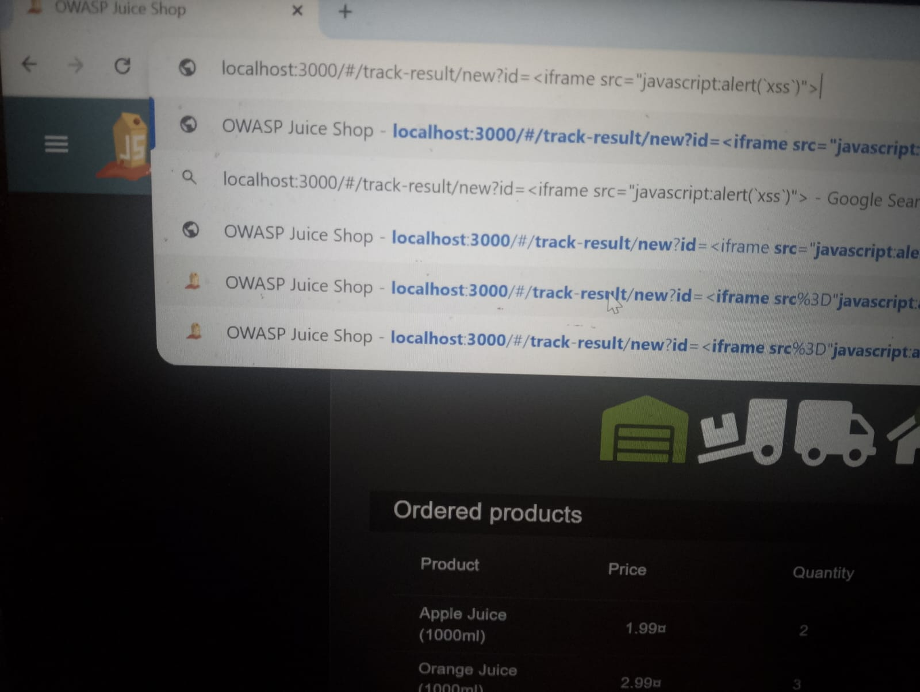
​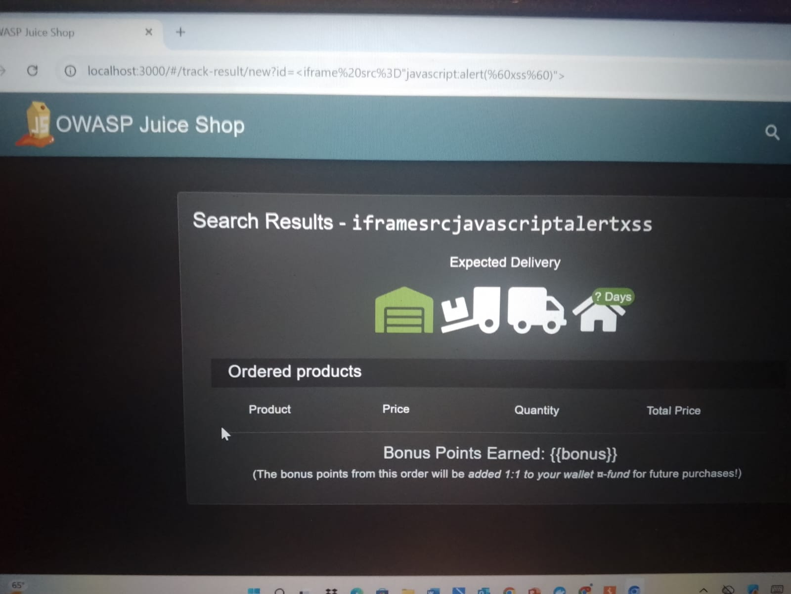
5. Successful Exploitation (Proof of Concept)
​By refining the injection point and using the search parameter q, I successfully bypassed the initial reflection barrier. The browser interpreted the injected <iframe> and executed the embedded JavaScript.
​Payload Used: <iframe src="javascript:alert('xss')">
​Result: A JavaScript alert box appeared, confirming that the code was executed within the context of the user's session.

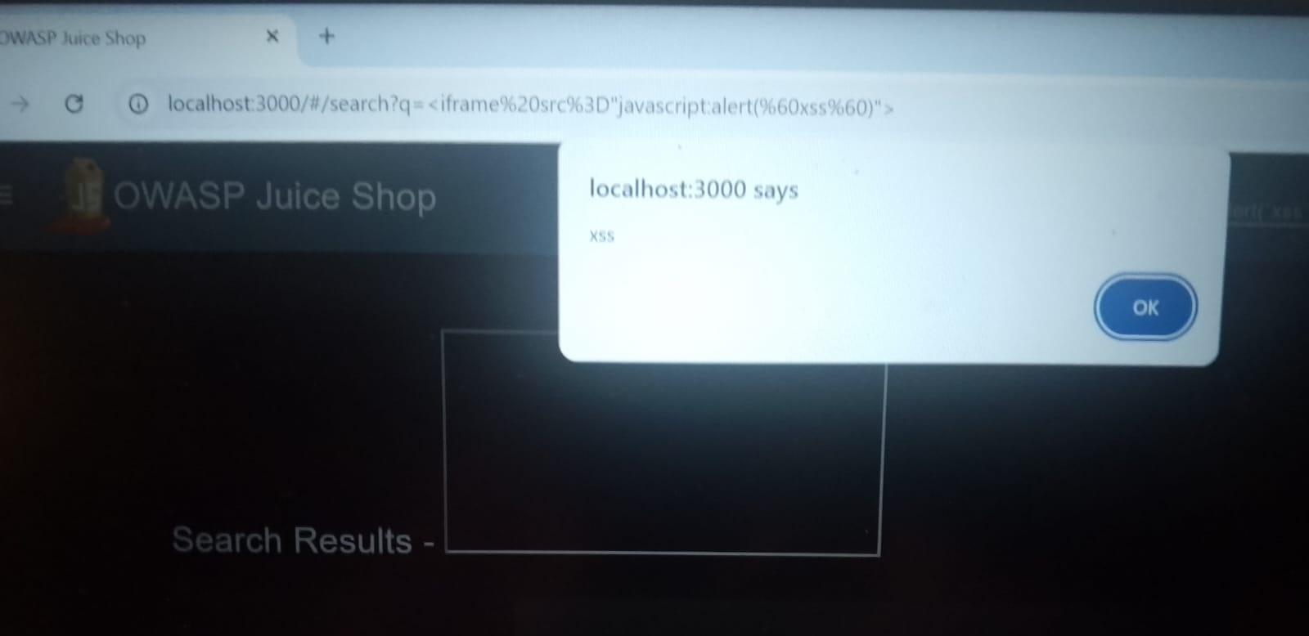
​6. Conclusion and Remediation of reflected xss:
​The successful execution of the alert() function proves that the application is vulnerable to Reflected XSS. This vulnerability exists because the application fails to properly sanitize user input before reflecting it on the web page.
​Recommendation:
The application should implement Context-Aware Output Encoding and a strict Content Security Policy (CSP) to prevent unauthorized script execution.
​
2.3 XSS Defense & Mitigation (Defense Strategy):
​To protect the application from XSS, the following defenses should be implemented:
​1. Output Encoding (Context-Aware):
​The most important defense is to encode all user-supplied data before rendering it in the browser.
2. Use Secure APIs:
​Avoid using dangerous JavaScript properties like .innerHTML. Instead, use safer alternatives like .textContent or .innerText, which do not parse HTML tags.
​3. Content Security Policy (CSP):
​Implement a strong CSP header to restrict which scripts can execute and where content can be loaded from.
​Example: A policy like script-src 'self' would have blocked the inline javascript:alert and the external SoundCloud iframe from running.
​4. Input Validation: Validate input on the client and server side to ensure it only contains:
-expected characters (e.g., alphanumeric only for search terms).
-Cross-Site Request Forgery (CSRF)
​-Vulnerability Description
​
3.0 CSRF is an attack that forces an authenticated user to execute unwanted actions on a web application in which they are currently authenticated. In this case, the application failed to verify if the request to update the user profile was intentionally sent by the user or by a third-party script.
​Step 1: Identifying the Target Action:
​First, we identified the "CSRF" challenge on the Score Board and navigated to the User Profile page. We observed how the application handles profile updates (like changing the username).
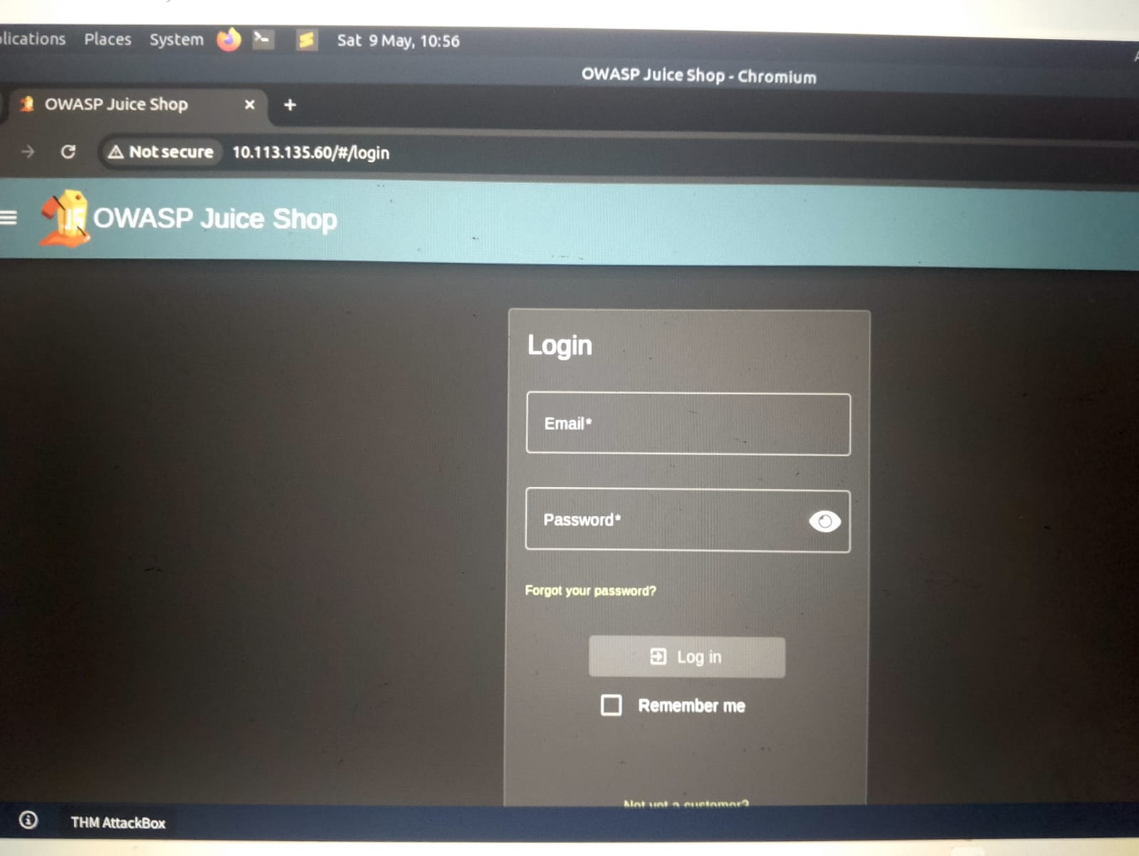
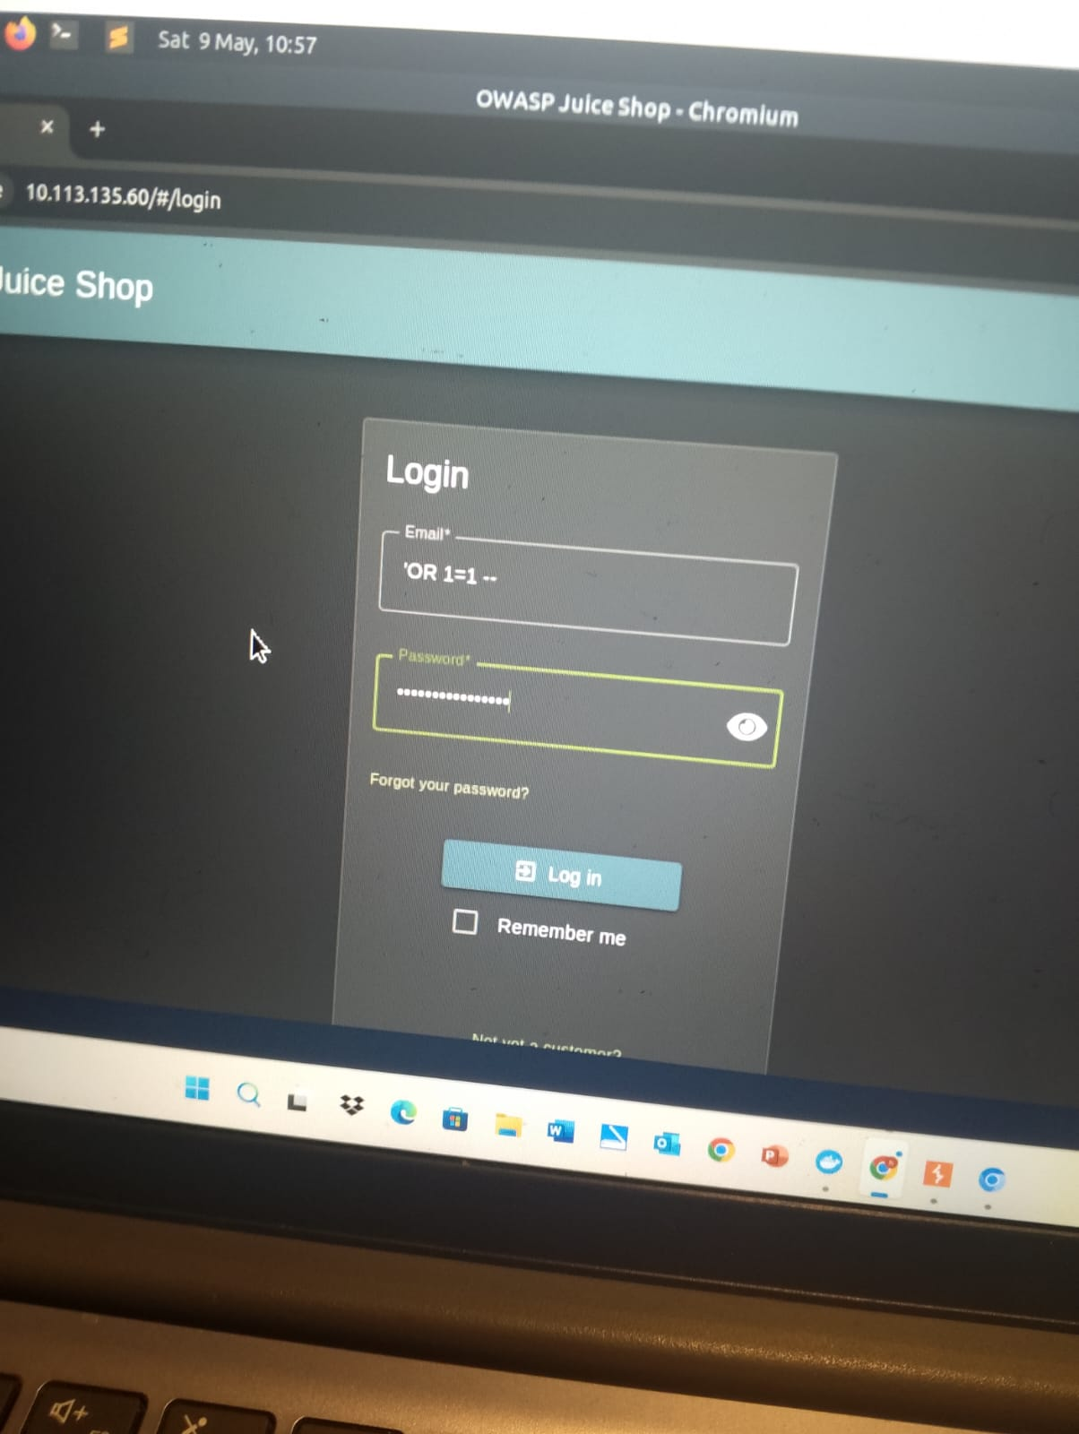
​Step 2: Capturing and Analyzing the Request
​Using the browser's Network Tab (Developer Tools), we captured the request sent when updating the profile.
​Observation: The request was a GET (or simple POST) request to /rest/user/change-password or /profile, and it lacked any unique, unpredictable tokens (CSRF Tokens).
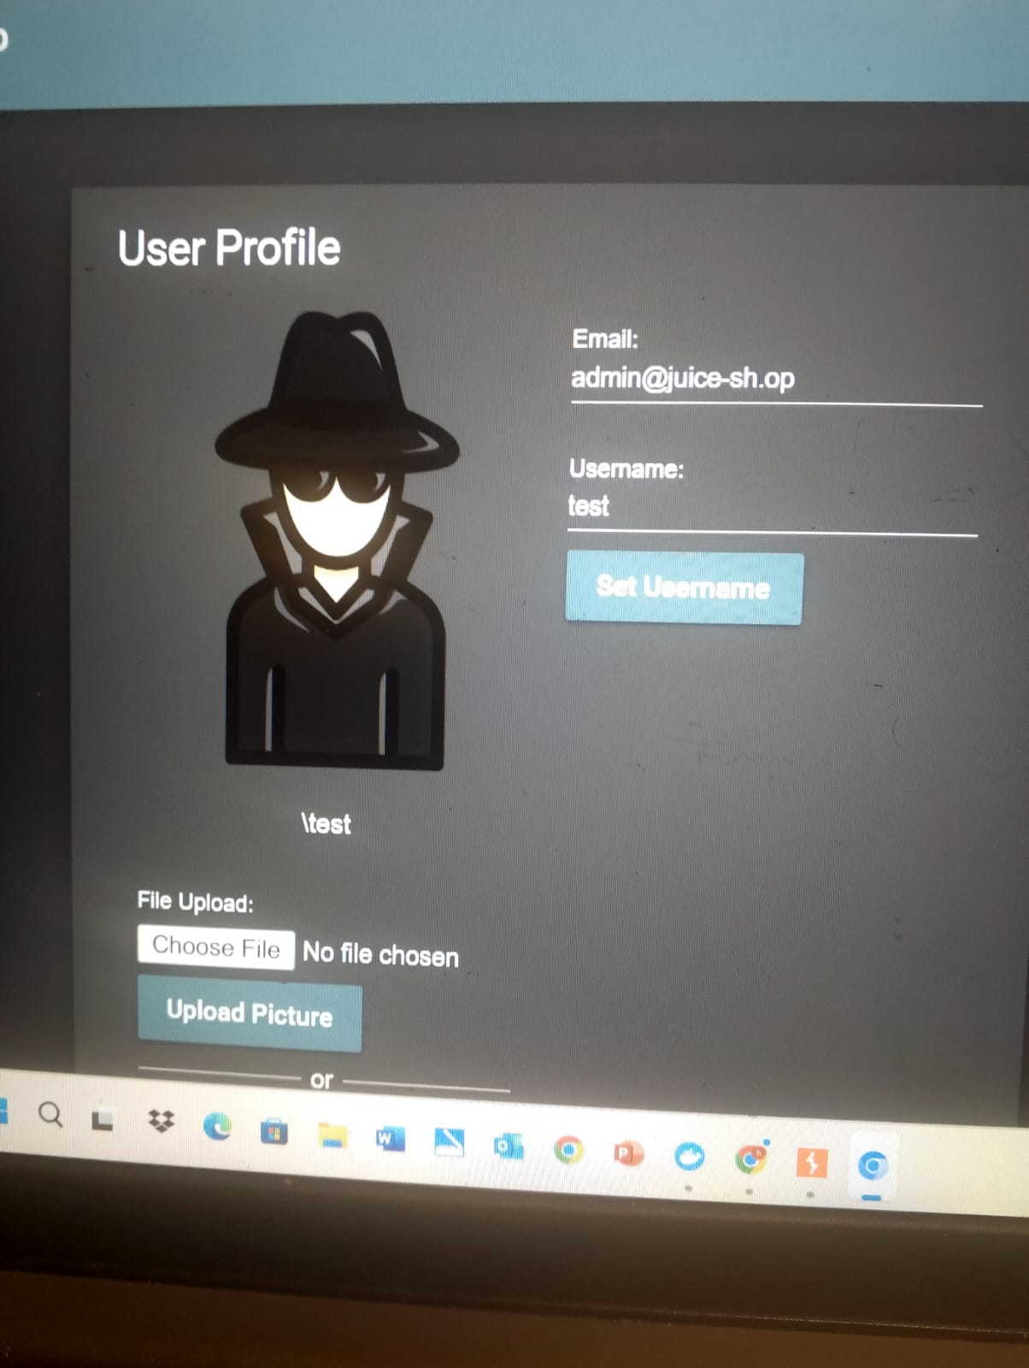
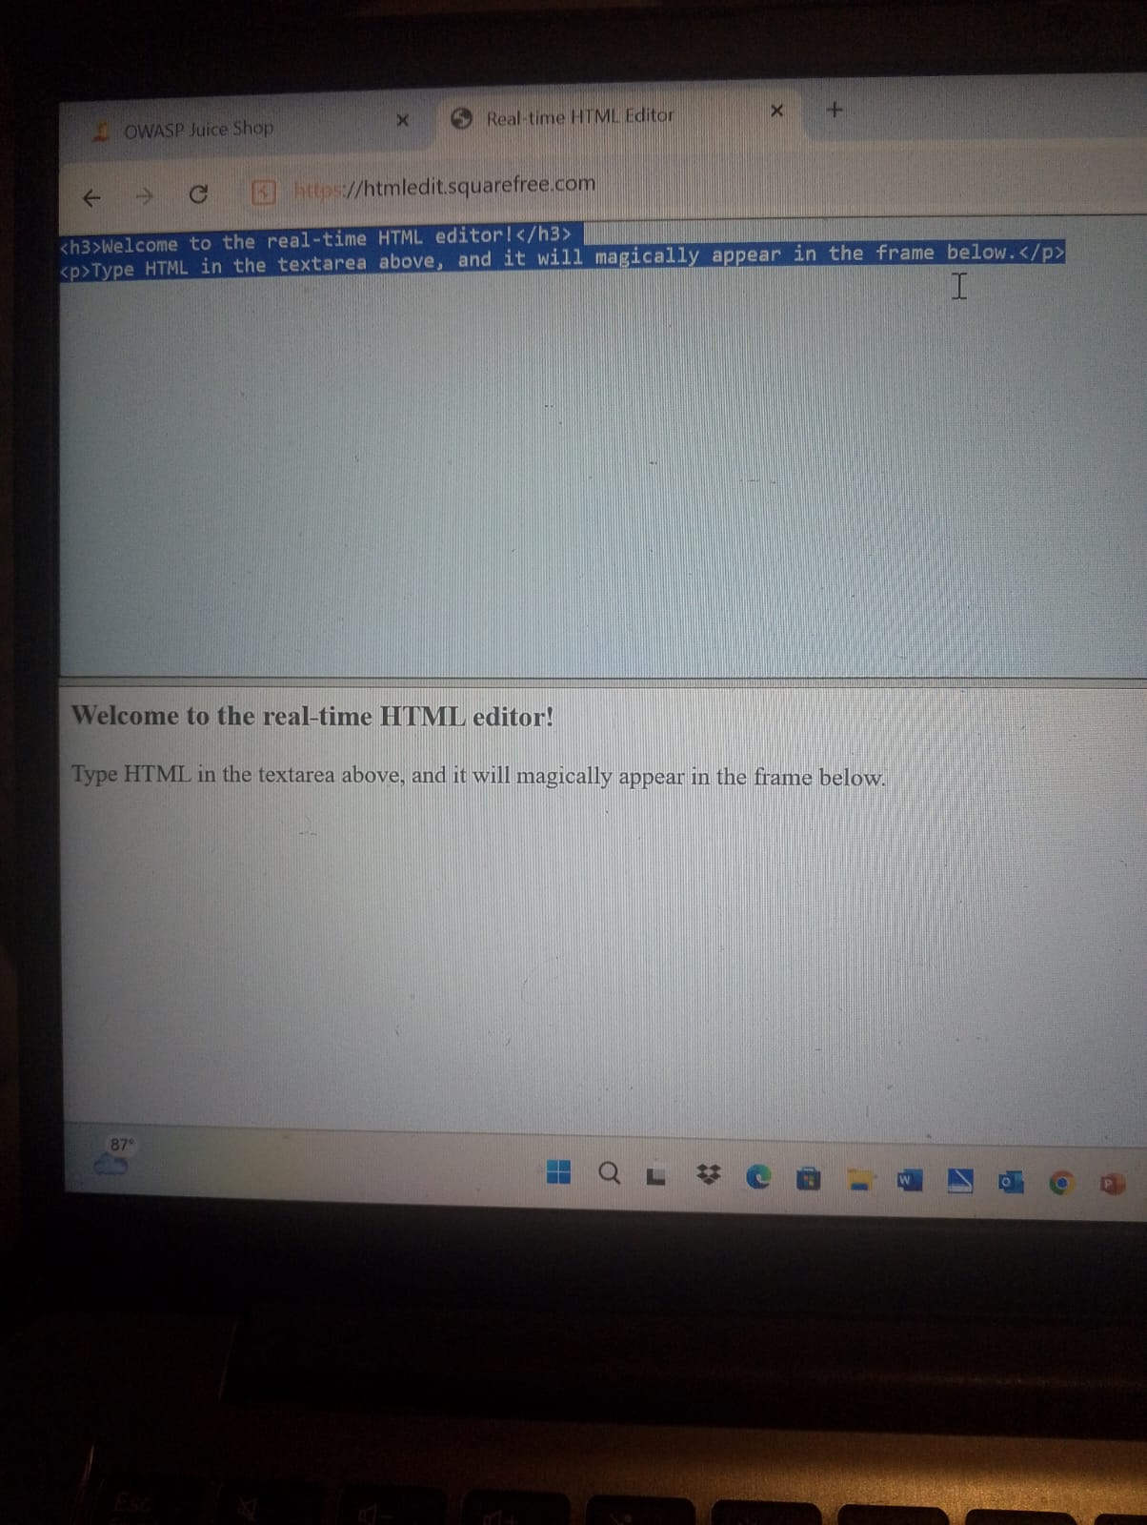
​Step 3: Executing the Attack
​By crafting a malicious link or a hidden form that sends a request to the update endpoint, the attacker can change the victim's profile information.
​Observation: Upon triggering the request, the "Success" notification appeared, confirming that the CSRF challenge was solved. The application accepted the change because the victim's session cookie was automatically included in the request by the browser.
​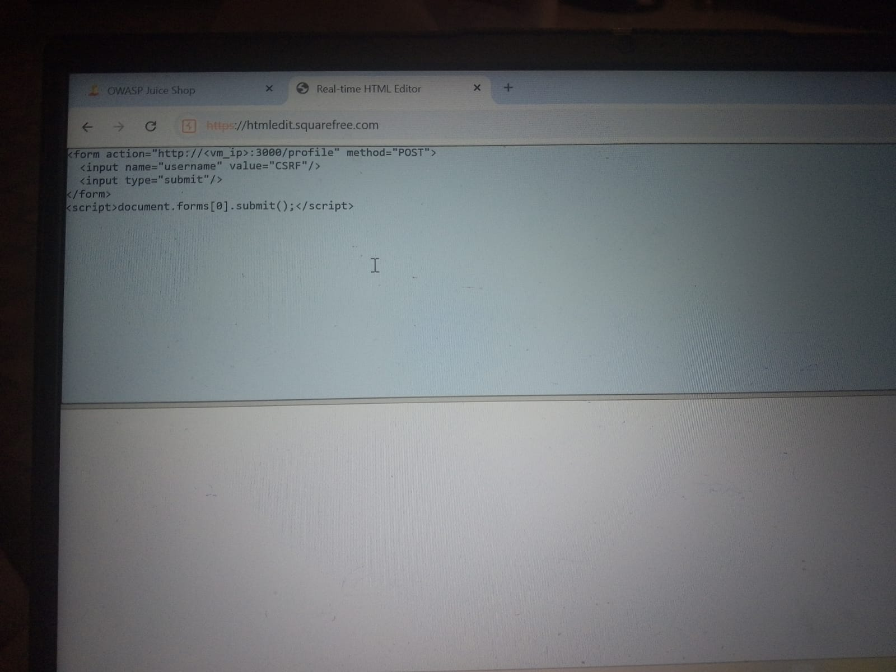
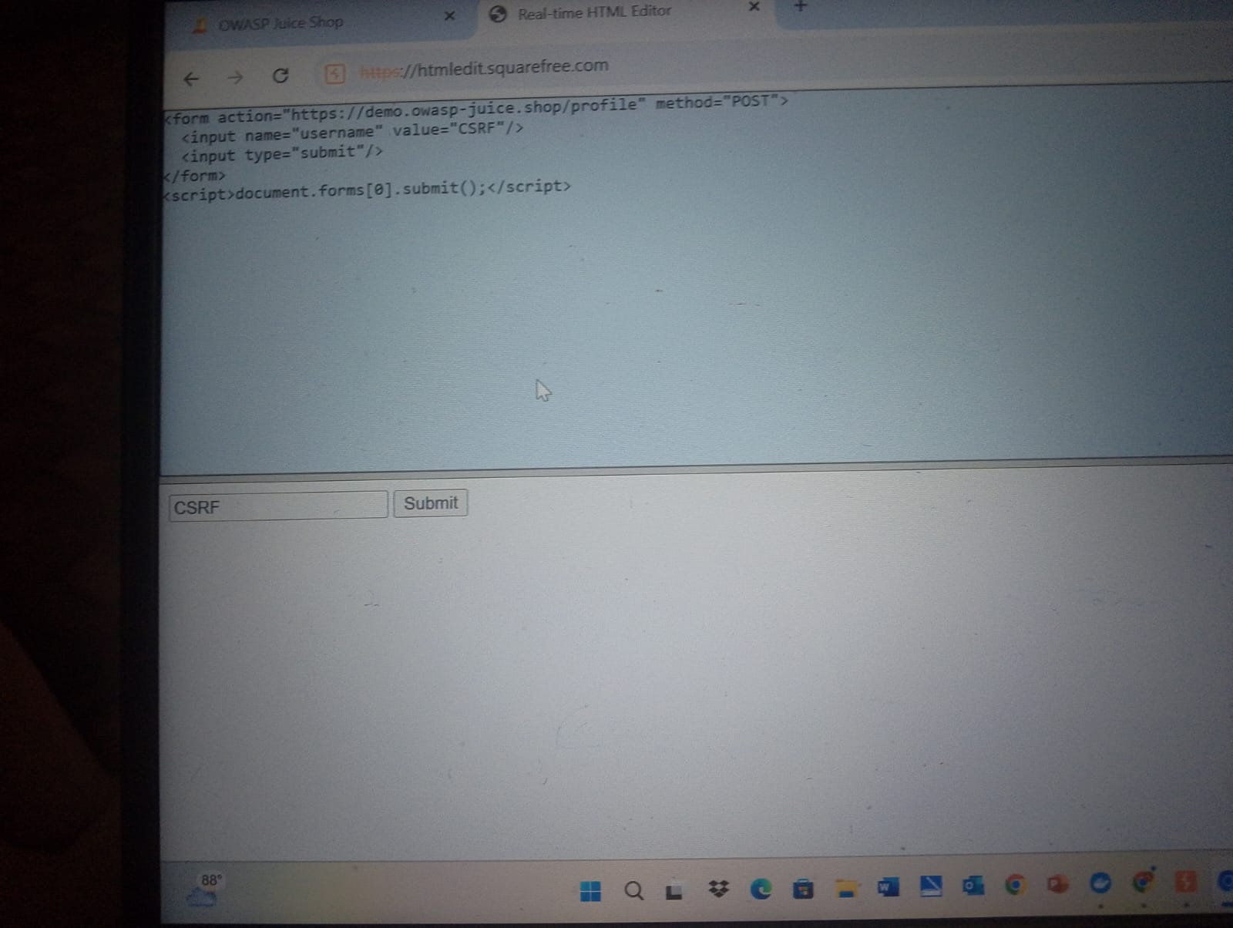
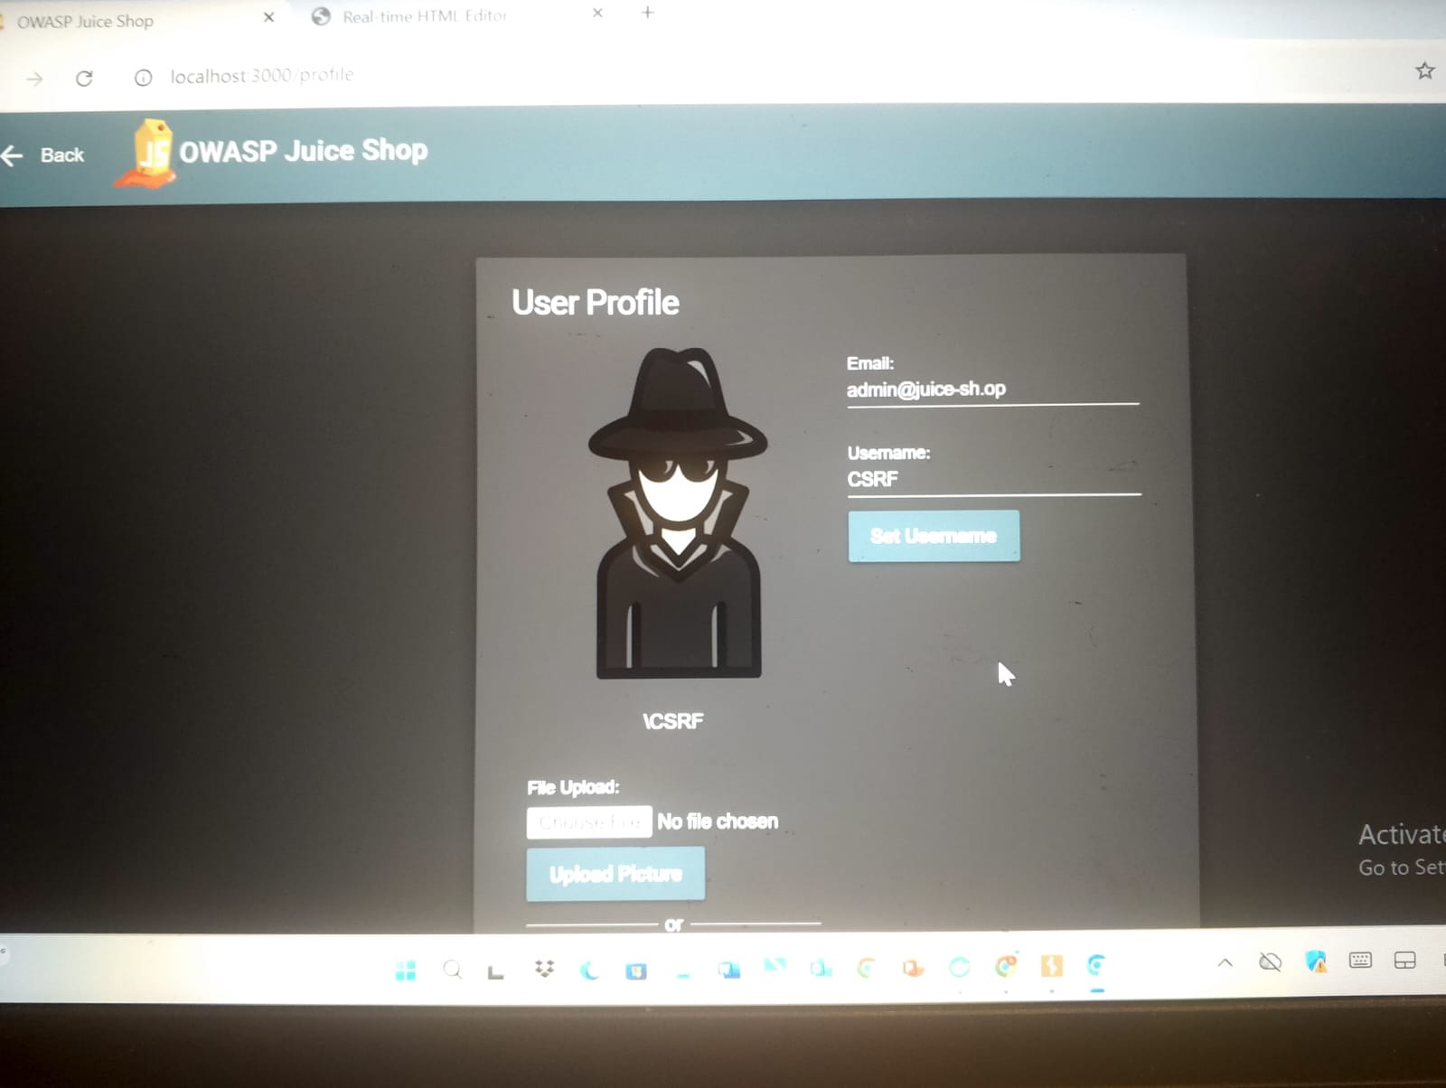
3.1 CSRF Defense & Mitigation (Defense Strategy):
​To defend against CSRF attacks, the application must ensure that requests are coming from a trusted source.
​1. Anti-CSRF Tokens (The Most Common Defense):
​The server should generate a unique, cryptographically strong, and unpredictable token for the user's session.
​How it works: This token is included in every state-changing request (like a hidden field in a form).
​Validation: The server checks if the token in the request matches the one stored in the user's session. An attacker cannot guess this token, so they cannot forge a valid request.
​2. SameSite Cookie Attribute:
​Set the SameSite attribute on session cookies to Lax or Strict.
​Lax/Strict: This instructs the browser not to send the session cookie during cross-site requests (e.g., when clicking a link from a malicious site). If the cookie isn't sent, the server won't recognize the user, and the attack fails.
​3. Custom Request Headers:
​For modern applications using AJAX/APIs, you can require a custom HTTP header (like X-Requested-With).
​Logic: Browsers restrict the ability of cross-site requests to add custom headers (due to CORS policy), making it much harder for an attacker to forge the request.
​4. Verifying Origin/Referer Headers:
​The server can check the Origin or Referer headers to ensure the request originated from the application's own domain. While helpful, this is considered a secondary defense as these headers can sometimes be spoofed or stripped.

4.0 Broken Authentication:
​Target: GDPR Data Erasure (Account Deletion):
​This vulnerability falls under Broken Authentication and Broken Access Control. It demonstrates how an application might fail to properly verify authentication or handle data erasure requests according to GDPR (General Data Protection Regulation) standards, potentially leaving data accessible or allowing unauthorized deletion.
​Step 1: Identifying the Privacy Challenge:
​On the Score Board, we identified the GDPR Data Erasure challenge. This challenge focuses on the user's right to be forgotten and how the application handles sensitive account deletion requests.
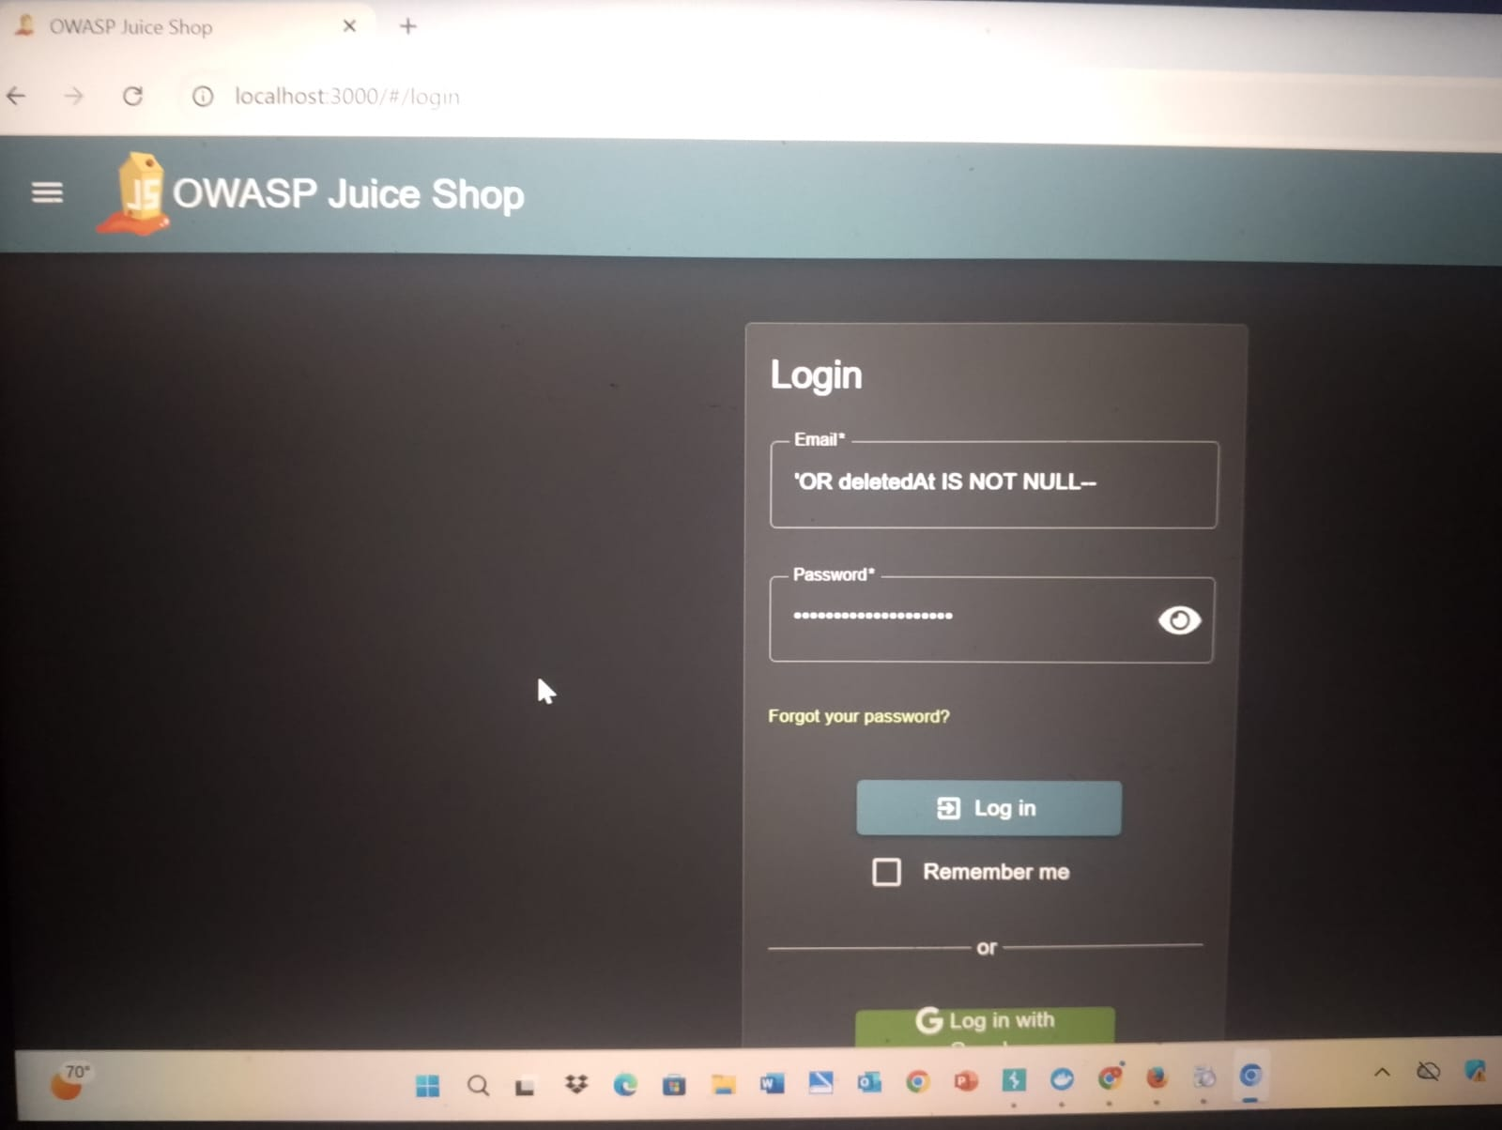
​
Step 2: Accessing the Deletion Interface:
​We navigated to the privacy settings or the account closure section to initiate the data erasure process. We monitored how the application requests confirmation and handles the session during this sensitive action.
​Observation: The application provides a "Close Account" or "Request Data Deletion" feature. The security test here is to see if this can be triggered without proper multi-step verification or if it leaves residues in the database.

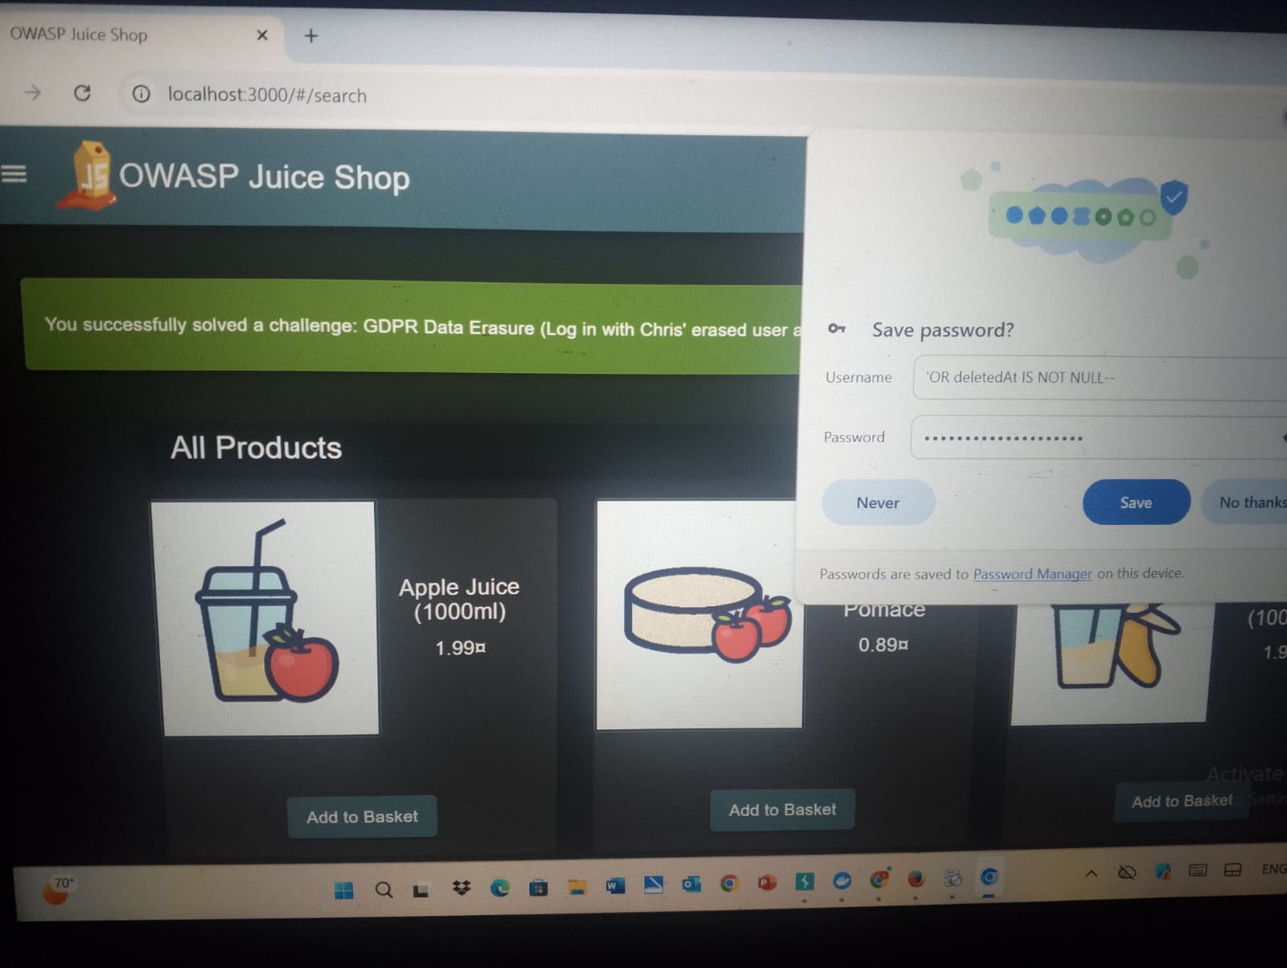
​

Bypassing Security Questions (Jim's Account)
​Title: Exploiting Predictable Security Answers
​Vulnerability: The application allows password resets based on security questions that can be solved through research or social engineering. This is a form of broken authentication where the "second factor" is weak and predictable.
​Exploitation: By targeting the user jim@juice-sh.op, we identified his security question: "Your eldest siblings' middle name?". Using available information or common name patterns, the correct answer was identified, allowing us to bypass the authentication layer and set a new password for his account.
​Observation: The "Success" notification and the ability to log in as Jim confirm that the reset mechanism does not have sufficient protection against guessing or automated attacks.
​
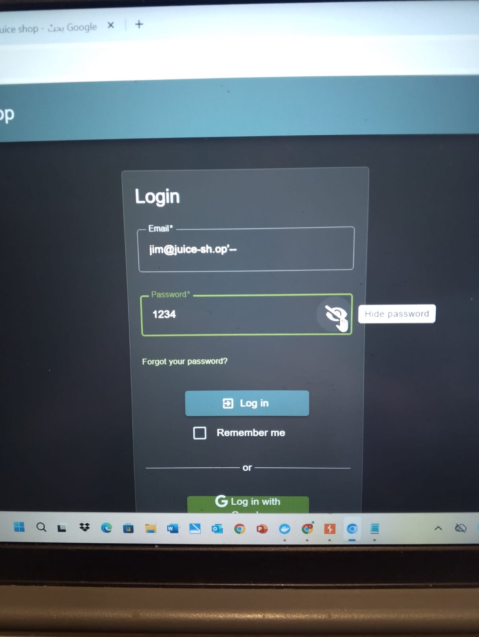
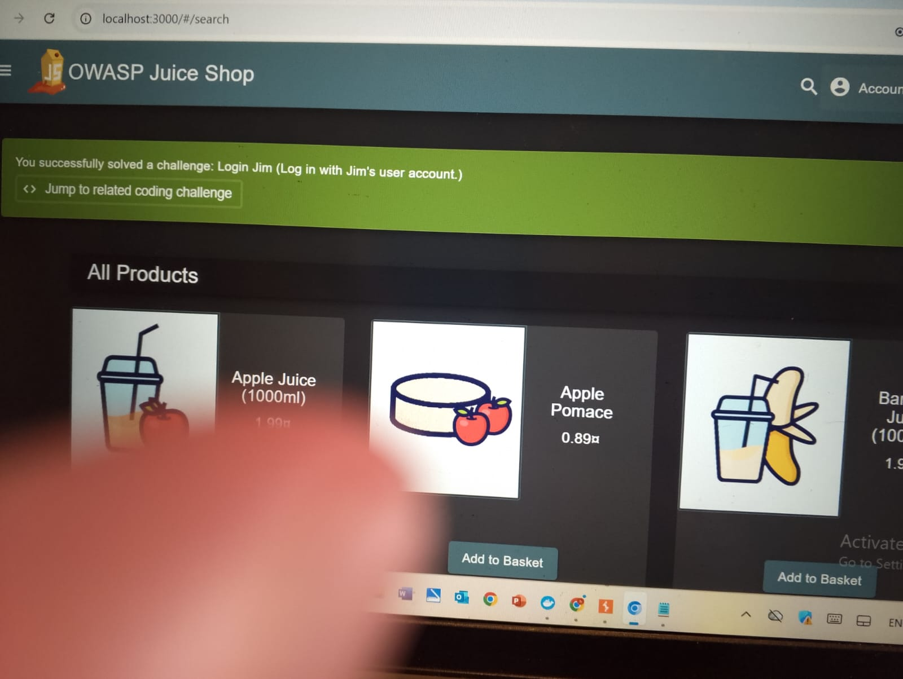
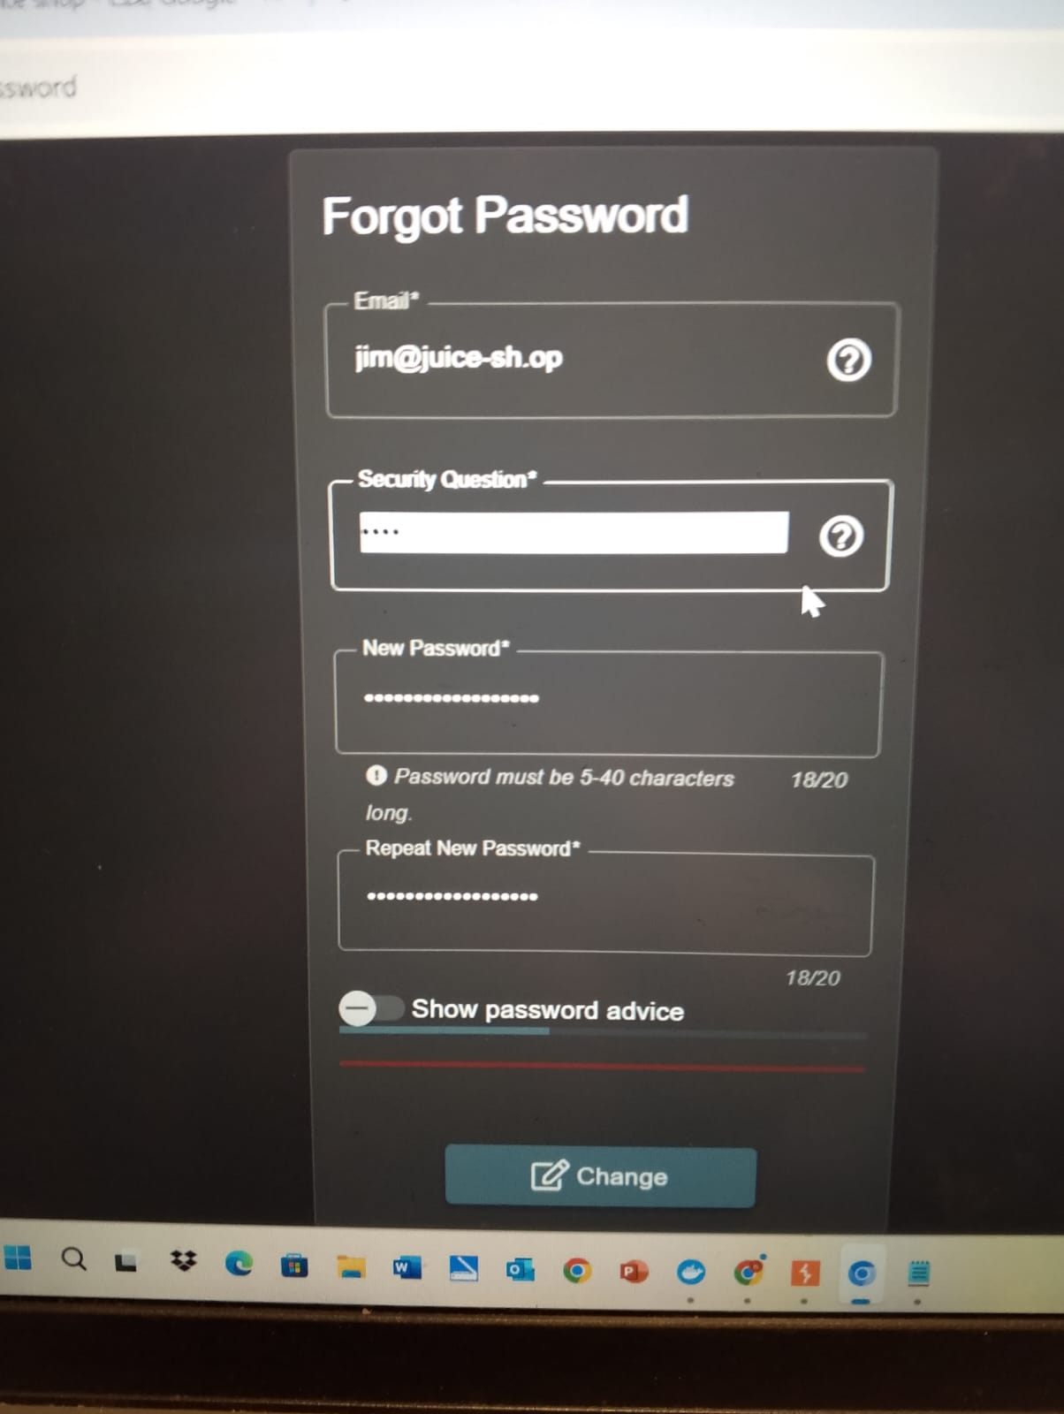
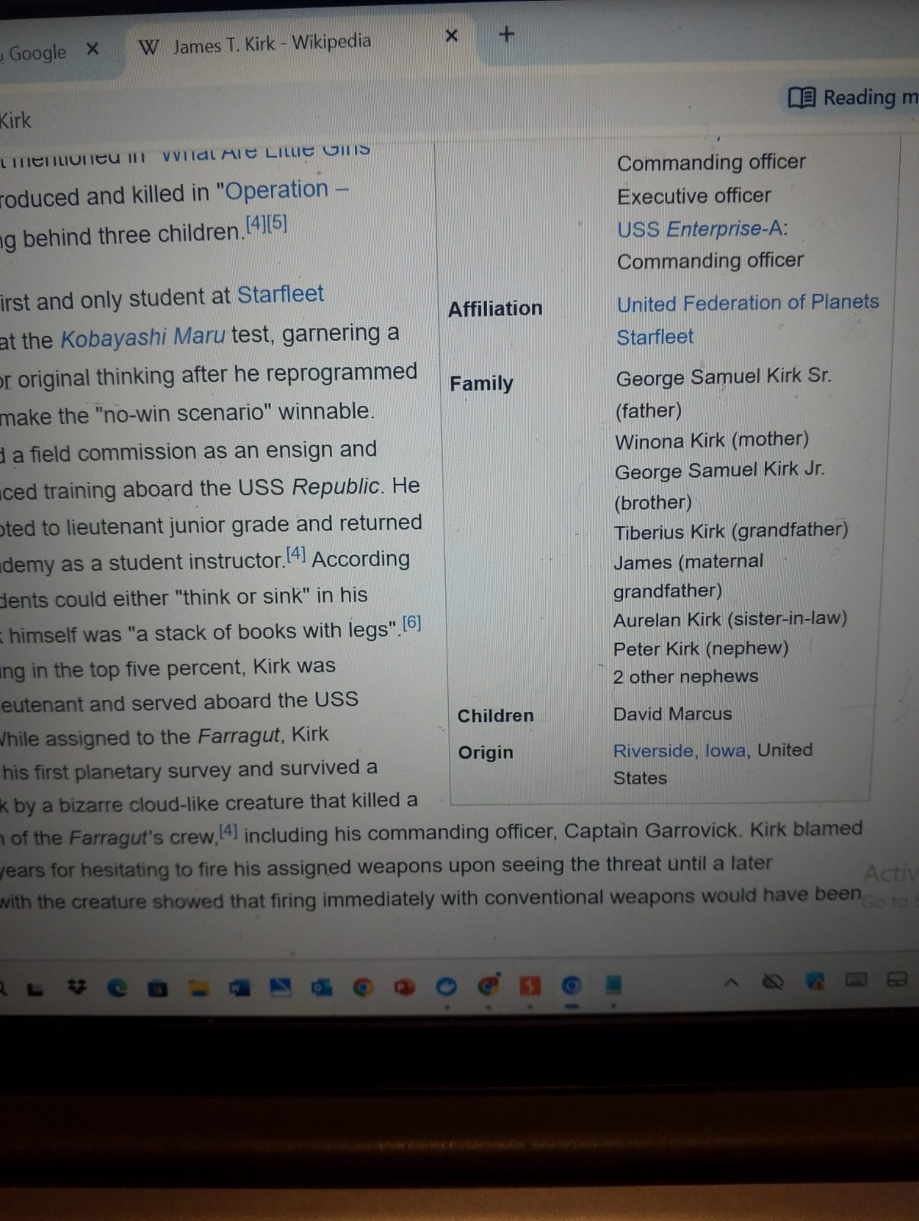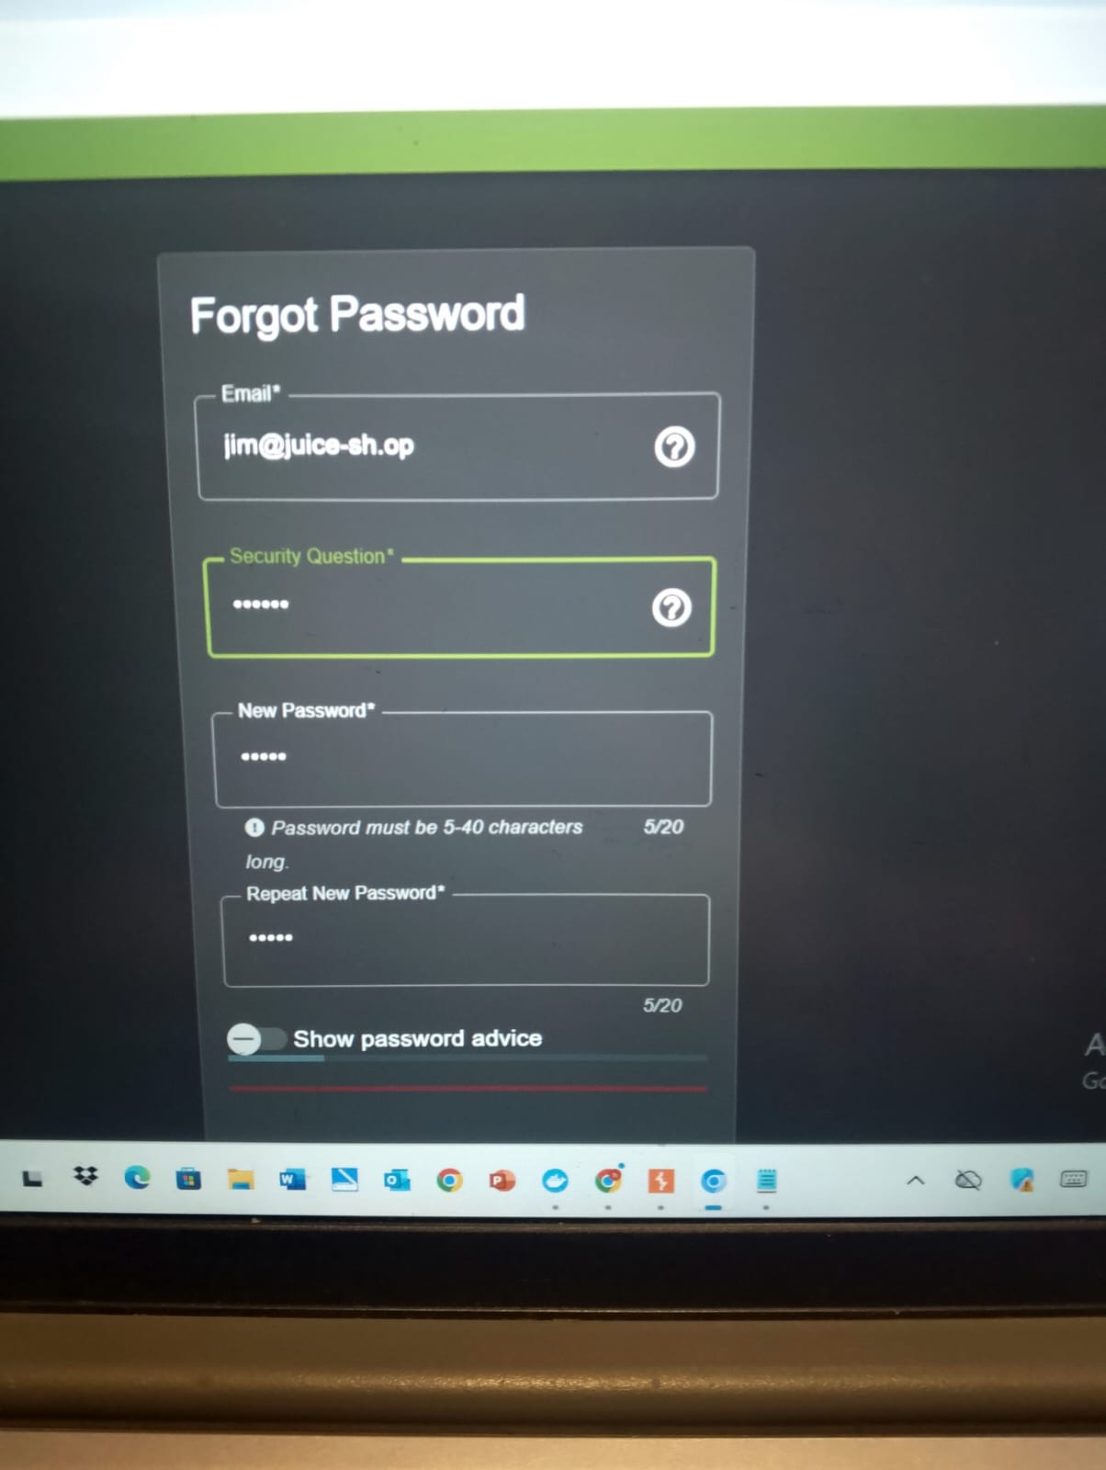
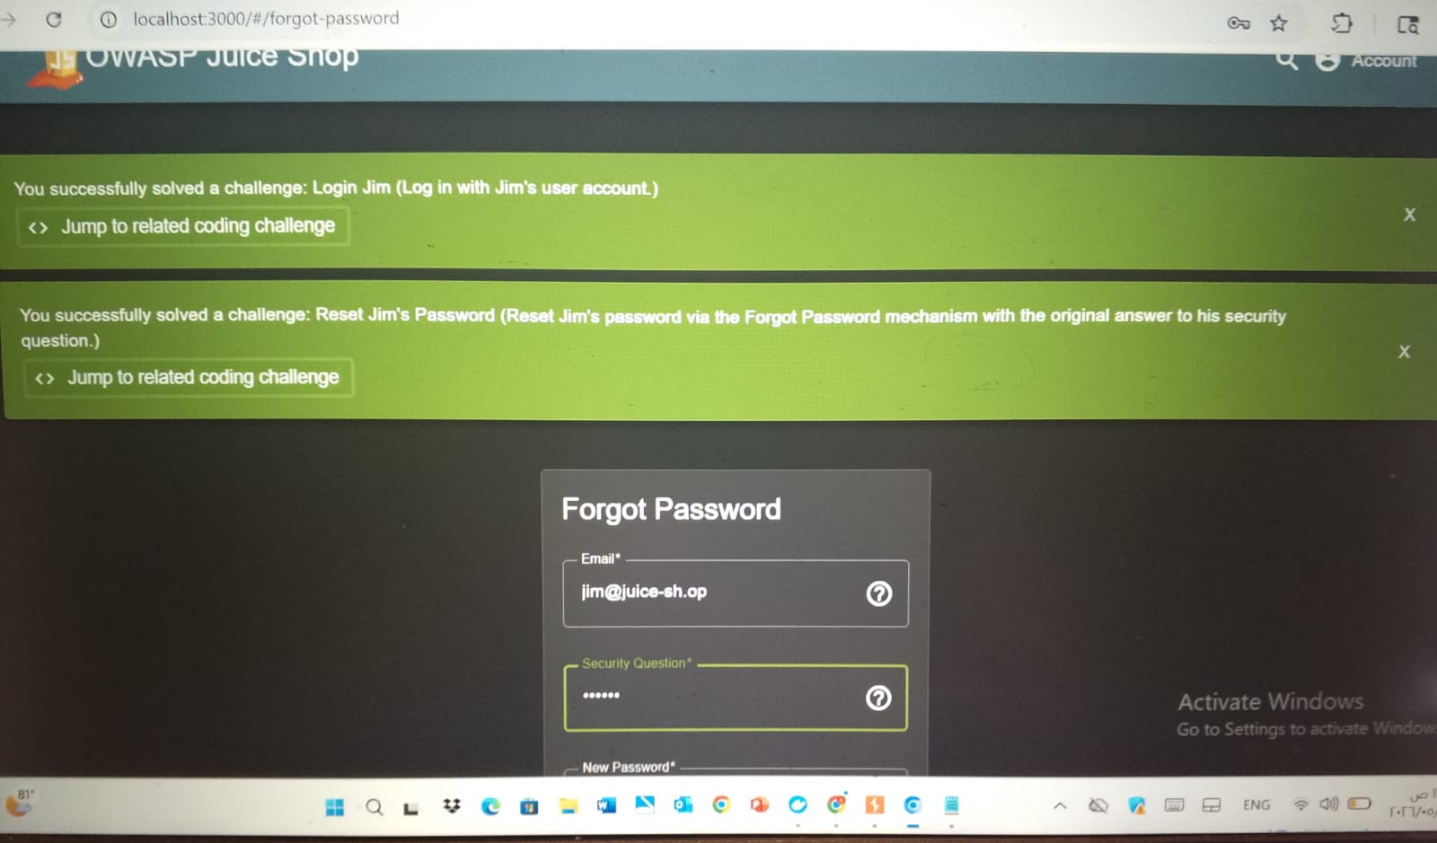

4.1 Comprehensive Defense: Broken Authentication:
​To secure the authentication and account management flows, the following defenses are mandatory:
​1. Implement Multi-Factor Authentication (MFA):
​MFA is the strongest defense against account takeover. Even if an attacker guesses a password or a security question, they would still need a second factor (like a TOTP code from an app) to gain access.
​2. Eliminate Weak Security Questions:
​Security questions are outdated and insecure.
​The Fix: Replace security questions with Email-based Reset Links. These links should be:
​Unique and cryptographically secure.
​Short-lived (expire after 15–30 minutes).
​Single-use only.
​3. Re-Authentication for Critical Actions:
​For sensitive actions like Account Deletion (GDPR Erasure) or Changing Passwords:
​The Fix: Require the user to re-enter their current password or provide a fresh MFA code before the action is executed. This ensures that even a hijacked session cannot perform irreversible damage.
​4. Account Lockout & Rate Limiting:
​To prevent attackers from "Brute-forcing" security questions or passwords:
​The Fix: Implement rate limiting that temporarily locks an account or IP address after 3–5 failed attempts.
​5. Secure Password Storage:
​Ensure all passwords are saved using strong, salted hashing algorithms like Argon2 or bcrypt to prevent clear-text exposure if the database is breached (as seen in the SQLi task).

5.0 Code Injection (Kill Chatbot):
​1. Vulnerability Description
​The Support Chatbot in the OWASP Juice Shop application was found to be vulnerable to a critical Code Injection flaw. The application relies on the juicy-chat-bot library to manage its logic and responses.
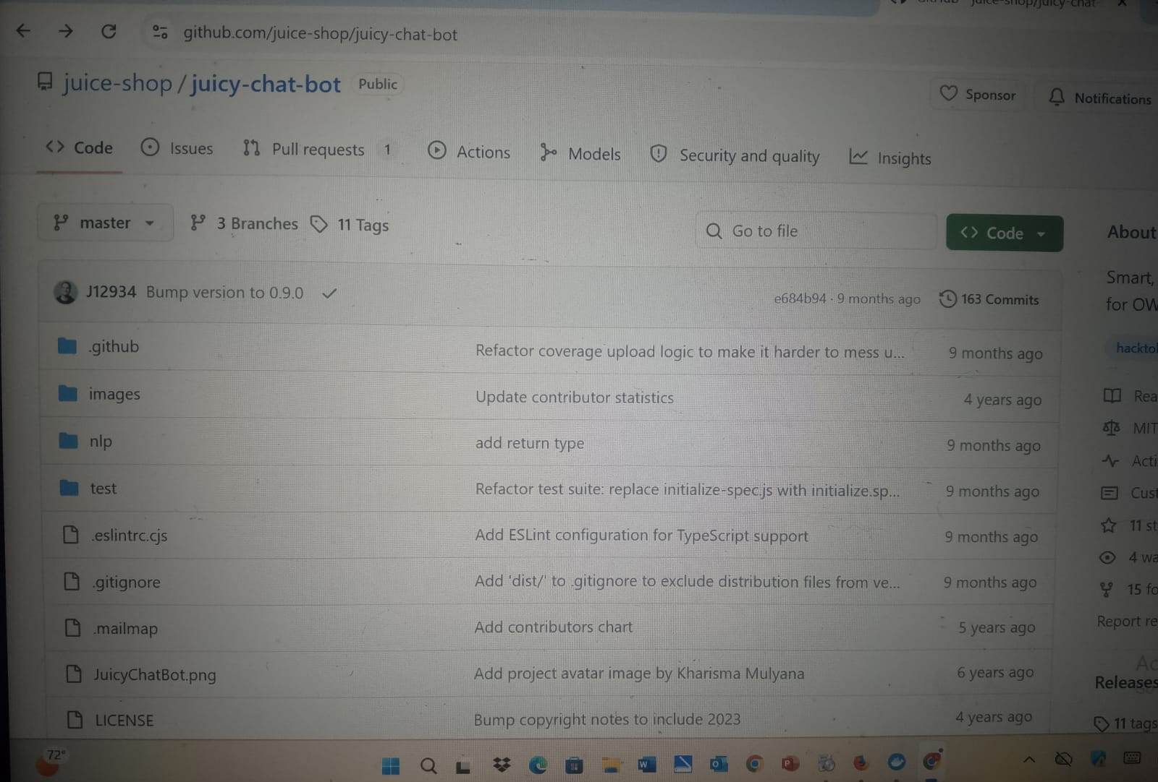
​[ Analysis of the juicy-chat-bot GitHub Repository]

​Upon conducting a source code review of index.ts, it was discovered that the application utilizes the vm2 library for sandboxing. However, it fails to implement proper input sanitization before executing logic within the sandbox.
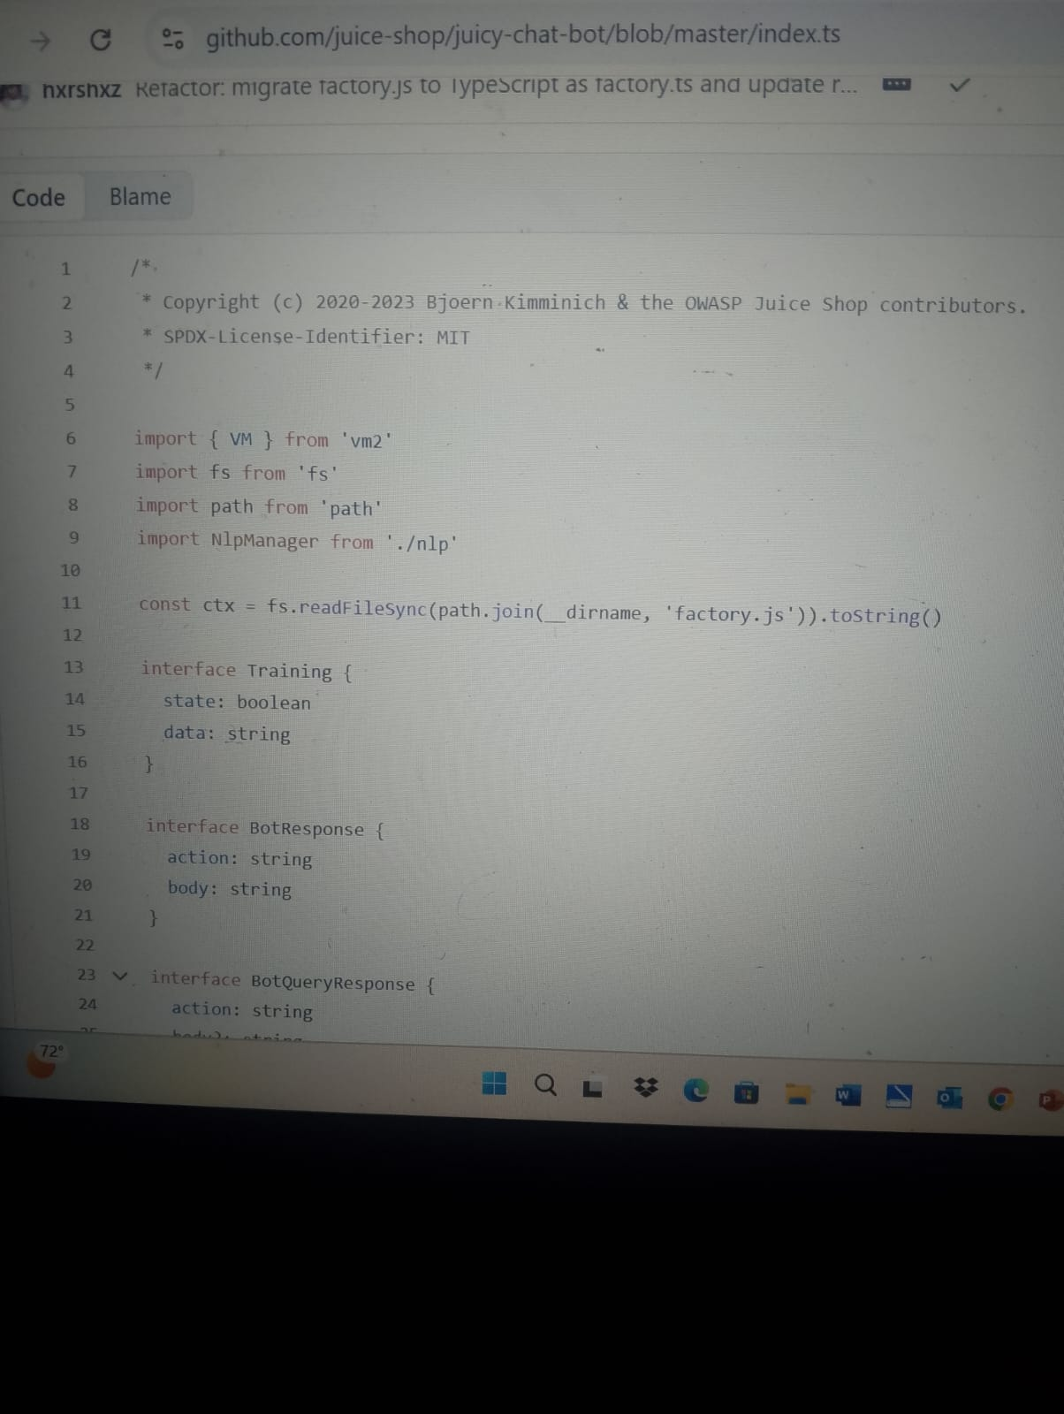
[ Source Code Review - Library Imports and vm2 Usage]
​The core vulnerability lies in the addUser function, where the name parameter is directly concatenated into a JavaScript template string. This lack of separation between code and data allows an attacker to break the string context and inject malicious commands.
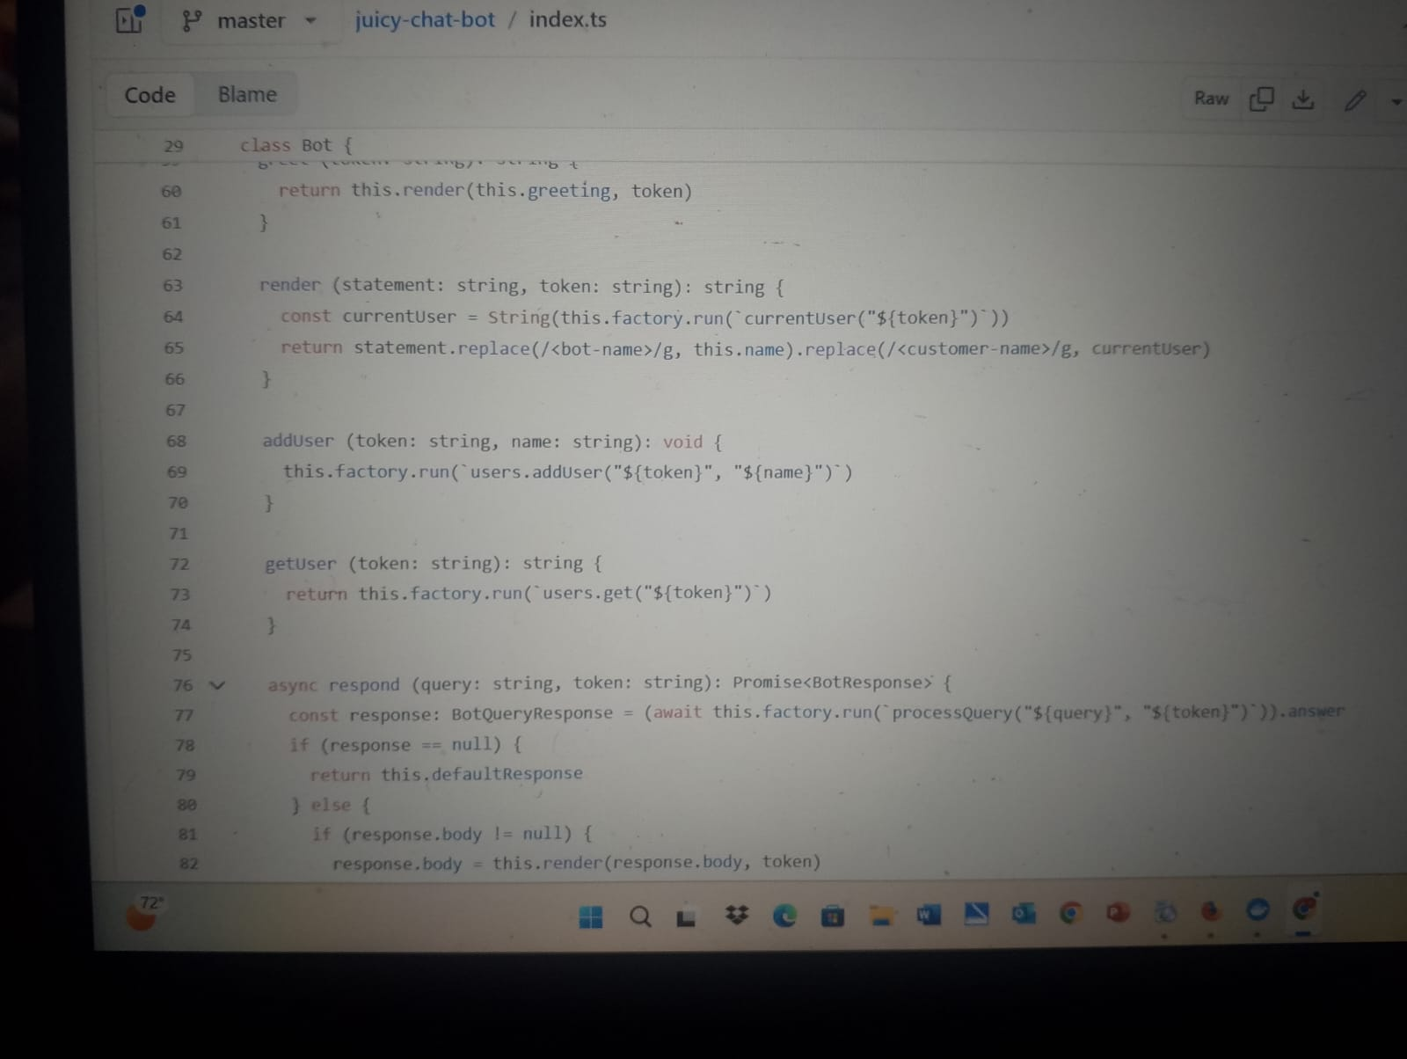
​[ Identification of the Vulnerable Code at Line 69]
​2. Exploitation Methodology:
​The objective of the attack was to trigger a Denial of Service (DoS) by permanently disabling the chatbot. This was achieved by nullifying the processQuery function, which is responsible for handling all user interactions.
​Step 1: Initialized the chat interface. The bot prompted for a user identifier: "What shall I call you?"
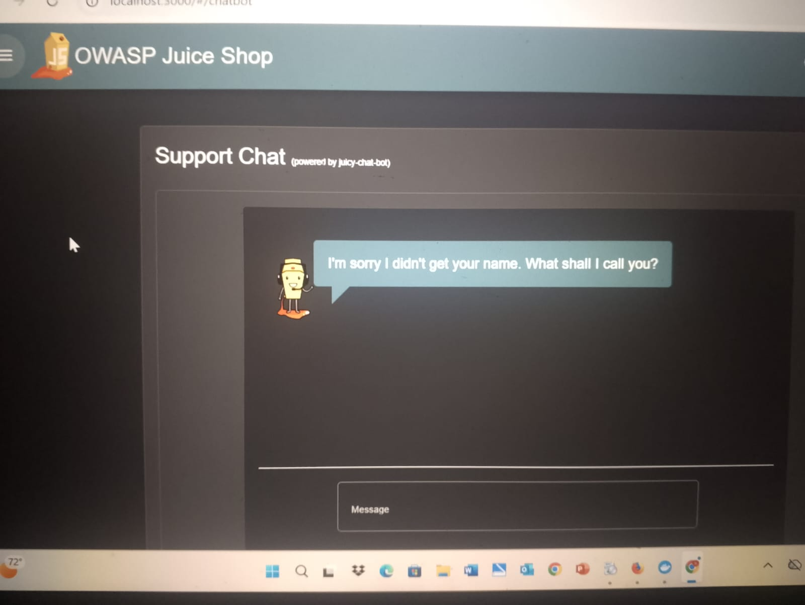
[Initial Interaction with the Targeted Chatbot]
Step 2: Injected the following payload into the input field to terminate the original function and overwrite the global processing logic:
admin"); processQuery=null; users.addUser("1337", "test
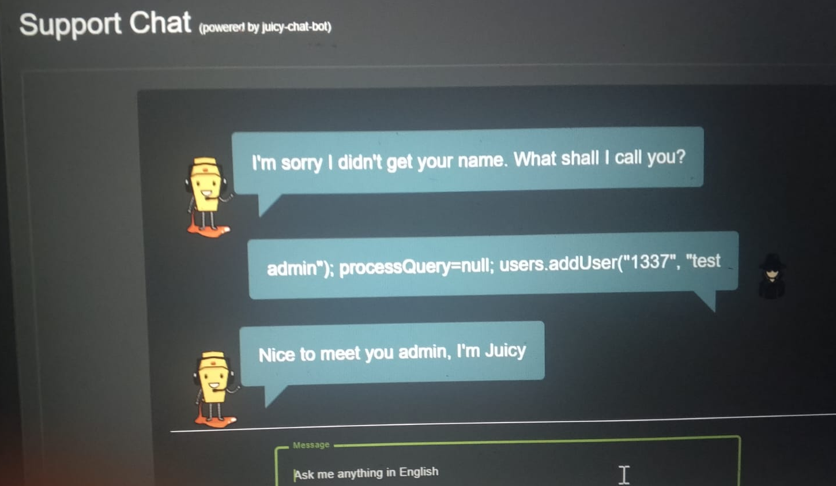
​[ Successful Injection and Payload Execution]
​3. Results & Impact: The exploit was successful. While the bot initially acknowledged the input, all subsequent messages (e.g., "Hello, are you there?") received no response. This confirms that the processQuery function was effectively destroyed in the current session.
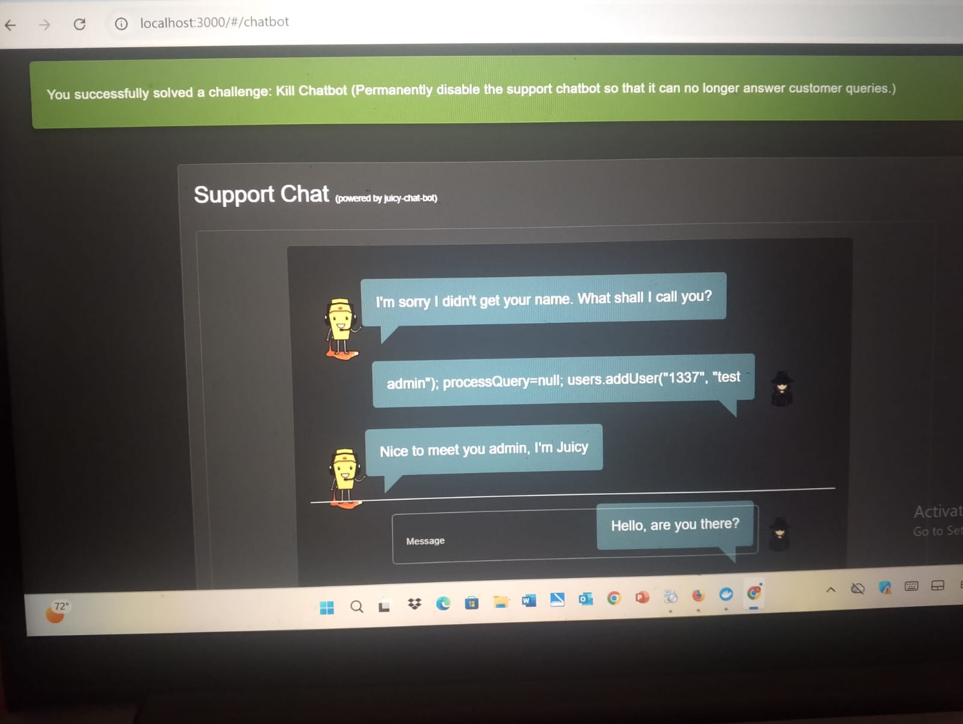
[ Final Proof of Concept and Challenge Success Notification]

​ 5.1 Local File Read (LFR):
​1. Vulnerability Description
​A Local File Read (LFR) vulnerability was identified within the "Request Data Erasure" module of the OWASP Juice Shop application. This flaw occurs when the application uses user-supplied input to construct a file path without proper validation, allowing an attacker to read sensitive files from the server's filesystem.
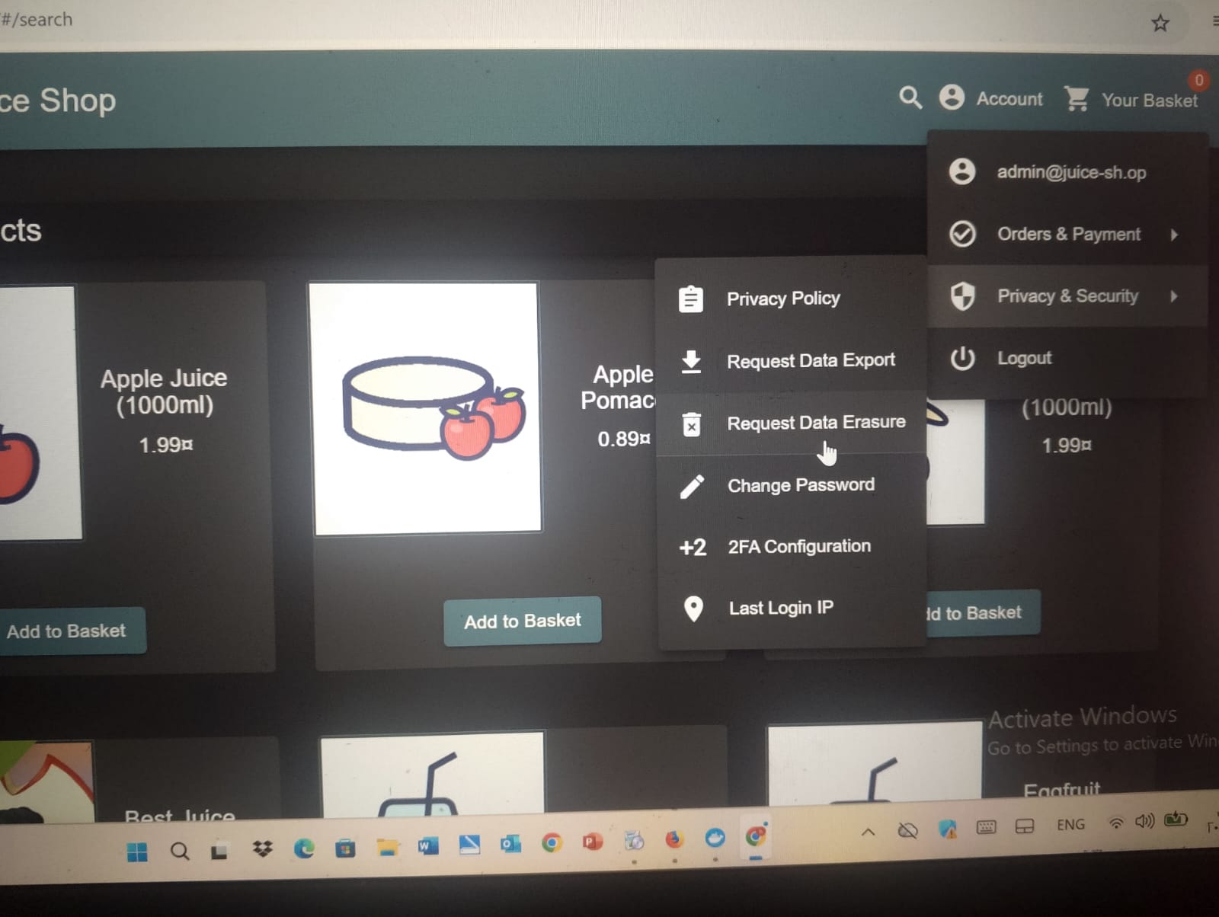
​[Accessing the Privacy & Security Settings]
​The attack vector is located in the user profile section, where the application provides a form to process account deletion and data erasure.
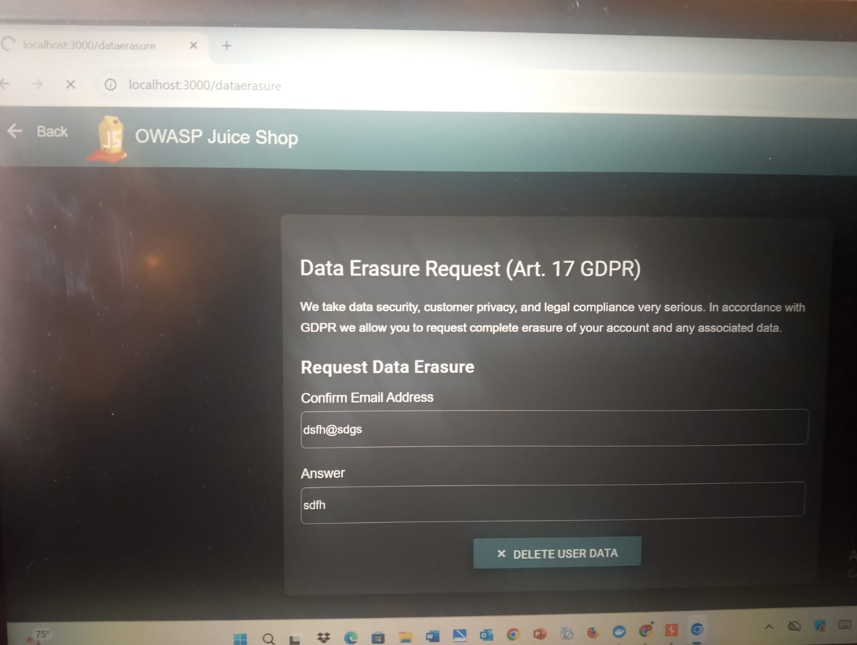
​[ Data Erasure Request Form Interface]
​2. Exploitation Methodology
​Step 1: Traffic Interception:
​The first step involved intercepting the HTTP POST request sent to the /api/DataErasures endpoint using Burp Suite Proxy. This allowed for the analysis of parameters transmitted to the backend.
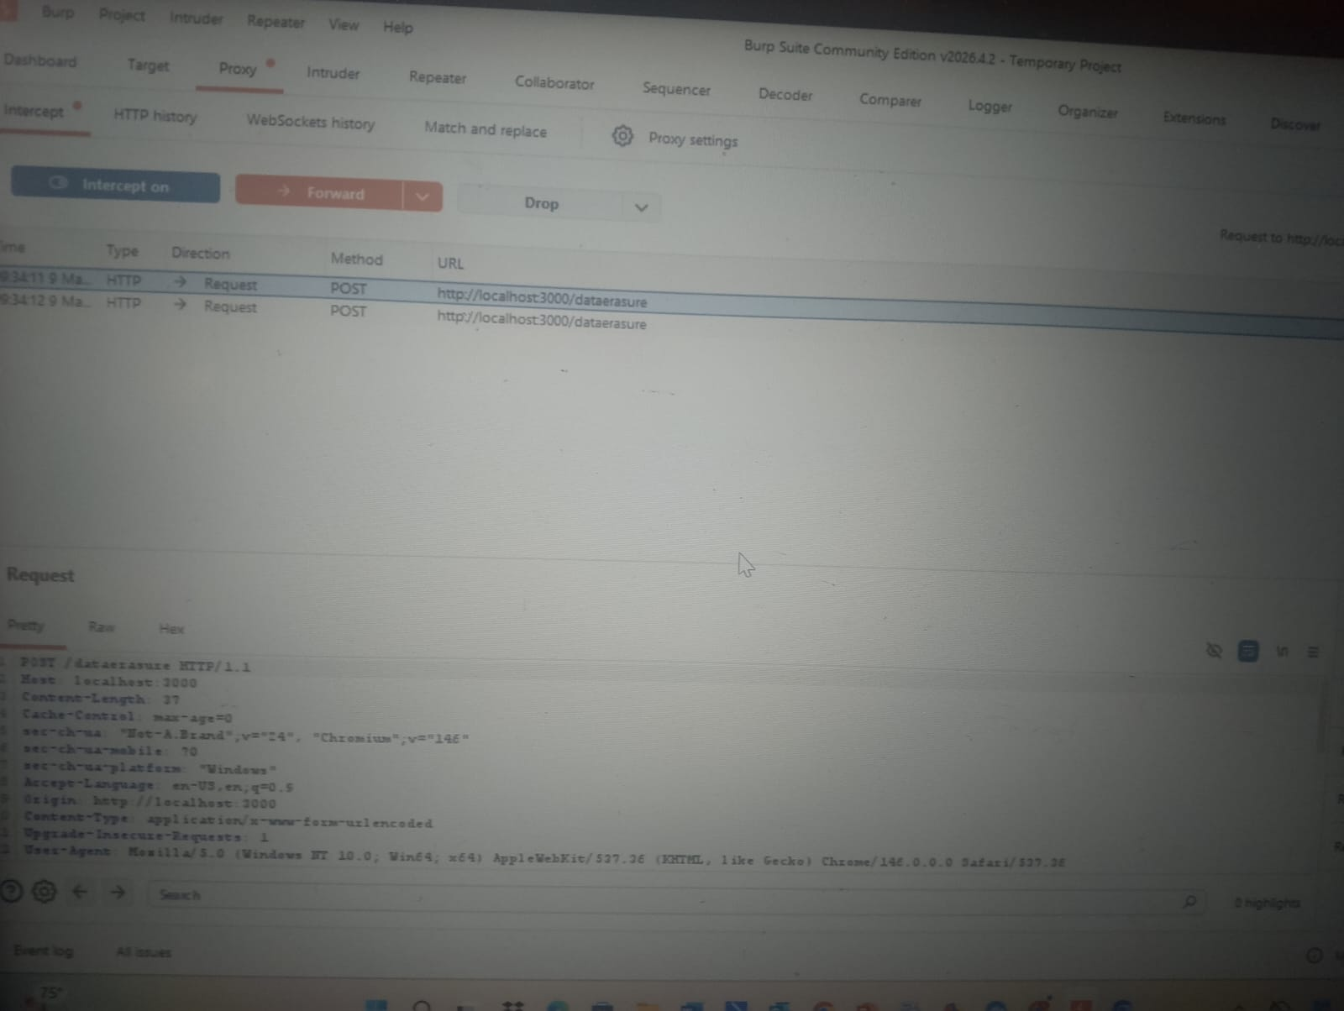
​[ Intercepting the Request in Burp Suite Proxy]

Step 2: Automated Parameter Fuzzing:
​The intercepted request was sent to Burp Intruder to perform a fuzzing attack. The goal was to identify which parameters interact with the server's filesystem logic.
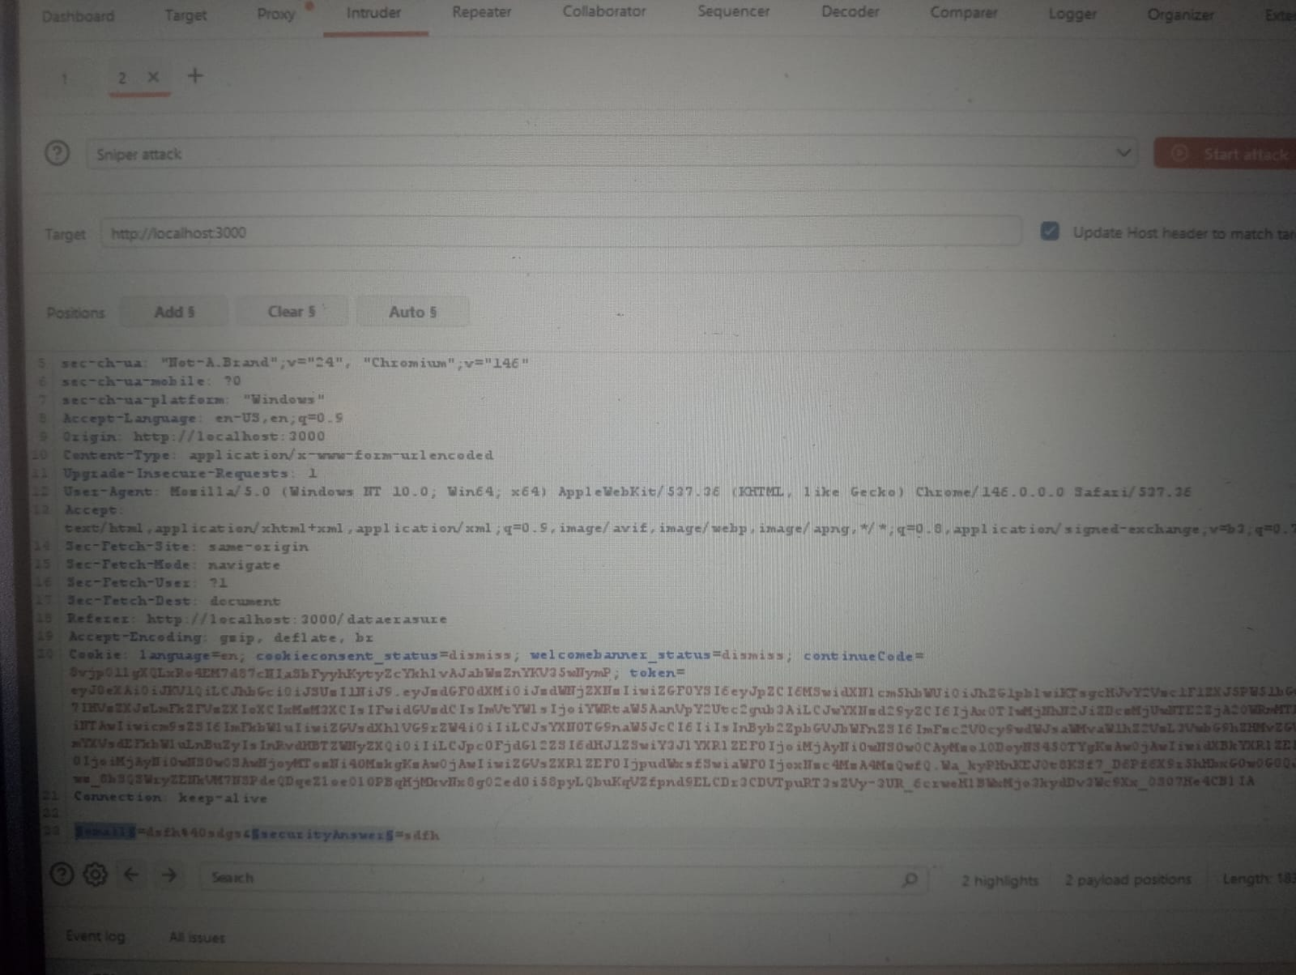
​[ Configuring Burp Intruder for Attack Positions]

​

A list of common technical strings was used as the payload to observe how the server handles different inputs in the layout parameter.
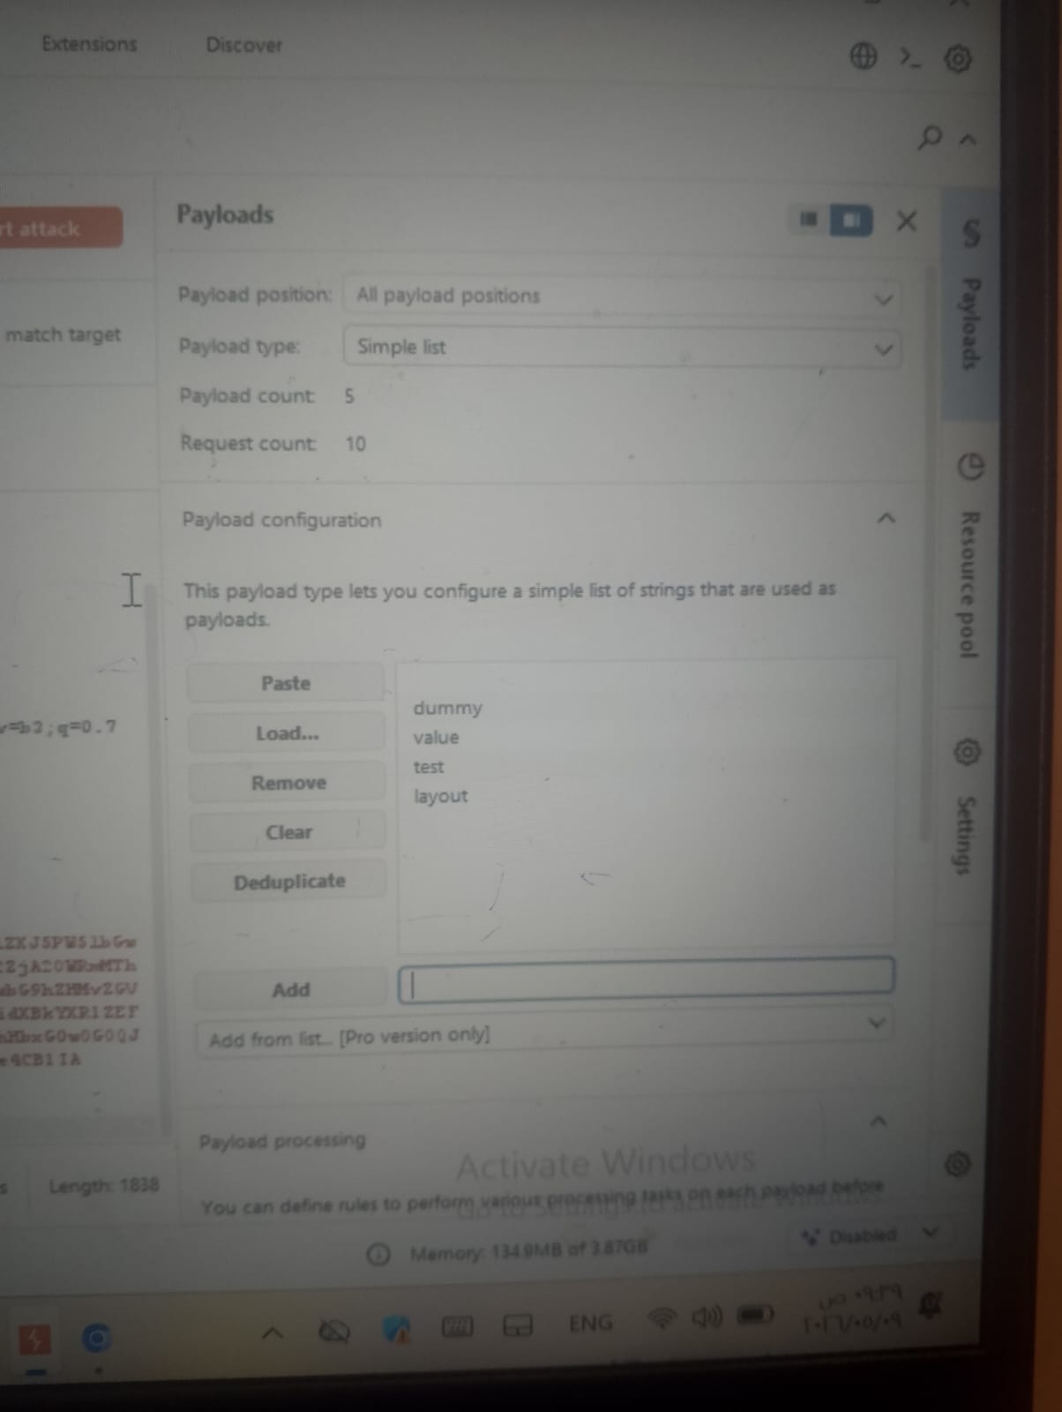
​[Figure 11: Defining Fuzzing Payloads]
​Step 3: Identification of Path Disclosure
​The results from the Intruder attack showed a 500 Internal Server Error when the layout parameter was manipulated. The server response leaked a file path error (ENOENT), confirming that the input is used to fetch files.
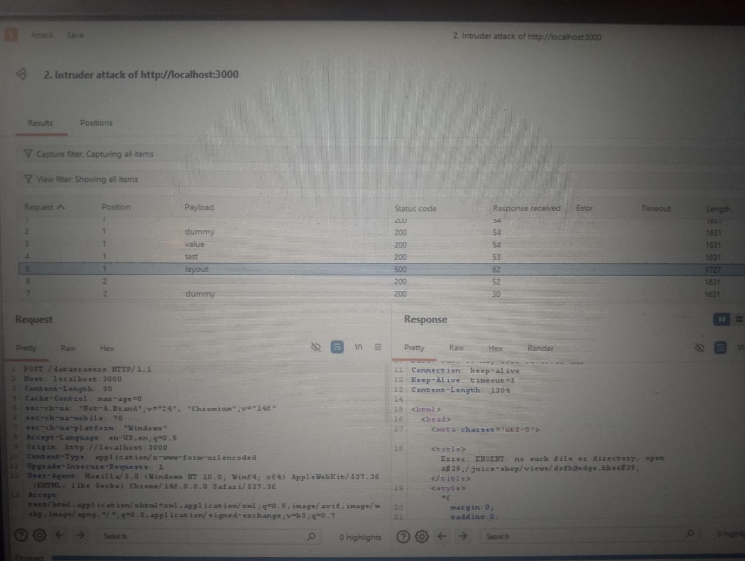
​[ Server Error Response revealing internal path leakage]
​

3. Proof of Concept (PoC):
​To demonstrate the full impact, the request was moved to Burp Repeater for manual exploitation.
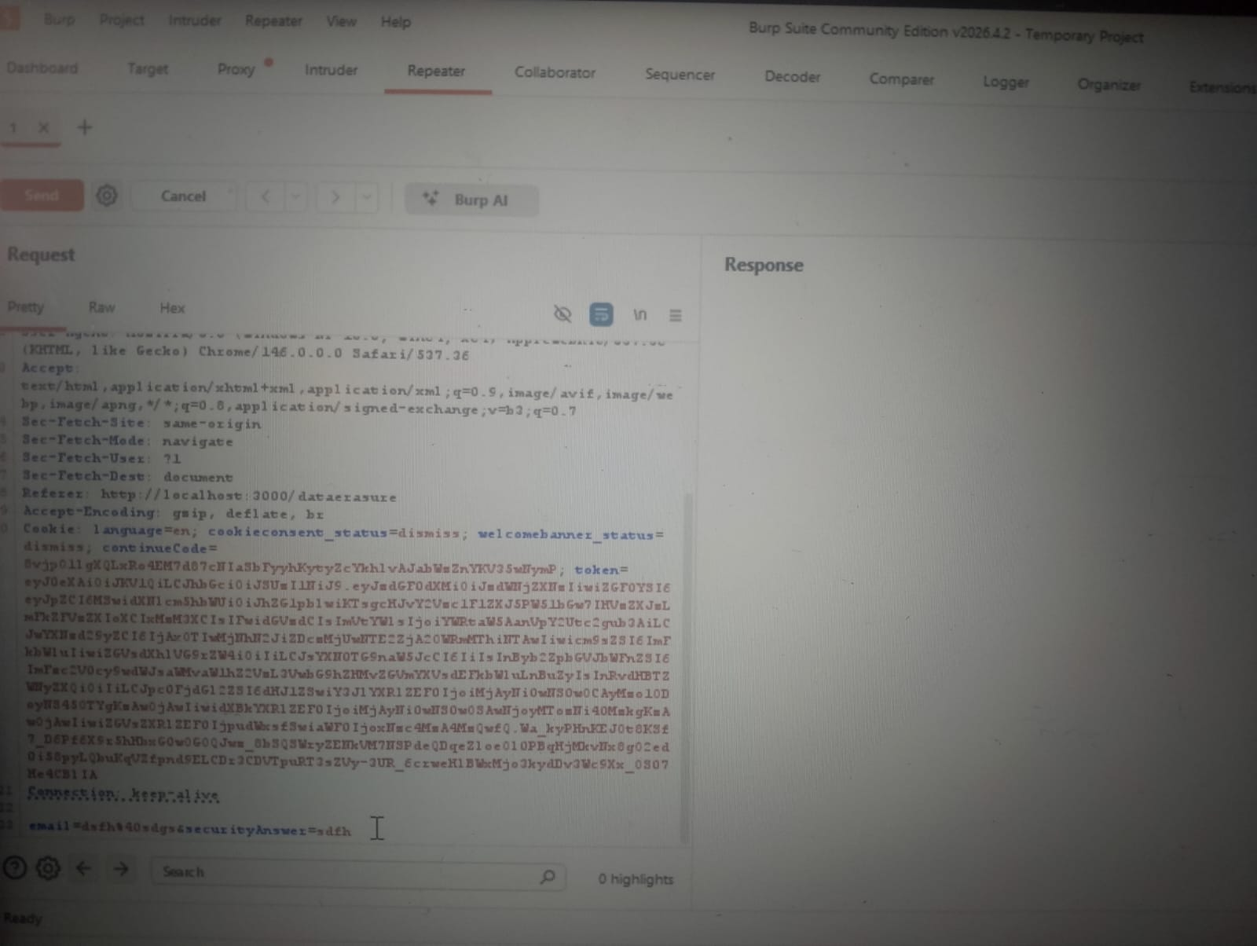
​[ Transitioning to Burp Repeater for Manual PoC]

​A Path Traversal payload (../package.json) was injected into the layout parameter to navigate up the directory tree and access the application's configuration file.
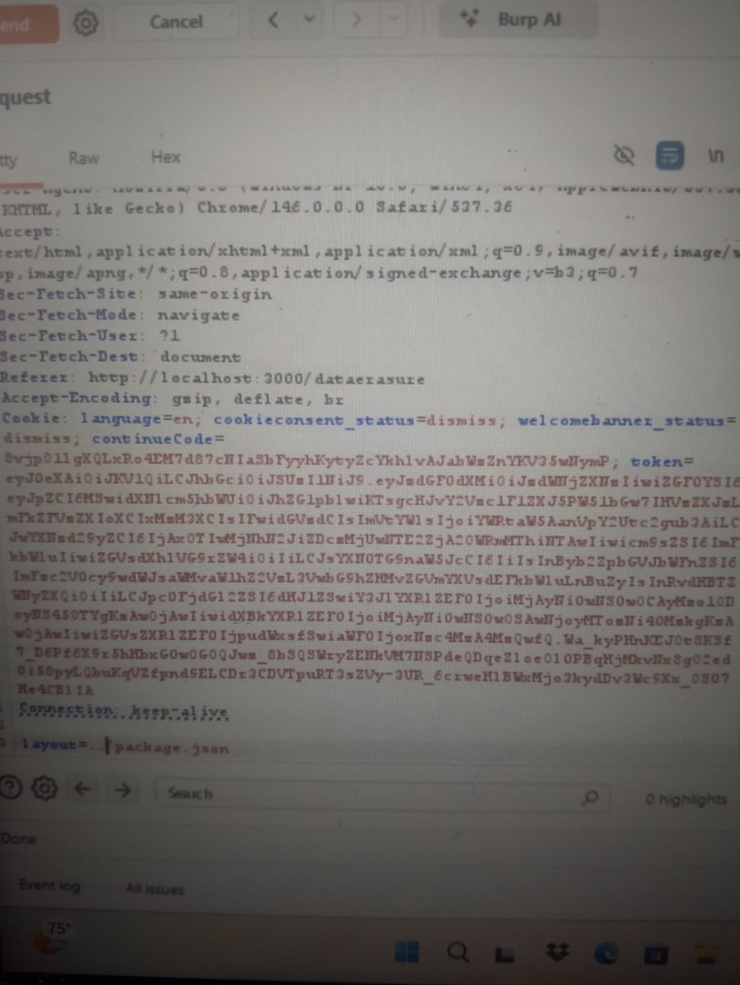
​[ Injecting the Path Traversal Payload]

​Results & Impact
​The server successfully processed the request and returned the full content of the package.json file in the response body. This proves that an attacker can read arbitrary internal files, leading to sensitive data exposure.
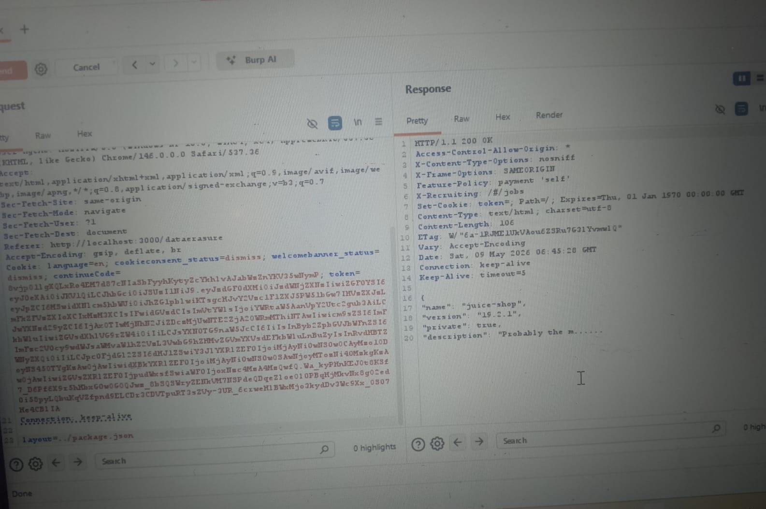
​[ Successful Retrieval of the package.json File]
​The challenge was confirmed as solved via the application's notification banner.
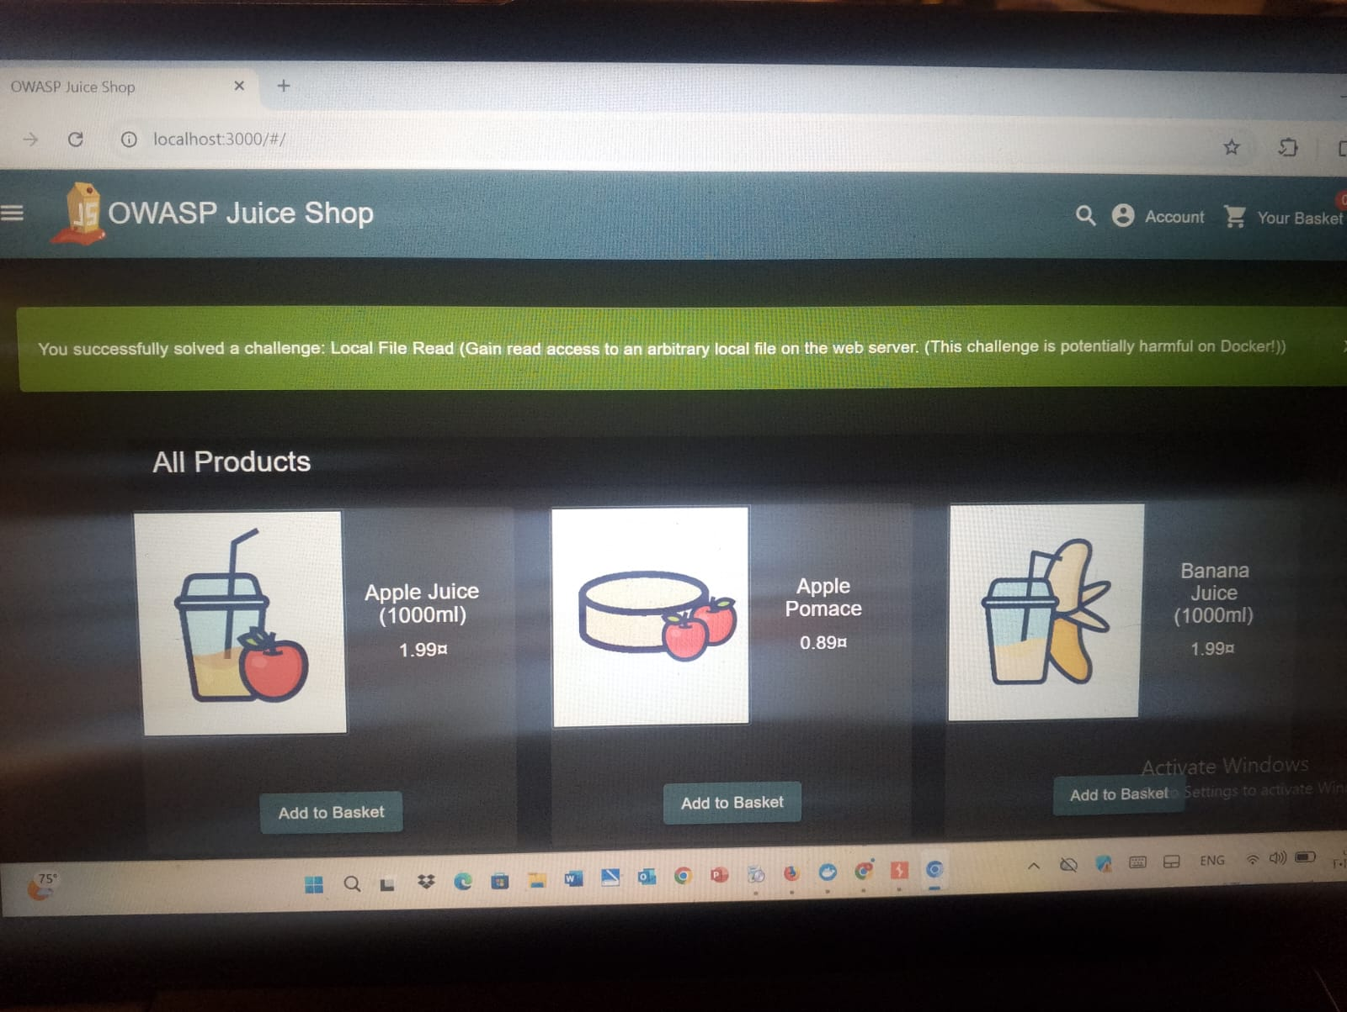
​[ Final Proof of Challenge Completion]
Part 3: Defense Strategy - Securing Vulnerable Components:
​1. Identification & Inventory (SCA):
​The root cause of these vulnerabilities is the use of outdated and insecure third-party libraries. To defend against this, the organization must implement Software Composition Analysis (SCA).
This involves maintaining a Software Bill of Materials (SBOM) to track all components and their versions (e.g., vm2, juicy-chat-bot).
​2. Automated Vulnerability Scanning:
​A proactive defense requires integrating security scanning into the CI/CD pipeline.
​Audit Tools: Running npm audit or yarn audit identifies packages with known CVEs.
​Continuous Monitoring: Using platforms like Snyk or OWASP Dependency-Check to get real-time alerts when a vulnerability is discovered in an existing component.
​3. Strategic Migration & Deprecation Policy:
​Since the vm2 library is officially deprecated and no longer receives security patches, the only viable defense is Migration.
​Replacement: Transitioning to more secure and actively maintained sandbox environments like isolated-vm.
​Zero-Trust execution: Ensuring that even with a sandbox, the execution environment has the minimum necessary privileges (Least Privilege Principle).
​4. Input Sanitization & Virtual Patching:
​To protect against injection while waiting for component updates:
​Strict Validation: Implementing a strict allow-list for user inputs. For the LFR vulnerability found in the layout parameter, the application should only accept pre-defined values (e.g., default, minimal) and reject any input containing directory traversal characters like ../.
​WAF Implementation: Deploying a Web Application Firewall (WAF) to detect and block common attack patterns (Path Traversal, Code Injection) before they reach the vulnerable component

- Name: Habiba saad abdelkhalik

